Moj SLOVAR :
- sail across – prepluti preko
- travel along – potovati skozi
- spices - začimbe
- voyage – potovanje

Povedi :
- Marco Polo was sail across the Atlantic ocean.
- Pablo Diaz was traveling along the China .
- My mum gets a spices in soup.
- We get a voyage to Greece .

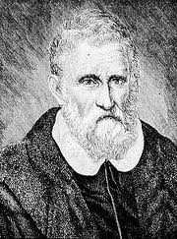MARCO POLO

SPICES
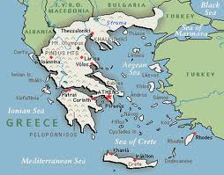VOYAGE

