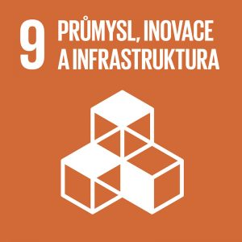
Industry, Innovation and Infrastructure

Authors: Tereza Maxerová, Marcela Lukášíková
Keywords: Sustainability, zero waste, upcycling
Objective: Build resilient infrastructure, promote inclusive and sustainable industrialization and foster innovation
Innovation and technological progress are key to solving economic and environmental problems. But 3.6 billion people remain offline, without access to online information, education or employment, or important health and hygiene information.


THEORETICAL PREPARATION
Global investment in research and development reached two trillion USD in 2016 (up from just 739 million USD in 2000).
Some 2.6 billion people in the developing world do not have access to an uninterrupted supply of electricity. 2.5 billion people do not have access to basic sanitation and nearly 800 million do not have access to water. Many millions of them live in sub-Saharan Africa and South Asia.
1 to 1.5 million people do not have access to reliable telephone services. 90 percent of the population lives within range of the mobile phone signal, but a significant proportion cannot afford mobile technology. In many African countries, especially low-income ones, inadequate infrastructure reduces corporate productivity by about 40 percent.
The manufacturing industry is a major employer with about 470 million jobs worldwide (2009) and about 16 percent of the global workforce (2.9 billion people). It is estimated that the manufacturing industry employed more than half a billion people in 2013.
One job in industry creates 2.2 jobs in other sectors. Less than 30 per cent of agricultural production in developing countries is processed industrially, compared to 98 per cent in high-income countries. Therefore, there is great potential for agricultural-industrial enterprises in developing countries.

Infrastructure is understood at two levels:
- In the economic sphere, it ensures conditions for the development of the economy, especially in transport, energy, services, etc.
- At urban level, all utilities in human settlements running under and above ground (water, gas, heat and electricity supply; communication technology such as radio, information from authorities, waste management, etc.) (Wikipedia, 2022).
A well-designed and reliable infrastructure is a prerequisite for a resilient economy, business and quality of life. It is therefore in the interest of the state to continue to develop infrastructure. At the same time, however, infrastructure must cause as little damage as possible, such as landscape fragmentation and land grabbing. High-quality infrastructure is crucial for the operation of the state, which is the reason for consistent funding over the long term. Public ownership is necessary, because quality infrastructure cannot be left to the short-term discretion of the market mechanism alone. The state should therefore maintain and improve the regulatory framework to ensure safety and quality as well as economic and social standards.
An important part of infrastructure is the electricity grid. This has traditionally been based on centralised generation in large power plants, but as the share of renewable energy generation increases, the grid will need to accommodate a large number of smaller sources. Decentralised production is growing thanks to the proliferation of new technologies, and local resources are enhancing security and benefiting the local economy. At the same time, the growth of renewable energy sources is purposefully supported by European and domestic legislation.
The transport infrastructure still follows the borders of the former Eastern Bloc. It is necessary to strive for the management of interstate roads in such a way that the Czech Republic does not become just a periphery – a place that is only quick and cheap to drive through or that is better to get around. It is in the interest of the state to ensure permanent and efficient connections with the core of the continent, especially with Germany, France and the Benelux countries. At the same time, however, regional transport infrastructure must be developed to mitigate the outflow of population from the peripheral regions of the Czech Republic.
Water infrastructure performs two basic functions: supplying drinking water and removing wastewater. Investments in water management will be particularly linked to adaptation to climate change, for example in drought mitigation. The most important challenge for water management is to ensure sufficient drinking water despite the deterioration of hydrological conditions due to climate change.
Today’s world is most affected by technological change, both at the level of the economy and society as a whole. Richer countries with higher innovation potential are much better able to adapt to these changes. Public investment in the information structure is therefore crucial for the Czech Republic to remain among innovative countries and not fall into the ‘periphery’ of development (CR 2030, 2022).
Industrialization
Industrialization is the development of industry and its social consequences. All societies throughout history have experienced continuous industrialisation to a greater or lesser extent. People’s inventiveness greatly influenced their way of life, such as the invention of the wheel, the discovery of metals, the printing press and the medieval pulley. Three centuries ago, however, there was great growth due to the development of steam engines, the use of oil and the use of electricity. This process has led to technological and scientific developments as well as an improvement in the professional level of employees.
The goal of this process was to create tools and develop equipment that would be capable of higher levels of production of a given good, and to maximize profit. The processes involved in this new technology will affect the evolution of the labour factor and ultimately economic outcomes such as Gross Domestic Product (GDP).
The latest industrialization: 20th and 21st centuries
In the aftermath of the world wars, progress focused mainly on military and armament aircraft. As far as medicine and pharmacy are concerned, developments have been achieved in the field of pharmaceuticals – morphine and penicillin. Since the globalization of the world in the mid-20th century, technology has experienced growth with the emergence of networks such as the internet.
Sustainability
One of the first definitions of sustainability in 1987 after concerns about societal growth: (Sustainable) development is development that meets the needs of the present without compromising the ability of future generations to meet their own needs (UNEP – Industry and Sustainable Development, 2010/2011).
Sustainable development is a type of development that also seeks to eliminate or mitigate the negative effects of the way human society has developed to date. Past and present developments based primarily on economic growth are irreversibly affecting the shape and functioning of our planet. Most natural resources are finite and over-exploiting them damages our planet, so it is essentially development on debt. Sustainable development takes into account not only economic growth but also social values and natural wealth. The central question is therefore how to preserve the quality of life and provide for the needs of current generations without compromising the needs of future generations and others. It is based on the understanding that the social, environmental and economic pillars of society are closely linked and that one cannot be prioritised at the expense of others (Ministry of the Environment, 2022).
Sustainable development is not a purely environmental concept. It is a complex concept in which several spheres are combined. The three pillars of sustainability can be derived from the definition of sustainable development:
- ecological (environmental)
- social
- economic (UNEP – Industry and Sustainable Development, 2010/2011)
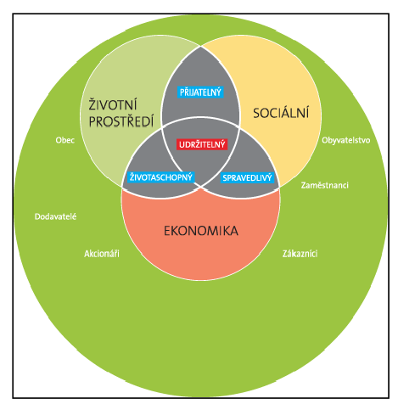
Figure 1: The three pillars of sustainable development (UNEP – Industry and Sustainable Development, 2010/2011).
While sustainable development has historically been rooted in the need to better protect nature and the environment, it now extends to good and effective governance. To achieve real sustainable development, coherent public policies in all their forms (strategies, laws, financial instruments) need to be developed. This can be achieved through evidence-based decision-making and improving the conditions for public participation to create meaningful social dialogue.
The need to make our world more sustainable has become prominent in Europe and the world in recent years. Almost all countries in the world are facing pressing challenges such as climate change, demographic change, loss of fertile land, and widening inequalities. Accelerating technological change and the increasing interconnectedness of the contemporary world means that it is necessary to see the world in context and to take into account the responsibilities of each state towards the global community (Ministry of the Environment, 2022).
Sustainability terms
Zero waste – a lifestyle that promotes the reuse of all resources without waste generation, landfilling or incineration. This set of principles supports the redesign of the life cycle of resources so that all products are reused. The goal is that no waste is sent to landfills, incinerators or the ocean (Wikipedia, 2022).
Upcycling – the process of reusing material that has less negative impact on the environment than current recycling. Upcycling does not use waste. It uses materials before they become waste. It is essentially about renovation, in principle we can say that anything that adds value to things otherwise destined for destruction, or condemned to further decay, is upcycling. This method is most often used in design, fashion and art (Třídění odpadu, 2022).
Slow fashion / fast fashion – the term slow fashion refers to the eco-friendly, sustainable and ethical fashion industry. Fash fashion is attacking customers with new and even more modern clothes than were fashionable last week. Characteristic of fast fashion is the low quality of the products, be it poor quality sewing, poor quality material and above all the huge amount of products that are created without any regard to whether there is actually a sale. Goods are produced in such quantities that even if the clothes do not find a user and end up on sale or in an incinerator, there is still money to be made from the products. Fast fashion is also produced by labour in poor conditions at severely undervalued wages (byGreyson, 2022).

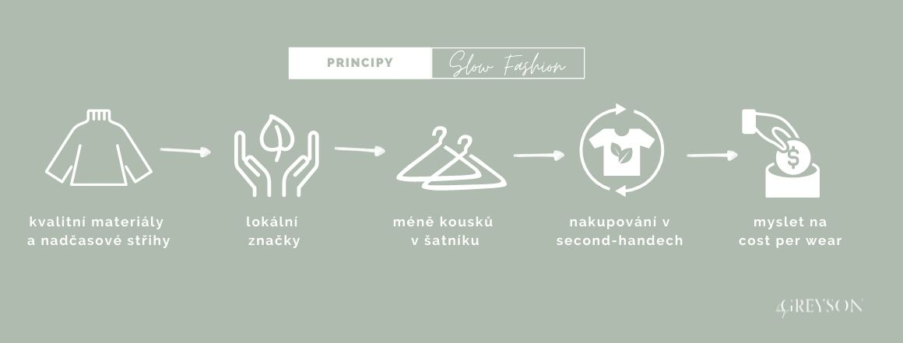
Figure 2: The principle of sustainable slow fashion
DRAFT LESSON PLAN
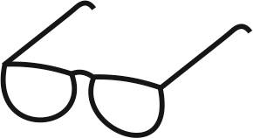
Estimated time: 45 minutes

Teaching stage | Activity description | Teaching method | Teaching form | Time
Motivation | - sustainability | Discussion | Mass frontal | 3 min.
Exposure | - Activity 1  Video: https://www.youtube.com/watch?v=Fk85s8nGNJk | Work with cards | Group | 10 min.
Fixation | - Worksheet – homework | Work with a worksheet | Individual group | ----
Application | - Activity 2 | Creation of a lapbook | Group | 30 min.

Motivation
The teacher asks students the following questions:
What is sustainability?
Is this an important topic for the future?
Together with students, they come up with a definition of sustainability, which the teacher writes on the board.
Exposure
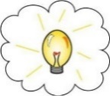
Using Activity 1, the teacher checks whether students correctly matched the concepts to the definitions.
Tip for the teacher:
With a debatable topic such as zero waste, controversy may arise. There are a lot of young people on YouTube promoting this lifestyle and posting various tips on how to do it.
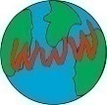See this video example: https://www.youtube.com/watch?v=Fk85s8nGNJk (13 min.) or
https://www.youtube.com/watch?v=pF72px2R3Hg (13 min.)

Fixation
The teacher assigns homework: completing and sticking the worksheet in the exercise book (see ‘Worksheet’).
Application
Using Activity 2, at the end of the lesson the teacher invites students who wish to present their product.

WORKSHEET
Task 1
Colour the recycling containers:
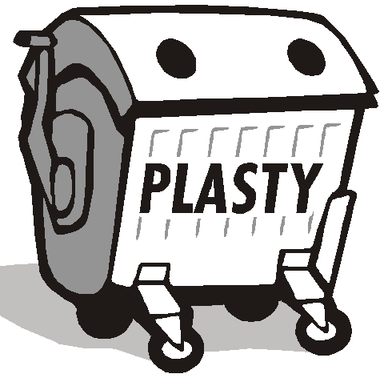
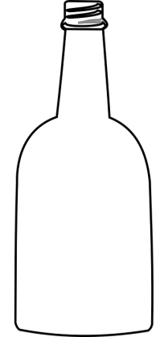

Match waste to the containers:
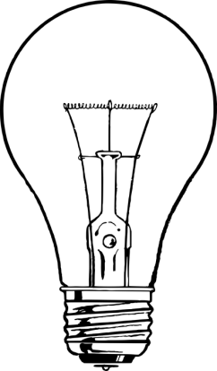


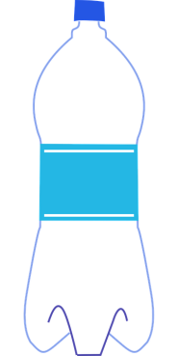
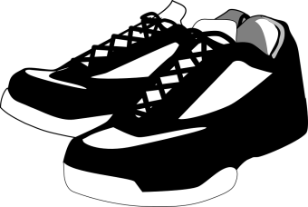

Task 2
Match unsustainable sources to sustainable energy options (multiple choice):
• Wind power plant
• Petrol/diesel car • Public transport • Solar panels on the roof
• Wood/coal heating • Heat pump heating • Car
• Coal power plant • Nuclear power plant


WORKSHEET – key
Task 1
Colour the recycling containers:
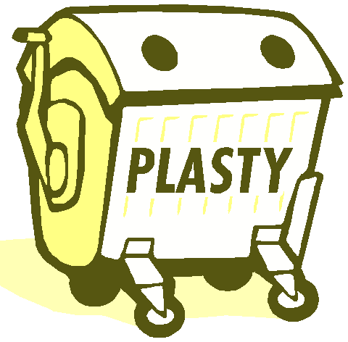
Match waste to the containers:

Task 2
Match unsustainable sources to sustainable energy options (multiple choice):
• Wind power plant
• Petrol/diesel car • Public transport • Solar panels on the roof
• Wood/coal heating • Heat pump heating • Electric car
• Coal power plant • Nuclear power plant

ACTIVITIES FOR STUDENTS

Activity 1 - Cards
The teacher hands out cards to students in pairs/fours (depending on the number of students in the class). In each set, the cards are cut in pairs in the form of concept-definition. The teacher also hands out blank cards on which students write an example of the concept and definition. For cards see Annex 1. Students are asked to match the concept to the definition and then write an example implementation on a blank card.
Activity 2 – Creation of a lapbook
Students are asked to work in pairs or fours in which they worked on Activity 1 to create a lapbook using the provided tools (Annex 2). Alternatively, they can invent their own tools. The lapbook must contain the topics from the previous activity. For this purpose, the teacher leaves the cards from Activity 1 with students. According to their own creativity, students can add other topics that seem appropriate.
Annex No. 1
SUSTAINABILITY | The ability to meet human needs with future generations in mind.

RECYCLING | Waste recovery method by which waste is reprocessed into products, materials or substances, whether for the original or other purposes

UPCYCLING | The process of reusing material that has less negative impact on the environment than current recycling, does not use waste.

ZERO WASTE | A lifestyle that promotes the reuse of all resources without creating waste

SLOW FASHION | Refers to the eco-friendly, sustainable and ethical fashion industry
Empty cards to write implementation examples:

Annex No. 2
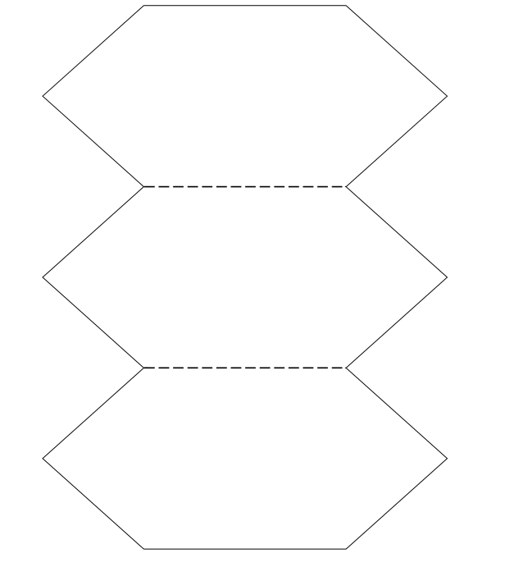
Note: cut unbroken lines, fold broken lines.
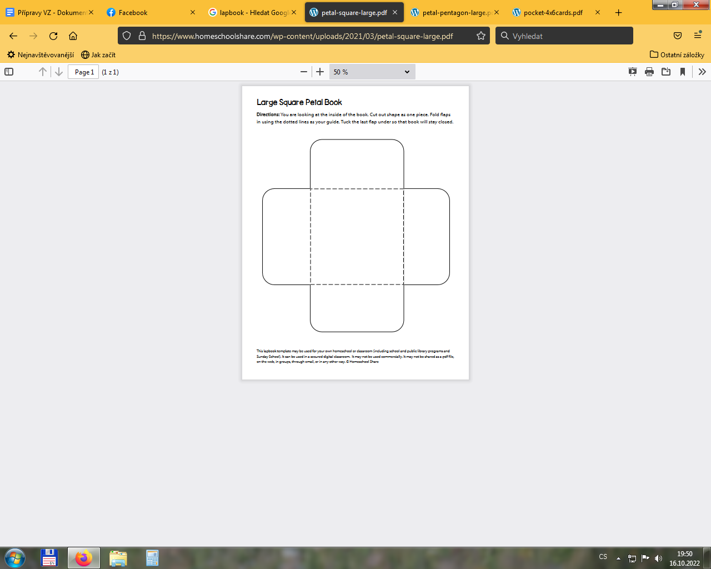
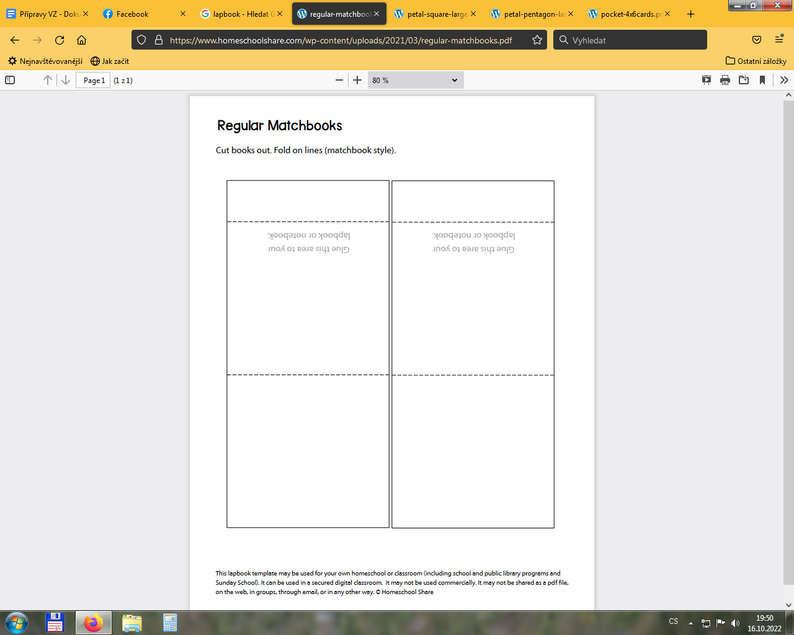
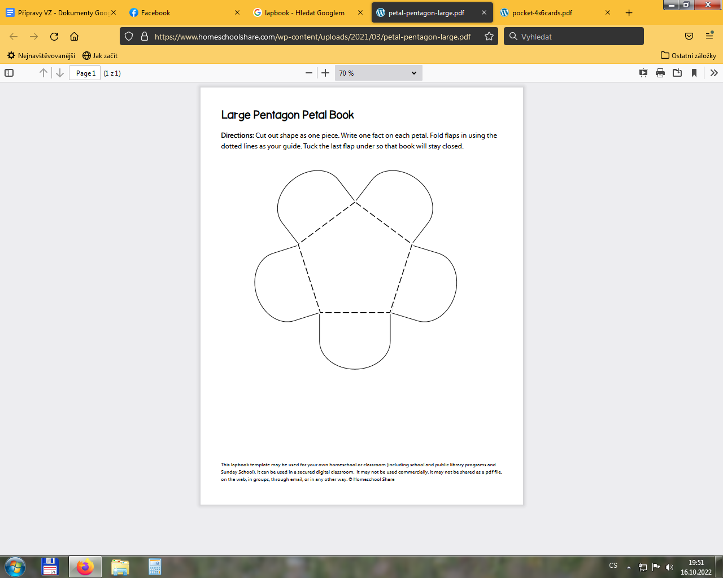
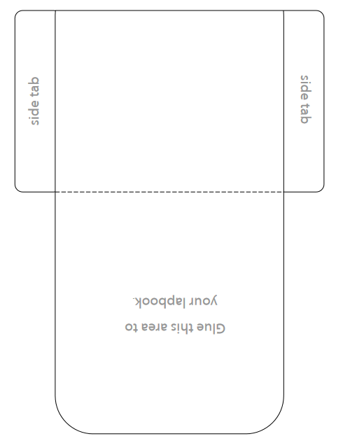
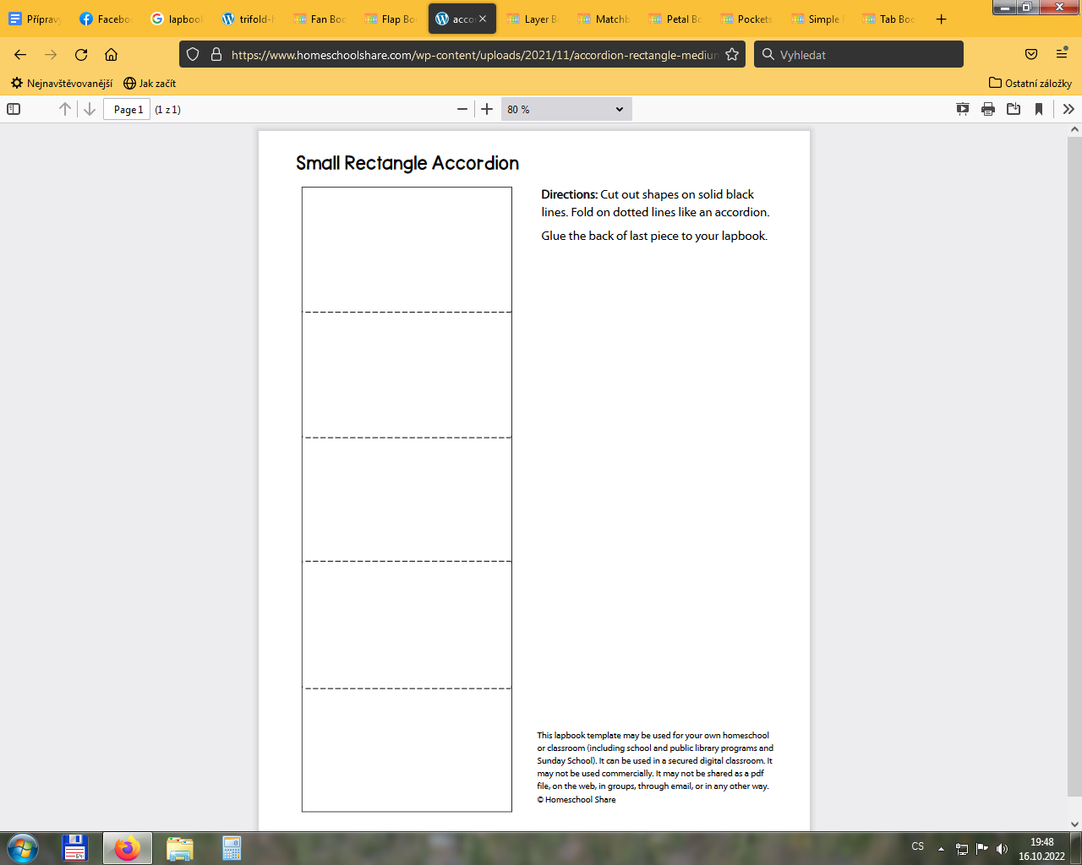
References:
byGreyson. (2022). Retrieved from z Co to je slow fashion a proč jí dát přednost před fast fashion?: https://www.bygreyson.shop/blog/slow-fashion/
ČR 2030. (2022). Retrieved from Infrastruktura: https://www.cr2030.cz/strategie/kapitoly-strategie/hospodarsky-model/2-4-infrastruktura/
Ministerstvo životního prostředí. (2022). Retrieved from Udržitelný rozvoj: https://www.mzp.cz/cz/udrzitelny_rozvoj
Industrializace - co to je, definice a koncept - 2021 - Economy-Wiki.com. from https://cs.economy-pedia.com/11031669-industrialization#menu-1
Třídení odpadu. (2022). Retrieved from Upcyklace: https://www.trideniodpadu.cz/upcyklace
UNEP – Průmysl a udržitelný rozvoj. (2010/2011). Retrieved from Průmysl a udržitelný rozvoj: http://www.amo.cz/wp-content/uploads/2016/01/PSS-Pr%C5%AFmysl-a-udr%C5%BEiteln%C3%BD-rozvoj-UNEP.pdf
Wikipedia. (2022). Retrieved from Infrastruktura: https://cs.wikipedia.org/wiki/Infrastruktura
Wikipedia. (2022). Retrieved from Zero waste: https://cs.wikipedia.org/wiki/Zero_waste
Worksheet pictograms:
https://www.brusperk-mesto.cz/seniori/obcan/komunalni-odpad/jak-spravne-recyklovat-sklo-342cs.html

