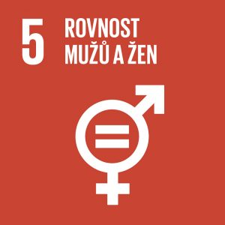

GENDER EQUALITY
Author: Martina Komárková
Keywords: gender, discrimination, violence, human trafficking, exploitation, early and forced marriage, female circumcision, sexual health, reproductive health, reproductive justice, equal rights to economic resources
Main UN Goals: Achieve gender equality and empower all women and girls
Women make up half of humanity but their opportunities lag behind those of men almost everywhere in the world. Only 26 percent of women sit in national parliaments (2022) and only 26 women (2021) are heads of states and world’s governments. Unpaid work in the form of caring for relatives and household chores is mostly done by women. One in three women faces some form of violence throughout her life. The aim is to improve the position of women in society and to end all forms of discrimination against women and girls.

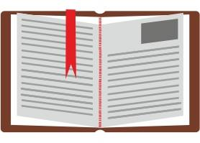
THEORETICAL PREPARATION

Facts about Gender Equality:
In South Asia, only 74 girls were enrolled in primary school for every 100 boys in 1990. In 2012, the numbers of girls and boys enrolled were balanced. In Sub-Saharan Africa, Oceania and West Asia, girls still face barriers to accessing primary and secondary education. Women in North Africa hold less than one in five paid jobs in the non-agricultural sector. In 46 countries, women hold more than 30 percent of seats in at least one chamber of national parliaments. 200 million women were forced to undergo female genital mutilation (female circumcision). One in three women faces some form of violence throughout her life, often by her intimate partner.
Impacts of the COVID-19 pandemic: women face additional responsibilities for household chores and childcare due to school closures. Women make up 70% of workforce in healthcare and social work and are on the front line in the fight against coronavirus. If a woman lives with a violent partner, domestic quarantine reduces her chances of seeking help (UN, 2022).
Gender
Gender is sometimes referred to as social sex. Unlike the term sex, which is understood exclusively in the biological sense, the term gender refers to cultural characteristics and models assigned to male or female biological sex, while emphasising social differences between women and men. These roles change over time and vary significantly according to the culture of each nation and the historical stage of development of society. Therefore, these roles are not natural and specific differences between men and women but they rather represent a temporary stage of development of social relations (Czech Statistical Office, 2016).
Gender discrimination
Gender discrimination means causing intentional social disadvantage of a person on the basis of the person’s biological sex. This type of discrimination, like others, can be distinguished into direct and indirect discrimination.
Direct discrimination: a form of treatment where one person is, was or would be treated less favourably than another person in a comparable situation. Discrimination on grounds of sex includes discrimination on grounds of pregnancy or maternity and on grounds of sexual identification (Czech Statistical Office, 2016).
Example: A situation where only young women are hired as receptionists (this is gender discrimination but also age discrimination) (monda.eu, undated).

Indirect discrimination: a situation in which an individual is treated in a way that appears to be based on a uniform neutral provision, criterion or practice, but persons of one sex are disadvantaged compared with persons of the other sex, unless such provision, criterion or practice is objectively justified by a legitimate aim and the means to achieve that objective are proportionate and necessary (Czech Statistical Office, 2016).
Example: a requirement for the position of the receptionist is that the applicant’s BMI score must be 20–22 points. It is likely that this criterion will be more difficult to meet by older women and men. The assumption may be that the employer wants to favour young slim women as a means of representing the company (monda.eu, undated).

Gender stereotypes
These are assumptions that simplistically attribute to men and women certain patterns of behaviour, jobs or roles that are affected by their gender.
Example: it is said that women cry and men do not. Women are orderly and men are not. Women should cook and men be soldiers (Čapek, 2021).

Sexual harassment
Sexual harassment may include not only sexual intercourse but also inappropriate treatment of a person who finds such treatment unpleasant or offensive, with the main purpose of lowering his or her dignity or creating a hostile or humiliating environment. The victim must endure such treatment, for example, in order to remain in employment (monda.eu, undated). Up to 70% of women have experienced sexual harassment, according to UN reports (Saitzová, 2021).
Example:
Male colleagues decorate the walls of the work environment with photographs of naked women in the presence of a female colleague.
Commenting on a female colleague’s appearance with sexual overtones and repeated double entendres.
The superior always gives an unpleasant job to the same colleague with a comment about his or her replaceability (monda.eu, undated).
Violence against women
According to a UN report, around 736 million women (about 35%) worldwide have experienced physical or sexual violence from their partner or another man. In its 27 years of activity, ROSA has helped some 61,000 victims of violence who were, along with their children, subject to life-threatening violence by their violent partner. According to the ROSA Centre, 90% of clients were blackmailed and intimidated, 42% were beaten and slapped and 30% were strangled (Saitzová, 2021).
Sexism
Sexism is the belief that one of the genders is inferior, less important or less capable. It is a term that refers to discrimination, prejudice and behaviour based on the sex or gender of others, and may even lead to violence-inducing behaviour that reinforces harmful stereotypes (Čapek, 2021; Pavésková, 2022).
Generally, sexism can be divided into:
Hostile (aggressive): manifests in the form of open and undisguised behaviour towards a certain group of people depending on their sex or gender.
Example: use of offensive language to describe women or parts of their bodies; stalking (online or offline); harassment with possible accompanying comments “She was asking for it”; physical assault (Pavésková, 2022).
Benevolent: less obvious at first glance but all the more potentially abusive and harmful. It is associated with stereotypes, trying to portray women as pure, fragile beings whose main purpose in life is to care for their children and others. It tries to make people believe that women are weaker which leads to the belief that they can be restricted in their freedom of choice (Pavésková, 2022).
Ambivalent: a combination of the two concepts above. This includes people who alternately perceive women as pure and innocent beings and then perceive them as manipulators (Pavésková, 2022).

Feminism
It is a human rights movement that seeks equality between the genders. It strives for social, economic and political equality. Feminism sees inequality in a predominantly male-dominated society, where gender stereotypes and sexism appear (Čapek, 2021; Nosková, 2019).
According to Zvěřina (undated), feminism is characterized by the following basic premises:
1. Conscious resistance to prejudice and humiliation of women by men;
2. The belief that masculine and feminine traits are shaped culturally and not biologically;
3. Promoting a value system that exposes cultural prejudices and limitations in the definitions of sexual roles and contradicts them in order to establish equal opportunities for both sexes (Zvěřina, undated).

Statistics – interesting facts
In India, 70% of children believe that it is a woman’s duty to do the laundry – and this belief is strongly rooted in the culture.
In the UK, 70% of women still do all the housework (Procter & Gamble, undated).
Every year in the Czech Republic, several dozen women die by the hand of their partner, husband or boyfriend. These deaths could have possibly been prevented if the victims had been offered timely help, dared to seek it or made it clear to those around them that they had a violent partner (Saitzová, 2021).
The Czech Republic lags behind the EU average in gender equality. The Czech Republic ranks 22nd out of 27 EU countries (Government of the Czech Republic, 2021).

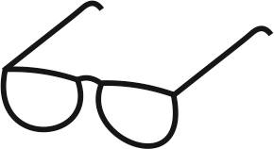
DRAFT LESSON PLAN
Estimated time: 1 teaching lesson (45 minutes)
Teaching stage | Activity description | Teaching method | Teaching form | Time
Motivation | Introduction of the topic using a motivational video (1:36 min.)  https://www.youtube.com/watch?v=-hc0kZh6CnM | Static projection  Discussion  Deductive interview | Mass frontal | 7 minutes
Exposure | Activity 1-  Gender  Gender discrimination  Gender stereotypes  Sexual harassment  Sexism  Feminism | Explanation, static projection  Discussion  Interview | Mass frontal  Mass  group | 16 minutes
Fixation | Worksheet | Explanation, demonstration | Mass individual | 10 minutes
Application | Activity 2 | Discussion  Interview | Mass group | 12 minutes

Motivation
First, students will be introduced the topic using a short motivational video, where the teacher can stop for a moment and ask students what they think of the video and what they found interesting. The teacher may also ask whether they agree with the information they learned in the video and encourage them to justify their opinions.
For example:
- Girls and boys are born with the same rights.
- Everyone should be allowed to go to school.

- Women and girls are denied various opportunities across the world including, for example, going to school, earning money, reading books, access to medicine, etc.
Motivational video: https://www.youtube.com/watch?v=-hc0kZh6CnM (1:36 min.)

Exposure
At this stage of the lesson, students will learn about new concepts related to the topic. In the course of Activity 1, they will be presented with concepts such as gender, gender discrimination, gender stereotypes, sexual harassment, sexism and feminism.
Students will be given cards with these terms and their first task will be to think about the terms and match correct pairs of cards. Matching the cards will require students’ attention and logical thinking. Once students are finished, the whole class with the teacher will check the pairs that students have matched and, if necessary, clarify any difficult areas.
After Activity 1, the teacher will discuss with students what they think about the terms on the cards, whether they have heard about the terms (on what occasion) and whether they experienced gender stereotypes, discrimination, etc. The teacher may also encourage students to come up with examples of the terms and to share them with others.
Fixation
Students will receive a worksheet from the teacher which they will work on individually. If they are not sure, they can consult their neighbour. Then they will check and discuss the worksheet with the teacher. The worksheet is designed for students to express their opinions and therefore, it is a good idea for the teacher and students to go through the worksheet and discuss the tasks.
For example:
Glasses:
- Which concepts have you placed in the male glass and which in the female glass? What made you decide this way?
- Do you think it would be better if your choice was different? Example: equal pay, educational opportunities, equal position in society, etc.?
Whose toy is it:
- On what basis did you decide to assign the toys to one or the other gender?
- Do you think it is okay for children to play with any toy regardless of gender?
- Has it ever happened to you (or someone else) that you were banned to play with a specific toy? If so, what was the reason?
- Have you ever played with a toy of the opposite sex? How did you feel about it?
Occupation:
- Do you think there are only male and female occupations?
- Do you think women should have the opportunity to have the same jobs as men?
- Are any of you considering a non-traditional profession in terms of gender? If so, which profession would it be?
Application
During the application stage, students will work in smaller groups on Activity 2 called Gender in Advertising. Students will receive printouts of different advertisements from the teacher and judge which of them support gender stereotypes. During the activity, students can cooperate and discuss the task.
Then the teacher will encourage students to identify advertising leaflets with the following: woman as a sexual object, woman as a housewife, man as a hunter, man as an expert.


WORKSHEET
- Assign to each glass what you think is more typical of the female gender and male gender:
Higher pay, care of household, care of children, head of family, victim of domestic violence, educational opportunity, financial literacy, victim of sexual abuse, compulsory marriage, lower status in society, decisive word

♂ ♀

- Add the correct words to find out the solution:

- It is sometimes referred to as social sex. This is a term that refers to society’s preconceived ideas about the differences in the behaviour of men and women and their social roles.
- The same in quality, quantity, value, etc.
- Rights that pertain to people are called ___________ rights.
- Inappropriate treatment with the main purpose of lowering a person’s dignity or creating a hostile or humiliating environment.
- This is the most widespread manifestation of human rights violation in the form of physical or sexual __________ against women by their partners or other men.
- Social status is determined by the ___________ of a person in the structure of society on the basis of a certain characteristic, in this case gender.
- A person who is in an uncomfortable situation or has died is called a __________.
- These are assumptions that simplistically attribute to men and women certain patterns of behaviour, jobs or roles that are affected by their gender. This is a gender _____________.

- Whose toy is this? Look at the picture and decide whether the toy belongs to a girl or to a boy.
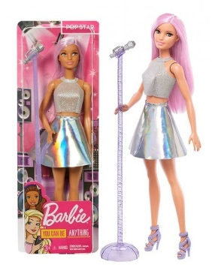
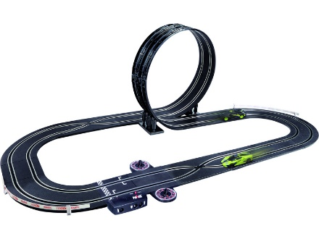


Female

Male
Boys’ toys:

Girl’s toys:

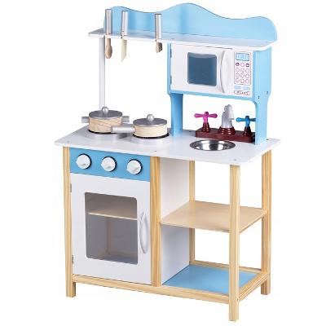

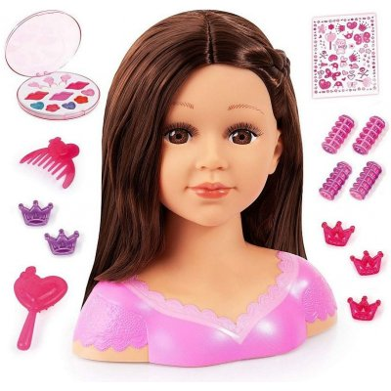
SHOP ASSISTANT
CONFECTIONER
BRICKLAYER
FIRE FIGHTER
Reflection:
Think about whether each job could be done by people of the opposite sex? Justify your opinion.
Reflection:
Do you think it is okay for anyone to play with any toy regardless of gender? Justify your opinion.
________________________________________________________________________________________
https://www.action.com/cs-cz/p/dtska-pistole-s-pouty/
4) Who would you assign the following occupations to?

DRIVER
CLEANER
BUTCHER
PAINTER
https://aukro.cz/nejlepsi-detske-kuchynky-hry-na-profese
https://www.prokonzole.cz/barbie/toys-barbie-you-can-be-anything-pop-star-nove/
https://panenky.heureka.cz/bayer-cesaci-hlava-charlene-super-brunetka/
https://www.autodraha.cz/polistil-autodraha-1-43-vr46-super-looping
https://shop.bentleymotors.com/products/continental-gt3-pull-back-toy-car
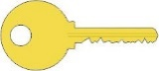
WORKSHEET – KEY

- Assign to each glass what you think is more typical of the female gender and male gender:
Higher pay, care of household, care of children, head of family, victim of domestic violence, educational opportunity, financial literacy, victim of sexual abuse, compulsory marriage, lower status in society, decisive word

♂ ♀

- Add the correct words to find out the solution:

 |  |  |  |  |  | G | E | N | D | E | R
 |  |  |  |  |  | E | Q | U | A | L
 |  |  |  |  |  | H | U | M | A | N
 |  |  |  | H | A | R | A | S | S | M | E | N | T
 |  |  |  | V | I | O | L | E | N | C | E
 |  | P | O | S | I | T | I | O | N
 |  |  |  | V | I | C | T | I | M
S | T | E | R | E | O | T | Y | P | E

- It is sometimes referred to as social sex. This is a term that refers to society’s preconceived ideas about the differences in the behaviour of men and women and their social roles.
- The same in quality, quantity, value, etc.
- Rights that pertain to people are called ___________ rights.
- Inappropriate treatment with the main purpose of lowering a person’s dignity or creating a hostile or humiliating environment.
- This is the most widespread manifestation of human rights violation in the form of physical or sexual __________ against women by their partners or other men.
- Social status is determined by the ___________ of a person in the structure of society on the basis of a certain characteristic, in this case gender.
- A person who is in an uncomfortable situation or has died is called a __________.
- These are assumptions that simplistically attribute to men and women certain patterns of behaviour, jobs or roles that are affected by their gender. This is a gender _____________.

- Whose toy is this? Look at the picture and decide whether the toy belongs to a girl or to a boy.

Female | Cleaner, shop assistant, confectioner
Male | Fire fighter, bricklayer, driver, butcher, painter
Boys’ toy: | Car, slot car track, gun, handcuffs
Girl’s toy: | Doll, combing head, kitchenette

ACTIVITIES FOR STUDENTS
FIRE FIGHTER
CONFECTIONER
BRICKLAYER
SHOP ASSISTANT
Reflection:
Think about whether each job could be done by people of the opposite sex? Justify your opinion.
Reflection:
Do you think it is okay for anyone to play with any toy regardless of sex? Justify your opinion.
________________________________________________________________________________________
https://www.action.com/cs-cz/p/dtska-pistole-s-pouty/
4) Who would you assign the following occupations to?

DRIVER
CLEANER
BUTCHER
PAINTER
https://aukro.cz/nejlepsi-detske-kuchynky-hry-na-profese
https://www.prokonzole.cz/barbie/toys-barbie-you-can-be-anything-pop-star-nove/
https://panenky.heureka.cz/bayer-cesaci-hlava-charlene-super-brunetka/
https://www.autodraha.cz/polistil-autodraha-1-43-vr46-super-looping
https://shop.bentleymotors.com/products/continental-gt3-pull-back-toy-car

Activity 1: Cards with terms
GENDER | - It is sometimes referred to as social sex.  - This term refers to cultural characteristics and models assigned to male or female sex.  - It emphasises social differences between women and men.
GENDER DISCRIMINATION | - Causing intentional social disadvantage of a person on the basis of the person’s biological sex.  - Example:  One day, dad told my sister to vacuum the house. She replied that she had to study and that her brother could do it. She was scolded by our dad who argued that her brother had to study too and suggested that his learning was more important.
GENDER STEREOTYPES | - These are assumptions that attribute to men and women certain patterns of behaviour, jobs or roles that are affected by their gender.  - Example:  It is said that women belong in the kitchen.  It is said that women cry and men do not.
SEXUAL HARASSMENT | - It may include not only sexual intercourse but also inappropriate treatment of a person who finds such treatment unpleasant or offensive  - The main purpose is lowering the person’s dignity or creating a hostile or humiliating environment.  - Example:  Commenting on a female colleague’s appearance with sexual overtones and repeated double entendres.
SEXISM | - It is the belief that one gender is superior to the other.  - The term refers to gender-based discrimination, prejudice and stereotypes, mostly against women and girls.
FEMINISM | - It is a movement that seeks political, economic and social equality between women and men.  - The movement fights especially for women’s rights, including the right to vote, hold public office, work and have the same pay as men for the same work, own property, right to education, and equal rights in marriage.

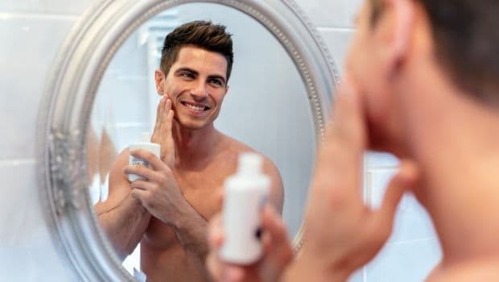
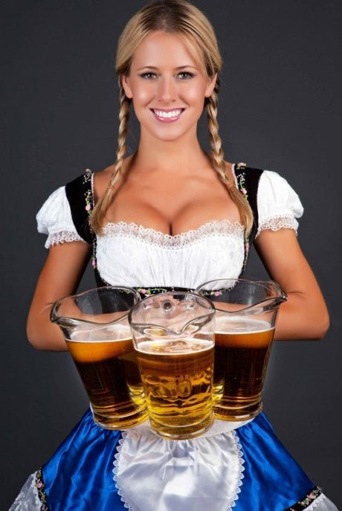
Activity 2: Gender in Advertising
https://food.ndtv.com/beauty/5-essential-skin-care-tips-for-men-1623691
https://www.pinterest.se/pin/128282289370499177/

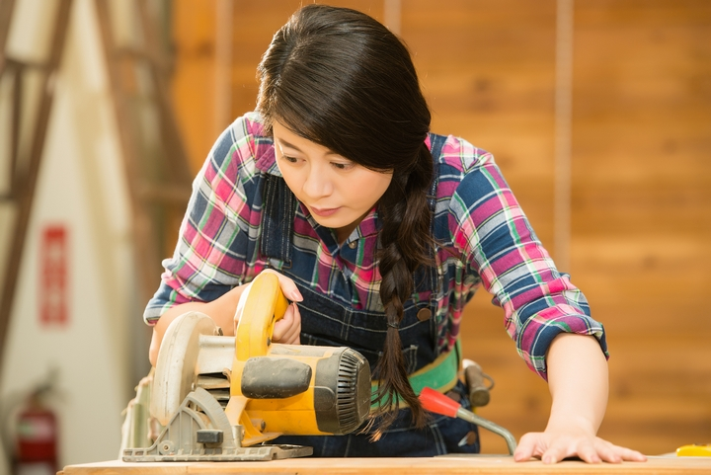

https://www.shemag.com/how-to-use-power-tools-for-women/

https://unsplash.com/s/photos/fragrance

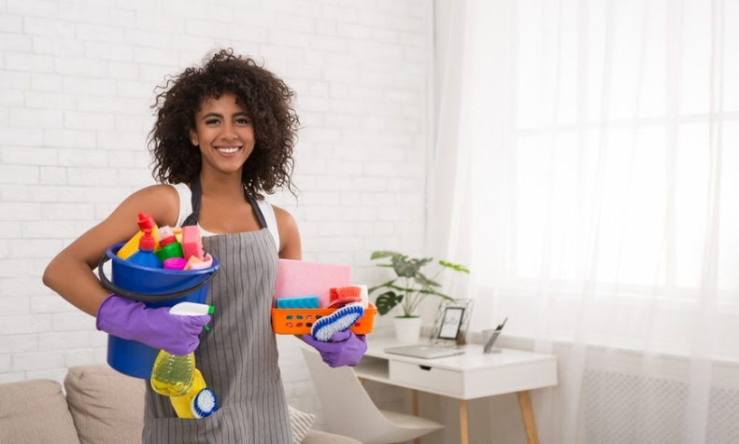
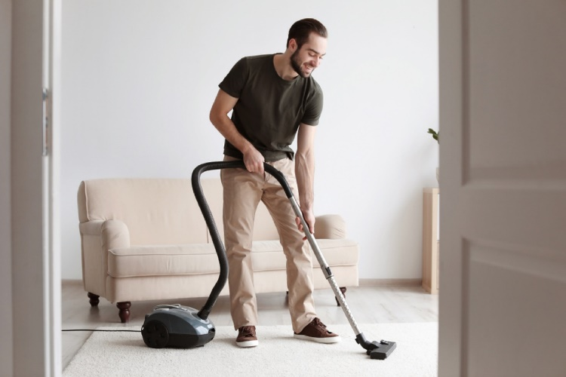
https://www.groupon.com/deals/m2s-cleaning-services-3

https://bestlifeonline.com/vacuuming-tips/

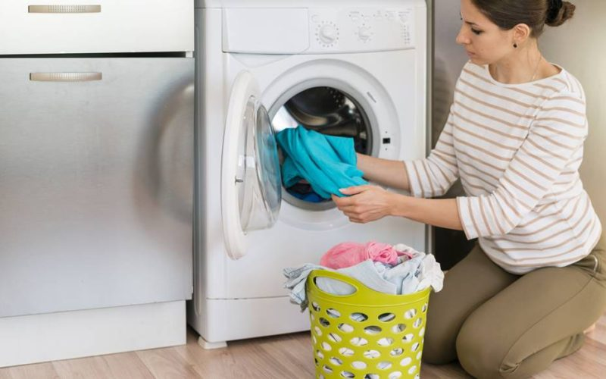

https://www.aazdravi.cz/vyprane-pradlo-jeste-nemusi-byt-ciste-naucte-se-prat-tak-abyste-se-spolehlive-zbavili-bakterii/



https://www.fitnesstienda.es/shaker-gym-baratos/

https://novtom.cz/blog

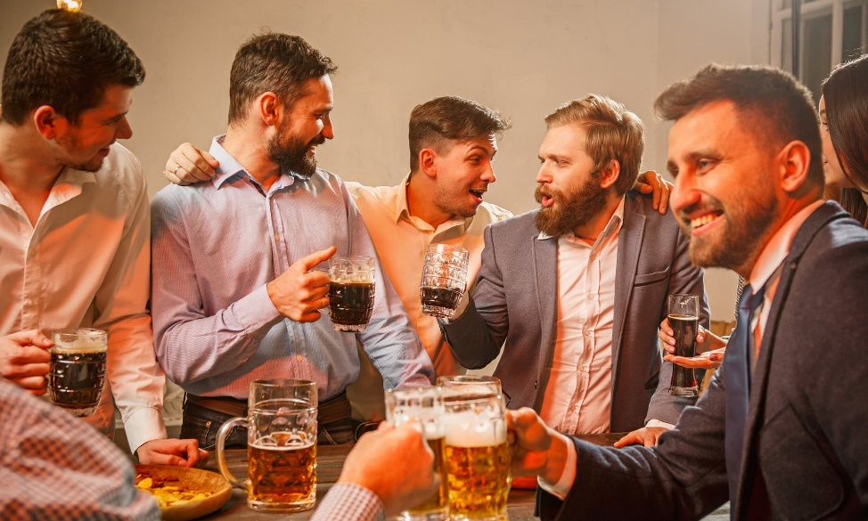

https://www.dailymail.co.uk/sciencetech/article-7555595/Study-warned-men-stop-drinking-trying-baby-debunked.html
References:
Čapek, R. (2021). Občanka 6: Chytrý občan (1st edition). Taktik International, s.r.o.
Czech Statistical Office. (29th February 2016). Gender: Basic Terms. https://www.czso.cz/csu/gender/gender_pojmy
UN. (2022). Sustainable Development Goals. https://www.osn.cz/osn/hlavni-temata/sdgs/
Procter & Gamble. (undated). Equality Between Men and Women. https://cz.pg.com/rovnopravnost-muzu-a-zen/
Monda.eu. (undated). Gender Discrimination. http://monda.eu/files/modules/gender/annex6_cs.pdf
Nosková, A. (8th March 2019). What Feminism Means Today and Why So Many People Oppose It? https://zena.aktualne.cz/kariera/co-znamena-feminismus-dnes-a-proc-se-proti-nemu-tolik-lidi-v/r~921934ac40c511e9b5e8ac1f6b220ee8/
Pavésková, K. (23rd February 2022). Talking About Sexism: What Is It? https://www.profairplay.cz/o-cem-se-bavime-kdyz-se-bavime-o-sexismu/
Saitzová, H. (6th August 2021). Violence Against Women Is Among the Most Widespread Human Rights Violations. https://advokatnidenik.cz/2021/08/06/nasili-na-zenach-patri-k-nejrozsirenejsim-projevum-porusovani-lidskych-prav/
Government of the Czech Republic. (28th October 2021). Press Report: Gender Equality Index 2021: The Czech Republic Still Has Room for Improvement in Gender Equality. https://www.vlada.cz/cz/ppov/rovne-prilezitosti-zen-a-muzu/aktuality/tz-index-rovnosti-zen-a-muzu-2021-cesko-ma-v-rovnosti-zen-a-muzu-stale-co-zlepsovat-191474/
Zvěřina, J. (undated). Feminism and Its Contemporary Forms. https://www.cdk.cz/feminismus-jeho-soucasne-podoby

