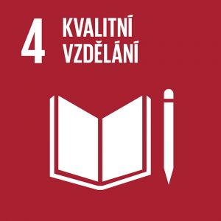
Quality Education

Authors: Kristýna Drábková, Tereza Dohnalová
Keywords: gender, gender inequality, gender and education, gender stereotypes, teaching profession
UN Goal: Ensure inclusive and equitable quality education and promote lifelong learning opportunities for all
In 2020, there were 1.6 billion children and young people in the world who could not go to school. At the same time, education helps reduce inequalities and is essential for fostering tolerance and peace. A quarter of the world’s primary schools lack electricity, drinking water and basic sanitation, and half of primary schools do not have computers and internet access (2020). The goal is for all children to acquire the skills they will need as citizens and for their work.


Theoretical preparation

Gender and education
Gender equality means a state where women and men are equal in their rights, responsibilities and opportunities. This is also linked to the fact that men and women should not be disadvantaged on the basis of their differences and should have access to the same opportunities.
The term gender is related to the social area, representing a set of characteristics and behavioural patterns of an individual regardless of their biological sex. Gender is the building block for assessing human masculinity and femininity. Both terms represent certain characteristics and specifics that are attributed to each biological sex.
Gender equality in education is one of the basic principles of democratic education. Gender stereotypes are present in schools, textbooks and learning resources. Gender is also often linked to the issue of bullying, where the gender dimension of bullying often manifests itself in the victim not conforming to the traditional notions of women and men. Boys who are bullied may like to play a musical instrument or dance, for example.
In schools, gender differences can be observed mostly in the physical arrangement of the space. We can notice that the space is mainly divided into female and male (a clear example of this is the toilets, which are almost always divided into female and male in schools). Gender is also visible in the seating plan, which can be easily affected by the teacher. Generally, boys usually choose and occupy their seats first, while girls mainly occupy the peripheral positions. Gender-balanced education is also influenced by the textbooks students use. Appropriate textbooks should contain gender-balanced illustrations and not just stereotypical examples of exclusively female and exclusively male roles. If learning resources only portray one gender in roles that we consider to be clearly defined, it can be very difficult to convince students that their social roles are not determined by their gender.
It is reported that communication between teachers and boys during classes takes by about 1/3 more time than communication with girls. The reason for the increased communication can be the boys’ lack of discipline. Boys tend to disrupt more, so teachers need to admonish them more often. In order to control these disruptions, teachers often try to involve them more in various activities. Another reason may be that boys are more interested and active, while girls tend to be shyer during questioning.
Boys are often rewarded for their knowledge and correct answers, while girls are more often rewarded for obedience and compliance. It turns out that teachers often act as “gender police”. Female teachers make sure that girls do not deviate from the traditional female gender role, while male teachers make sure that boys do not deviate from the traditional male gender role. It is not only the behaviour but also the attitudes of teachers that further deepen the differences in how students act. They stimulate different behaviours and thus reinforce different attitudes or personality traits. This is because students tend to behave according to their teachers’ expectations. Even though teachers may not directly formulate their attitudes towards gender roles of men and women, both male and female students can indirectly sense these attitudes through preferring or rejecting individuals in the class.
It is not typical for the Czech Republic that there would be any barriers to choosing a field of study. Even though it is a free choice of the individual, there are significant differences between boys and girls in the choice of fields of study. The typical predominance of boys can be found, for example, in technical sciences, which is an area affected by a number of gender stereotypes. People rationalize that boys simply have “genes” for maths and excel in logical thinking. Every year in April, the doors of technical universities, companies and research centres are opened to girls for one day. Girls Day is an interactive open day for girls who have a unique chance to learn about a wide range of fields of study and professions in areas such as IT, telecommunications and construction. Girls Day takes place simultaneously in sixteen European countries with the aim of attracting girls to science and technology and inspiring them to choose attractive and promising fields that are still perceived as male-dominated. Girls Day can set girls on the path to a successful career. Girls Day is traditionally celebrated on the fourth Thursday of April as part of the International Girls in ICT Day, which has been held for ten years in countries around the world under the auspices of the United Nations. The event is open to all girls between the ages of 15 and 25, participation is free-of-charge (https://girlsday.cz/).
Currently, we are experiencing a predominance of female teachers and the feminization of the profession. Several factors play a role, including the lower enthusiasm and motivation of men to pursue the profession and the growing interest of women. It is also important to mention the salary in this profession as this is one of the reasons for men choosing a different job. In terms of gender, the school level also plays a role. There is a higher representation of women in kindergartens and primary schools, while in lower secondary schools the representation of men is much higher. On the other hand, male teachers in universities outnumber women.
School is one of the places where gender stereotypes can be broken down. School is also a place where equal opportunities for women and men in society should be fully promoted. In terms of education, equal opportunities represent the possibility for every individual, regardless of gender, to choose an educational path that suits their dispositions and wishes. And even if this educational field is typical for the opposite gender. Girls with an aptitude for mathematics should have the opportunity to study technical secondary and university courses and be encouraged to study mathematics and other science subjects already in elementary school. Similarly, boys interested in educating young children should be encouraged in their decisions to study teacher training courses; they should not, for example, be permanently exposed to doubts about their manhood if they are interested in raising and educating children.
Despite the fact that schools have the potential to break down stereotypes and disrupt social inequalities, they are often unable to fulfil this function. Teachers, just like all people living in a society, are influenced by the stereotypes that exist in that society. Teachers need to try really hard to ensure that their behaviour towards students is not influenced by stereotypes.
In order for a school to be a gender-sensitive place, the following needs to be ensured:
- Teachers must begin to use a gender-responsive and gender-appropriate approach to teaching and education so that all male and female students are equally respected, supported and developed;
- Teachers must have modern teaching tools that show women and men as equals and that emphasise the value of individual dispositions over societal expectations of gender roles.

Internet resources:
Gender a vzdělávání. In: Ministerstvo školství, mládeže a tělovýchovy [online]. 2019 [cit. 2022-10-10]. Retrieved from: https://www.msmt.cz/ministerstvo/proc-je-dulezite-se-zabyvat-genderovou-rovnosti-v-kontextu

Genderové stereotypy ve škole. In: Ústav učitelství a humanitních věd [online]. 2017 [cit. 2022-10-10]. Retrieved from: http://kuhv.vscht.cz/files/uzel/0017037/T%C3%A9ma_14_2.pdf?redirected

Genderově citlivá výchova: Kde začít? In: Příručka pro vyučující základních a středních škol, vydaná v rámci projektu Rovné příležitosti v pedagogické praxi [online]. 2007 [cit. 2022-10-10]. Retrieved from:
https://is.muni.cz/el/ped/podzim2020/SO533/um/Genderove_citliva_vychova_Kde_zacit.pdf?lang=en

Gender ve škole. In: Národní pedagogický institut České republiky [online]. 2006 [cit. 2022-10-10]. Retrieved from:
https://www.nidv.cz/media/materialy/aktuality_download/gender-ve-skole-obcanska-nauka.pd

Book resources:
JANOŠOVÁ, Pavlína. Dívčí a chlapecká identita: vývoj a úskalí. Praha: Grada, 2008. [cit. 2022-10-10]

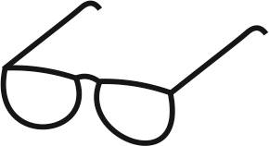
Draft lesson plan

Estimated time: 45 min
Teaching stage | Activity description | Teaching method | Teaching form | Time
Motivation | - Activity 1 – Revealing the topic of the lesson  - Worksheet, exercise 1, 2 | Activation, worksheet | Group | 6  min
Exposure | - Gender, gender inequality, gender stereotypes  - Activity 2 – Women’s versus men’s matter  - Worksheet, exercise 3, 4 | Presentation, worksheet, activation | Frontal  Individual/  group | 30  min
Fixation | - Joint check of the worksheet | Discussion | Joint | 5 min
Application | - Activity 3 – Girls and boys in class self-government | Activation | Individual in groups | 4 min

Motivation
At the beginning of the lesson, a group activity takes place in which the teacher projects Picture 1 on the board (see Activity 1 – Revealing the topic of the lesson) and invites the students to think about the picture. First, each student takes about a minute to think and then discusses the picture with the neighbour. Then the teacher shows Picture 2 (see Activity 1 – Revealing the topic of the lesson) and the students discuss the picture in pairs. Once the topic of the lesson is clear to the students, the teacher distributes the worksheet in which the students do the first and second exercise.

Exposure

In the main part of the lesson, the teacher gives a short explanation to introduce the topic. This is followed by Activity 2 – Women’s versus men’s matter, for which the classroom space needs to be arranged so that everyone (including the teacher) sits in a circle. The activity is about assigning occupations and activities to the male and female gender. The teacher supervises the students, is part of the circle and participates in the activity. After Activity 2, the students return to their desks and complete the worksheet (Tasks 3 and 4).

Tip for the teacher: The teacher can also show the students different videos (or just a part of them) to make them aware of gender issues. Links to the videos can be made available if someone wants to watch any of the videos at home.
https://www.youtube.com/watch?v=wseqfI0JpV8&ab_channel=ADRACZ
https://www.youtube.com/watch?v=jvSVzrueDsM&ab_channel=ADRACZ
https://www.youtube.com/watch?v=ccrHHtzLA_w&ab_channel=CMSTV%40FILMSTUDIOCOMVISION
https://www.youtube.com/watch?v=zKR1LkJf_hc&ab_channel=TEDxTalks
Fixation
The teacher checks the completed worksheet together with the students and provides space for discussion (especially for Tasks 2 and 4). The students can ask questions if they do not understand something in the lesson.
Tip for the teacher: If the students have no questions, the teacher can go back to Activity 2 and ask the students how they felt about the activity. For some, this identification may have been difficult as they have already experienced various stereotypes.

Application
The teacher gives the students homework to be completed in groups of 4 or 5. The students may form the groups themselves, but they must not be only boys or only girls. To complete the task, they will need a student from another class to provide them with the necessary information.


Worksheet

1. Match the term in the left column with the correct explanation in the right column.
Gender
Identification of an individual according to biological characteristics.
A term referring to social differences between women and men which are socially and culturally conditioned.

Sex
Equal status and participation of both genders in all spheres of public and private life at all levels, including decision-making processes and leadership positions.

Gender equality

Established and simplistic ideas about women and men and their characteristics and social roles.
Gender stereotypes


2. Look at the following picture and write what comes to your mind in relation to gender.

______________________________________________________________________________________________________________________________________________________________________________________________________________________________________________________________________________________________________________________________________________________________
3. Cross out the sentences that you do not consider gender-correct.
Male and female students should have equal opportunities.
In school, subjects could be divided into girls’ and boys’. It can be clearly determined which subject is more suitable for boys and which for girls.
Secondary teacher training courses should only be for girls.
In kindergarten, children should always be taught only by women (teachers).
The teacher should give equal space for girls and boys to express themselves.

Whether my friends are girls or boys is my free choice.

4. In the five expressions below, the letters have been rearranged, always referring to a school subject. Write the correct name of the subject and your opinion if it can be determined whether the subject is more often taught by a male teacher or female teacher. Try to justify your opinion.
EHZCC GNUGAALE = …………………………………
____________________________________________________________________________________________________________________________________________
AHCYILPS COIENUTAD = ……………………………………………..
____________________________________________________________________________________________________________________________________________
ESAIMMTATCH = ……………………
____________________________________________________________________________________________________________________________________________
KROW CISIITTVEA = ……………………………………..
____________________________________________________________________________________________________________________________________________
ORSYITH = …………………………
____________________________________________________________________________________________________________________________________________


Worksheet – KEY
1. Match the term in the left column with the correct explanation in the right column.
Gender
Identification of an individual according to biological characteristics.
A term referring to social differences between women and men which are socially and culturally conditioned.

Gender
Equal status and participation of both genders in all spheres of public and private life at all levels, including decision-making processes and leadership positions.

Gender equality

Established and simplistic ideas about women and men and their characteristics and social roles.
Gender stereotypes

2. Look at the following picture and write what comes to your mind in relation to gender.

Here the students’ answers may differ, everyone will probably write something slightly different. Some students may not like this picture because a woman should work as a cook, while a man should work in an office. Other students may write that previously it was normal in society that men tended to work in an office, while women were cooks but today this is not the standard. They can mention, for example, the MasterChef show, which they know from television and in which contestants are both men and women.

3. Cross out the sentences that you do not consider gender-correct.
In school, subjects could be divided into girls’ and boys’. It can be clearly determined which subject is more suitable for boys and which for girls.
Secondary teacher training courses should only be for girls.
Male and female students should have equal opportunities.
In kindergarten, children should always be taught only by women (teachers).
The teacher should give equal space for girls and boys to express themselves.

Whether my friends are girls or boys is my free choice.

4. In the five expressions below, the letters have been rearranged, always referring to a school subject. Write the correct name of the subject and your opinion if it can be determined whether the subject is more often taught by a male teacher or female teacher. Try to justify your opinion.
EHZCC GNUGAALE = CZECH LANGUAGE
AHCYILPS COIENUTAD = PHYSICAL EDUCATION
ESAIMMTATCH = MATHEMATICS
KROW CISIITTVEA = WORK ACTIVITIES
ORSYITH = HISTORY

Again, the students will probably respond individually. Generally, this is about making them aware that teaching a specific subject is not exclusively a matter of one particular gender. If they have a female Czech language teacher, it does not mean that this is the rule and that they will always have a female teacher in Czech language classes.


Activities for students

ACTIVITY 1: Revealing the topic of the lesson
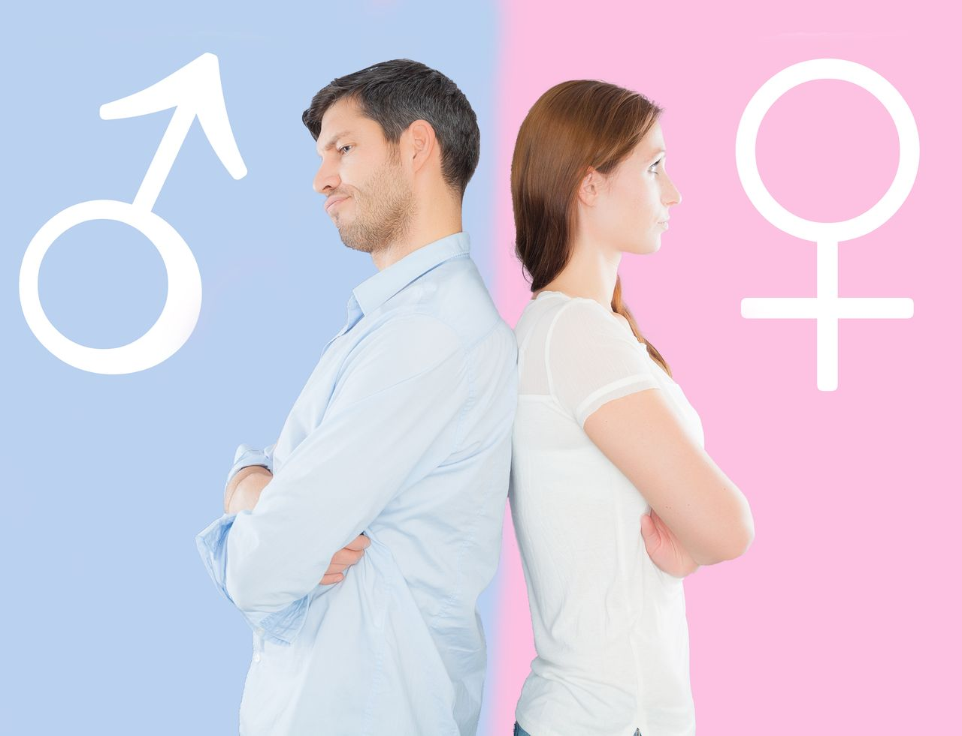
Picture 1 (source: https://seznamte.se/a/muz-vs-zena)

Picture 2 (source: https://archiv.hn.cz/c1-66166180-cesi-vyznam-vzdelavani-nepodcenuji)
The teacher projects Picture 1 and asks the students to think about it. The teacher does not say anything about the topic of the lesson and lets the students work individually. After about one minute of each student thinking alone, the teacher invites the students to share their ideas in pairs. Then the teacher projects Picture 2 and again asks the students for reflection, this time in pairs. The students should conclude that the first picture shows gender issues, while the second picture is related to education. Together they will discuss gender inequality in education.
ACTIVITY 2: Women’s versus men’s matter
Inside the circle, the teacher places pieces of paper containing different professions and activities (see below). The teacher starts this activity to show the students how it works. The teacher picks one card. There is a profession or an activity on it. If there is a profession, the teacher reads it out loud and says whether it is a gender-neutral profession or whether it is purely male or female. The rest of the class responds. If the teacher says, for example, that a cook should only be a woman, the students try to find arguments that support the opinion that a cook can also be a man.
The same applies to the names of activities, where the individual who pick a card indicates whether he/she thinks that the activity is more typical for men or women. The class again looks for arguments and tries to convince the student that this activity can also be performed by the opposite gender.
The aim is for the students to understand that it is not possible to claim that a certain profession is only for one gender; today’s opportunities are diverse. The same is true of the activities written on the cards. For example, vacuum cleaning in not only for women, while mowing the grass is not only for men. This activity will allow the teacher to better understand the students’ gender attitudes.

Cards – professions:
Programmer | Warehouse keeper
Teacher | Accounting officer
Shop assistant | Lawyer
Baker | Bus driver
Psychologist | Company director
Rescuer | Carpenter
Hairdresser | Police officer
Masseur | Gardener
Architect | Archaeologist
Bank specialist | Bartender
Nanny | IT engineer
Journalist | Hotel director
Customs officer | Actor
Courier | Painter

Cards – activities:
Vacuum cleaning | Ironing
Mowing the grass | Putting children to bed
Doing the dishes | Shopping for furniture
Laundering | Shopping for food
Cooking | Coming up with birthday presents
Replacing a broken bulb | Painting the walls
Using a drill | Making a dog kennel
Maintenance of an outdoor pool | Picking apples from a tree
Washing the car | Walking the dog
Feeding fish in the aquarium | Cleaning the garage

ACTIVITY 3: Girls and boys in class self-government
In this activity, the students think about the gender structure of the class self-government. They also realize the expectations that other students have of the girls and boys who serve on the class self-government.
The students divide themselves into groups of 4–5. Their joint task is to conduct a conversation with a student from another class on the topic of class self-government. The task of each group is to find out and write down what functions/positions are in the class self-government, who performs these functions (girl, boy) and the reason why these individuals were chosen for these positions. They compare the situation of the other class with their own.

(12)

https://www.msmt.cz/ministerstvo/proc-je-dulezite-se-zabyvat-genderovou-rovnosti-v-kontextu
JANOŠOVÁ, Pavlína. Dívčí a chlapecká identita: vývoj a úskalí. Praha: Grada, 2008. Psyché (Grada). p. 41
http://kuhv.vscht.cz/files/uzel/0017037/T%C3%A9ma_14_2.pdf?redirected
http://kuhv.vscht.cz/files/uzel/0017037/T%C3%A9ma_14_2.pdf?redirected
https://is.muni.cz/el/ped/podzim2020/SO533/um/Genderove_citliva_vychova_Kde_zacit.pdf?lang=en
https://is.muni.cz/el/ped/podzim2020/SO533/um/Genderove_citliva_vychova_Kde_zacit.pdf?lang=en
https://www.msmt.cz/ministerstvo/proc-je-dulezite-se-zabyvat-genderovou-rovnosti-v-kontextu
https://www.msmt.cz/ministerstvo/proc-je-dulezite-se-zabyvat-genderovou-rovnosti-v-kontextu
https://www.nidv.cz/media/materialy/aktuality_download/gender-ve-skole-obcanska-nauka.pdf

