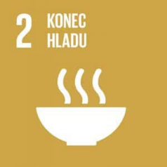
Zero Hunger
Authors: Lukáš Cík, Michal Hanzl
Keywords: hunger, chronic hunger, hidden hunger, famine, malnutrition, food security, sustainable agriculture
UN Goal: End hunger, achieve food security and improved nutrition and promote sustainable agriculture
Approximately 1 in 10 people in the world suffer from hunger. Almost every third person does not have regular access to enough food (2020). Conflicts, COVID-19, climate change and growing inequalities threaten food security worldwide. Interestingly, the world grows enough food. But it does not reach everyone. The goal is for no one to suffer from hunger by 2030.

Theoretical preparation

Hunger evokes a number of different situations. The term hunger is commonly associated with food deprivation which is related to a decrease in blood sugar. However, hunger can also be considered on a broader scale as a global problem of food scarcity. In this context, a distinction is made between two cases of food scarcity – chronic hunger and hidden hunger.
Chronic hunger is a long-term lack of energy-satisfying food that causes malnutrition in the population.
Hidden hunger is defined as a long-term deficiency of various substances needed for the body in an energy-satisfying diet, whether essential nutrients, vitamins or minerals. This deficiency then results in various health problems of the population.
Last but not least, the word hunger is also associated with the term famine, which refers to a crisis associated with insufficient food intake that takes place in a particular place, resulting in increased morbidity and mortality (cf. Hronová, 2014 & Polnická, 2022).
No matter if hunger is chronic or hidden, it is important to bear in mind the health risks of insufficient food intake or dietary diversity. When the body is deficient in all essential nutrients, it falls into a state of total body decrepitude – marasmus. If the diet contains enough sugars and fats but not enough protein, the human body becomes muscularly weak and swelling may occur, resulting in the so-called kwashiorkor malnutrition.
When people are deficient in various vitamins and minerals, they are at risk of many health problems.
Globally, the number of people suffering from malnutrition has decreased over the past decades, but as of 2016, 12.9% of people were undernourished, meaning one in nine – about 795 million people. The vast majority of these people live in developing countries – the largest percentage in Sub-Saharan Africa (one in four people).
Poor nutrition is also responsible for nearly half (45%) of under-five deaths – 3.1 million children a year. Globally, one in four children suffer from stunting and as many as one in three in developing countries (UN, undated).
The issue of world hunger is being addressed by many organisations working to achieve enough food for everyone on the planet. In the context of these efforts, the term food security is commonly used, which was defined by the World Health Organization (WHO) as sufficient access to high-quality food to enable people to lead healthy and active lives. According to the WHO, food security depends on three pillars:
- Food availability;
- Access to food – whether through cultivation or financial sufficiency;
- Food use – sufficient knowledge for responsible food management.
These pillars should be stable in time – people should not be afraid of hunger (Peková, 2013).
In the context of food security, the concept of sustainable agriculture is also mentioned, the aim of which is to grow food with the least possible burden on the soil and the environment, i.e., without excessive use of chemicals, as this is the only way to ensure long-term food security.
Organic agriculture promotes biodiversity and uses far less energy than conventional agriculture.
The positive effect on nature is a large reduction in the leaching of nitrates, pesticides, heavy metals and carbon dioxide. By buying sustainable fruit and vegetables, each of us contributes to the protection of nature, animals and our own health (Oppitzová, undated).
Last but not least, it is important to understand that there is plenty of food for the world’s population but the problem lies in its distribution. The more developed part of the world has a surplus of food, and hunger of its inhabitants is more related to the issue of insufficient income of some households. The less developed parts are directly faced with a lack of food. The issue of hunger is influenced by many factors – natural conditions or disasters, governments of different countries, geopolitical conflicts and others (Ovčačík, 2020).











Second objective of UN: Zero Hunger
https://www.youtube.com/watch?v=eU0G-bRMpec&t=26s&ab_channel=ADRACZ

Draft lesson plan
Estimated time: 45 min
Teaching stage | Activity description | Teaching method | Teaching form | Time
Motivation | - Lesson topic  - Facts about hunger in the world | Discussion, activation | Joint | 5 min
Exposure | - Activity 1 – Causes of hunger  - Discussion about various food-related situations in the world  - A closer look at the issue of hunger  - World hunger statistics  - Deficiency of food or certain food components  - Responsible food management  - Completion of worksheet | Worksheet, activation, discussion | Joint, pair work | 30 min
Fixation | - Activity 2 – Quiz  - Repetition of key findings | Activation, discussion | Group, joint | 8 min
Application | - Homework assignment | Activation | Individual | 2 min

Motivation
At the beginning of the lesson, the teacher tells the students selected keywords and interesting facts on the topic from the theoretical part. If the students think they have revealed the topic of the lesson (or its content), they will stand up. When all or most of the students are standing, the teacher invites them to share their ideas. Then the teacher explains the content of the lesson.
Exposure
The teacher divides the students into six groups for Activity 1 (Pictures showing the causes of hunger in the world) – each group is given a picture and has some time for discussion. Then each group shares their observations with the rest of the class. The teacher moderates and controls the activity.
In the main part of the lesson, the students work in pairs or small groups with the worksheet in which they complete the tasks and discuss their observations and ideas. The teacher consults with the students on their answers. After completing the worksheet in groups or pairs, a joint check follows.
Fixation
In the fixation phase, Activity 2 (Quiz) is carried out with the students and evaluated to consolidate the information on world hunger.
Application
For homework, the students inform people around them about the importance of not wasting food.



Worksheet – Zero Hunger

            - Decide whether the statements on hunger are correct (yes/no):
The proportion of undernourished people in developing countries is roughly 12.9 percent: | YES | NO
Globally, one in ten children suffer from stunting. | YES | NO
The vast majority of hungry people live in developing countries. | YES | NO
Asia has the highest number of hungry people in the world (about 2/3 of the population). | YES | NO
20 million schoolchildren in developing countries go to school hungry. | YES | NO
Poor nutrition causes nearly half (45%) of under-five deaths which equals 3.1 million children a year. | YES | NO

            - Write in your own words what the following terms mean:
Chronic hunger:
___________________________________________________________________________
Famine:
___________________________________________________________________________
Hidden hunger:
___________________________________________________________________________
Food security:
___________________________________________________________________________
Sustainable agriculture:
___________________________________________________________________________
Hunger:
___________________________________________________________________________

- On a blank map of the world, indicate the risk areas where people suffer from hunger or malnutrition and write below the picture what these areas are collectively called:

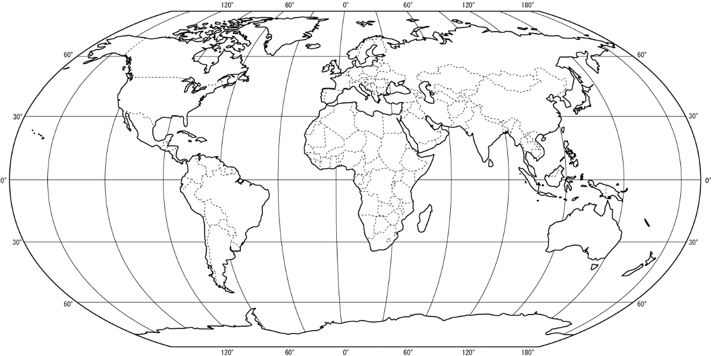


- Fill the plate with your opinions on how to solve the food crisis:

- Write at least three specific things you can do to stop wasting food:
___________________________________________________________________________
___________________________________________________________________________
___________________________________________________________________________
___________________________________________________________________________


Worksheet – Zero Hunger

            - Decide whether the statements on hunger are correct (yes/no):
The proportion of undernourished people in developing countries is roughly 12.9 percent: | YES | NO
Globally, one in ten four children suffer from stunting. | YES | NO
The vast majority of hungry people live in developing countries. | YES | NO
Asia has the highest number of hungry people in the world (about 2/3 of the population). | YES | NO
20 65 million schoolchildren in developing countries go to school hungry. | YES | NO
Poor nutrition causes nearly half (45%) of under-five deaths which equals 3.1 million children a year. | YES | NO

            - Write in your own words what the following terms mean:
Chronic hunger – long-term lack of calorie intake
Famine – mass extinction of the population in an area as a result of long-term starvation
Hidden hunger – lack of vitamins, minerals and trace elements
Food security – physical and financial availability of sufficient quantities of quality food for a country’s population
Sustainable agriculture – the ability of farms to produce food “indefinitely” without long-term damage to the land and surrounding ecosystems.
Hunger – a feeling induced by a lack of food

- On a blank map of the world, indicate the risk areas where people suffer from hunger or malnutrition and write below the picture what these areas are collectively called:

Belt of hunger and malnutrition

- Fill the plate with your opinions on how to solve the food crisis:
Better food redistribution
Help the poor more
Stop wasting food
Regulate shops not to throw away so much food

- Write at least three specific things you can do to stop wasting food:
Do not throw away uneaten food
Take only as much as you can eat
Do not cook too much food

Activities for students

Activity 1 – Pictures showing the causes of hunger in the world
The teacher presents the students with pictures related to the causes of hunger in the world and food waste. In groups, the students discuss what each picture represents and reflect on how the situations in the pictures affect the issue of hunger in the world. The pictures can be projected or printed and handed out.
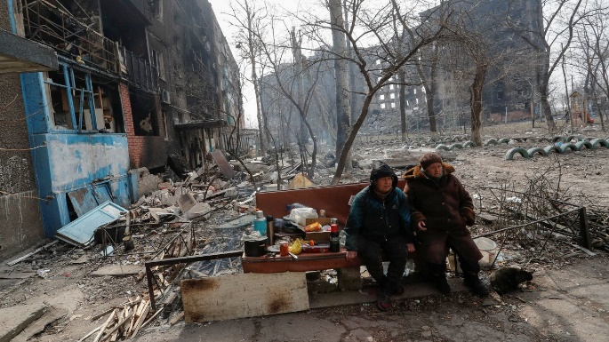

Picture 1 Picture 2
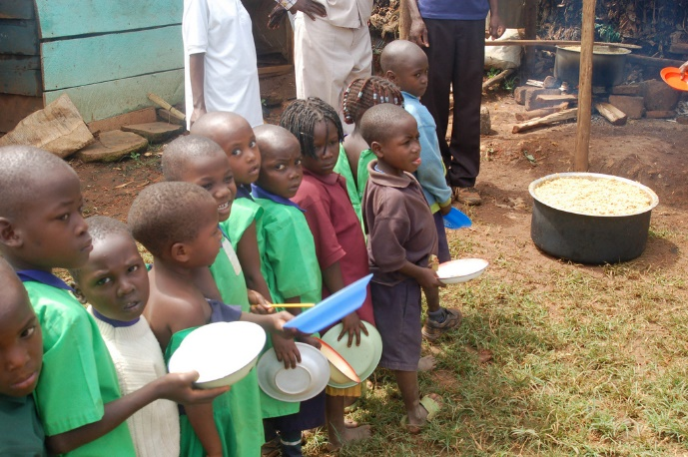
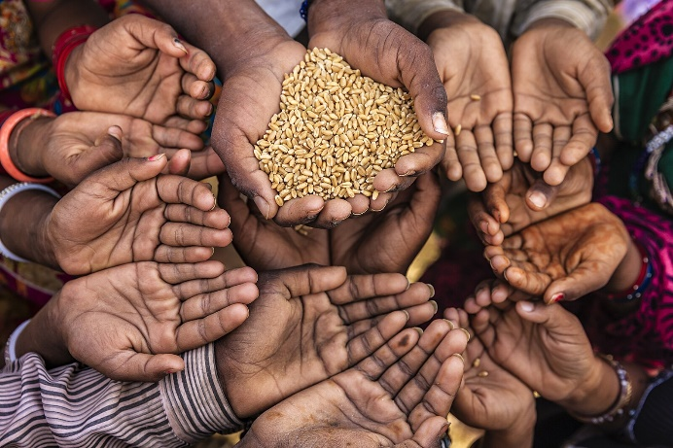
Orange food fight – Italy War in Ukraine
Picture 3 Picture 4
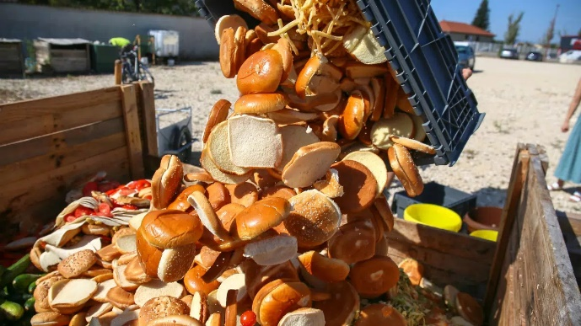
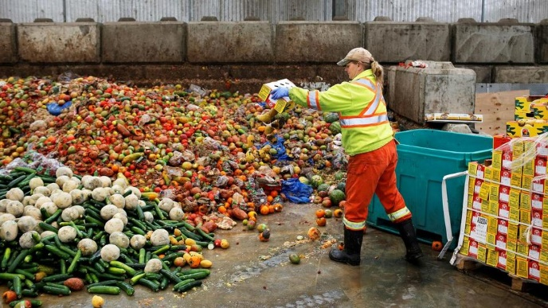
Food redistribution in a developing country 1 Food redistribution in a developing country 2
Picture 5 Picture 6
Food waste 1 Food waste 2
Activity 2 – Quiz
The teacher reads out the questions the purpose of which is to review the key findings from the previous activities and possible answers. The students write down their answers. Finally, the answers in the quiz are checked.

- A person who does not have enough vitamins, minerals and trace elements suffers from:
  - Chronic hunger
  - Hunger
  - Hidden hunger
- If good quality food in sufficient quantities is affordable to the population in a given country, we can say that the country has achieved:
  - Food security
  - Chronic hunger
  - Sustainable agriculture
- The percentage of undernourished people in developing countries is roughly:
  - 5.6 %
  - 12.9 %
  - 25.1 %
- In which part of the world do most people suffer from hunger?
  - South America
  - Asia
  - Africa
- How many million children in developing countries go to school hungry?
  - 20 million
  - 30 million
  - 40 million
- In Asia, more than half of the population is hungry.
  - Yes
  - No
- The ability of a farm to produce food “indefinitely” without long-term damage to the land and surrounding ecosystems is called:
  - Ecological agriculture
  - Food agriculture
  - Sustainable agriculture
- Possible solutions to the food crisis do not include:
  - Stop wasting food
  - Restrict food production
  - Better food redistribution

References:
Hronová, T. (2014, 15 October). Dvě miliardy lidí ohrožuje skrytý hlad, varují odborníci v nové studii. Člověk v tísni. https://www.clovekvtisni.cz/dve-miliardy-lidi-ohrozuje-skryty-hlad-varuji-odbornici-v-nove-studii-1713gp
Oppitzová, M. (undated). Co je to udržitelné zemědělství?. Tvoje místo. https://tvojemisto.cz/co-je-to-udrzitelne-zemedelstvi/
UN. (undated). Fakta o hladu. https://www.osn.cz/sdg-2-vymytit-hlad-dosahnout-potravinove-bezpecnosti-a-zlepseni-vyzivy-prosazovat-udrzitelne-zemedelstvi/fakta-o-hladu/
Ovčačík, Z. (2022). Seznamte se s projektem Nulový hlad: Aktivity. https://docplayer.cz/168721300-Aktivity-seznamte-se-s-projektem-nulovy-hlad.html?fbclid=IwAR0dpRTh9HcJxxj0zYTto2UqQhz7bVxDIYH9wO49vGVgduI5CLeBSIwQ7lA
Peková, A. (2013). Potravinová bezpečnost: Shrnutí bodu agendy II. Výboru v rámci Studentského modelu Valného shromáždění OSN 2013. http://simulaceplzen.cz/wp-content/uploads/2016/11/II-Potravinov%C3%A1-bezpe%C4%8Dnost.pdf
Polnická, A. (2022, 10 June). Hlad: Proč ho máme a jak funguje?. Svět plodů. https://www.svetplodu.cz/clanek/133/jak-funguje-hlad/
Veselý, M. (2020, 8 June). Nejdůležitější vitamíny a minerály – stavební kameny vašeho zdraví. Brain market. https://www.brainmarket.cz/nase-novinky/nejdulezitejsi-vitaminy-a-mineraly/
Pictures:
Picture 1: https://www.srovname.cz/clanky/wp-content/uploads/2019/09/oranzova-bitva.jpg
Picture 2: https://img.ihned.cz/attachment.php/150/77278150/zNpODVw3HkdcPU9lhxJ4n16GsibQvutR/tag_reuters.com_2022_newsml_RC2N9T92EAEM_127734072.jpg
Picture 3: https://1gr.cz/fotky/idnes/22/053/cl8h/LUH939ffa_GettyImages_524903696.jpg
Picture 4: https://img.krestandnes.cz/2017/03/7583625554_64c1f449df_b.jpg
Picture 5: https://senoptica.com/wp-content/uploads/2022/06/fOOD-WASTE-1.jpeg
Picture 6: https://d39-a.sdn.cz/d_39/c_img_QP_L/WkMDt.jpeg?fl=cro,0,93,1800,1012%7Cres,1200,,1%7Cwebp,75

