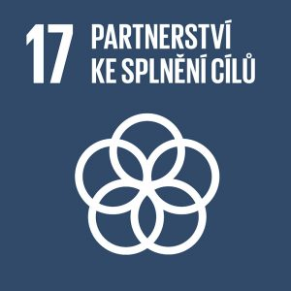
Partnerships for the goals

Authors: Kristýna Drábková, Tereza Dohnalová
Keywords: Sustainable fashion, slow fashion, fast fashion, sustainable development, degradability of materials
Objective: Strengthen the means of implementation and revitalize the Global Partnership for Sustainable Development
Cooperation is needed between countries and between people and organisations within countries. Today’s interconnected world offers us no other reasonable option. The aim is to ensure that all countries allocate sufficient resources to the SDGs. Developed countries should commit to helping the less developed.
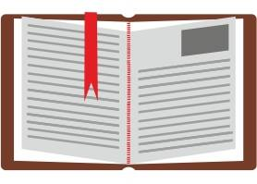

Theoretical preparation

Sustainable development
Sustainable development is a type of development that seeks to eliminate or mitigate the negative effects of the way human society has developed to date. Present developments based primarily on economic growth have a negative effect on the functioning of our planet. Most natural resources are finite and humans are damaging the planet by over-exploiting them. Sustainable development takes into account not only economic growth but also social values and natural wealth.
Sustainable development consists of three pillars: economic, environmental and social. Sustainability seeks to meet the needs of the present without compromising the ability of future generations to meet their needs. The social, environmental and economic pillars of society are closely interlinked and one of them cannot be prioritised at the expense of the others.

- The economic pillar consists of all economic activity in society, the aim is to achieve good economic growth. Healthy economic growth should generate sufficient resources to protect the environment and, conversely, a healthy environment should not constrain economic growth.
- The basic prerequisite for the environmental pillar is environmental protection. The environmental idea is that goods and services should be produced in a way that does not use resources that harm the environment.
- The social pillar deals with society – people. It strives for balance and equality between groups and individuals. It also addresses the differences between countries with advanced economies and those that are not so well off. The social pillar also addresses compliance with good working conditions and access to hygiene.

Sustainable fashion refers to clothing and accessories that are produced in an environmentally and socially responsible way. The main goal is to find a balance in the design, production and consumption of clothing. Manufacturers strive not to deplete natural resources and avoid exploitation of individuals and communities. If we want to promote sustainable fashion, we can wear the clothes we already have and not keep buying new ones. Other options are second-hand shopping or swapping/borrowing clothes from friends.
Fast fashion versus slow fashion
Fast fashion and slow fashion are among the most discussed terms in fashion.
Fast fashion is truly fast. Large multinational chains can create new collections inspired by the latest trends in a matter of weeks and distribute them immediately to their branches. Big companies such as H&M or Gap achieve this thanks to their cleverly designed logistics system, the factories they own and, most importantly, their global presence. As a result, we can find new pieces in the shops every week that mimic the latest trends. Since 2000, clothing production has more than doubled globally, and the average person now buys 60 percent more clothing that lasts about half as long as it did 15 years ago.
The opposite is slow fashion. This is an approach adopted by previous generations. They were able to perceive the value of things, take care of them and appreciate them. The main means of slow fashion is quality, which has recently been replaced by quantity together with a higher purchase price. So, the goal is to have a wardrobe filled with quality pieces that we will appreciate more. Slow fashion is more about the way we think, because whether the product is locally sourced, grandma’s or from a fast fashion chain store, it is about not getting rid of it when a button falls off, but instead sewing it on and wearing the product until it completely falls apart.

Sustainable design techniques in clothing
There are many techniques and options that can be used to create different products that have the least impact on the environment. There are manufacturing options that minimize non-renewable energy consumption, as well as use materials that are much more environmentally friendly and conserve or save water. The same applies to the fashion world. Many designers choose techniques that differ from conventional manufacturing by being more environmentally friendly.
One of these techniques is, for example Design for Longevity, which aims to extend the life of a product so that people do not replace clothes too often. This can be achieved by using classic ageless patterns and colours that do not go out of fashion.
It is also important to adhere to the principle of Zero Waste Design. It is reported that up to 15% of textiles intended for clothes production end up as waste on the floors of cutting rooms. In order to create a garment using this method, it is necessary to know the dimensions of the fabric or to use draping. Some designers also use the leftover fabric as garment decoration.

Degradability of materials
According to their origin, textile fibres can be divided into chemical (viscose, nylon, silk or polyester) and natural (cotton, linen, hemp or wool). The production of chemical fibres is energy-intensive compared to natural fibres and some of them (nylon or polyester) are made from petroleum. Moreover, they do not decompose easily in nature. Cotton is the most traditionally used natural fibre. However, its production is very environmentally demanding, which is why new materials such as hemp and bamboo are coming to the fore.

Water consumption
Of course, the production of clothing also involves considerable water consumption. It takes 2,700 litres of water to produce one cotton T-shirt, an amount of water that equals 70 showers. Speaking about the production of jeans, which are the most demanding to manufacture, the numbers change significantly. To manufacture a single pair of trousers, 3,700-9,500 litres of water is required, which equals 285 showers. Unnecessary toxic water, i.e. water used during textile dyeing or other production stages, is often discharged directly into rivers. The water then contains substances (e.g. arsenic, lead, mercury) that are extremely harmful to all forms of aquatic life and to people living in the immediate vicinity of these streams. In China, the largest producer of jeans, 40% of rivers and lakes are highly toxic. The local rivers are often blue because of indigo used to dye jeans. The textile industry thus accounts for 20% of the world’s water pollution.
References:
Internet resources:
10 tipů na českou udržitelnou módu. In: ČR 2030. [online]. 2019 [cit. 2022-10-10]. Retrieved from: https://www.cr2030.cz/magazin/kvalita-zivota/10-tipu-pro-udrzitelnou-modu/
Sustainable design techniques. In: Future Learn. [online]. 2018 [cit. 2022-10-10]. Retrieved from: https://www.futurelearn.com/info/courses/sustainable-fashion/0/steps/13558

Udržitelná móda: Co to je a jak může pomoci zachránit planetu? In: Fomo. [online]. 2022 [cit. 2022-10-10]. Retrieved from: https://heyfomo.cz/udrzitelna-moda-co-to-je-a-jak-muze-pomoci-zachranit-planetu

Book resources:
BARTLOVÁ, Ada. Vše, co jste chtěli vědět o módě. Brno, Vyd. 1. 2018. [cit. 2022-10-10] ISBN 978-80-7565-330-7

SKLENÁKOVÁ, Diana. Trvale udržitelný rozvoj a ekonomický růst [online]. [cit. 2022- 10-10] Retrieved from: https://is.muni.cz/th/osi5a/DIPLOMOVA_PRACE.pdf. Diplomová práce. Masarykova univerzita.

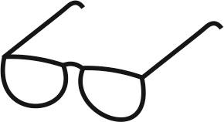
Draft lesson plan

Estimated time: 45 min.
Teaching stage | Activity description | Teaching method | Teaching form | Time
Motivation | - Activity 1 – Thinking about sustainable fashion | Activation | Mass | 7 min.
Exposure | - Fast fashion, slow fashion  - Worksheet – exercise 1, 2  - Videos:  https://www.youtube.com/watch?v=GDWTUL1xwPM  https://www.youtube.com/watch?v=6AEr0tpTAMs  - Worksheet – exercise 3, 4 | Presentation, using a worksheet, activation | Frontal  Individual / group | 25 min.
Fixation | - Activity 2 – Anti-advertisement | Activation | Group | 10 min.
Application | - Activity 3 – The world in the wardrobe | Activation | Individual | 3 min.

Motivation
At the beginning of the lesson, all students stand in the middle of the classroom. The teacher asks students the following questions (see Activity 1 – Thinking about sustainable fashion). Students relocate in the classroom according to their answers. Students have the opportunity to comment more on the answers if they wish to communicate their own experience. At the end of the activity, the teacher asks students about the likely topic of the lesson.
Exposure
In the main part of the lesson, the teacher gives a short explanation of the main differences and features of fast fashion and slow fashion. Students are then given the Worksheet. Their task is to complete the first two exercises, which they will then check together.
After checking, the teacher shows students a video about fast-fashion chains. Students have the opportunity to make up their own minds about these shops and find out what is behind the conspicuously low prices of their clothes. A short discussion may follow the video.
Video

What is Slow Fashion?; https://www.youtube.com/watch?v=GDWTUL1xwPM (2:06)
Fast Fashion Environmental Impact | Fast Fashion Effects On Environment | The Planet Voice: https://www.youtube.com/watch?v=6AEr0tpTAMs (3:03)

Students then complete the remaining two exercises in the Worksheet and check them together.
Fixation
The teacher starts Activity 2 with these words: We often buy things because of advertisements. Where do you most often see advertisements? A short discussion follows. Students’ task is to create an anti-advertisement for a product. This means that they create their own advertisement, which will not entice others to buy the product, but will discourage them.

Application
At the end of the lesson, students are assigned homework in which they will focus on the clothes they wear. The main objective will be to explore their clothes to find out more information related to sustainable fashion.


WORKSHEET – Sustainable fashion

1. Explain in your own words what sustainable fashion is.

2. Match the average water consumption with the following items:
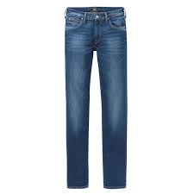  a) jeans | A) 8,860 litres of water
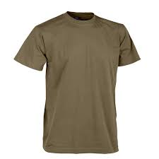  b) cotton T-shirt | B) 3,700 to 9,500 litres of water
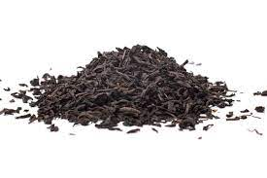  c) 1 kg of black tea | C) 290 litres of water
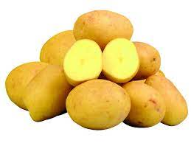  d) 1 kg of potatoes | D) 15,415 litres of water
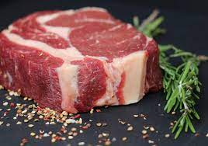  e) 1 kg of beef | E) 2,700 litres of water

3. Add the missing words in the text:

fast fashion | quality | half | factories
slow fashion | multinational chains | doubled

_______________ is truly fast. Large ________________________ can create new collections inspired by the latest trends in a matter of weeks. Big companies such as H&M or Gap achieve this thanks to their cleverly designed logistics system, the ______________ they own and, most importantly, their global presence. Since 2000, clothing production has more than ________________ globally, and the average person now buys 60 percent more clothing that lasts about ________________ as long as it did 15 years ago.
The opposite is ____________. The main means of slow fashion is _____________, which has recently been replaced by quantity together with a higher purchase price. So, the goal is to have a wardrobe filled with quality pieces that we will appreciate more. Slow fashion is more about the way we think.
4. Unused clothing can be used in other ways than throwing it away. In each bubble, write what other possibilities you can think of.

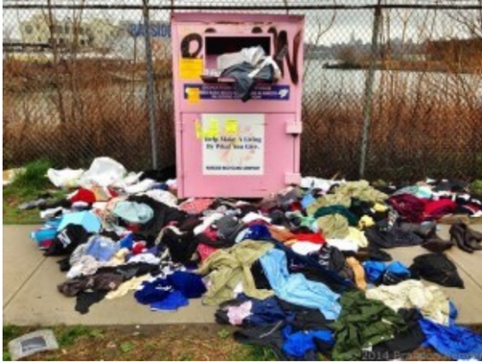


WORKSHEET – KEY

1. Explain in your own words what sustainable fashion is.
These are clothes and accessories that are produced organically. Sustainable
fashion is the opposite of fast fashion. Sustainable fashion is of better quality and
is ethical.

2. Match the average water consumption with the following items:
a) jeans | A) 8,860 litres of water
b) cotton T-shirt | B) 3,700 to 9,500 litres of water
c) 1 kg of black tea | C) 290 litres of water
d) 1 kg of potatoes | D) 15,415 litres of water
e) 1 kg of beef | E) 2,700 litres of water
3. Add the missing words in the text:

fast fashion | quality | half | factories
slow fashion | multinational chains | doubled

Fast fashion is truly fast. Large multinational chains can create new collections inspired by the latest trends in a matter of weeks. Big companies such as H&M or Gap achieve this thanks to their cleverly designed logistics system, the factories they own and, most importantly, their global presence. Since 2000, clothing production has more than doubled globally, and the average person now buys 60 percent more clothing that lasts about half as long as it did 15 years ago.
The opposite is slow fashion. The main means of slow fashion is quality, which has recently been replaced by quantity together with a higher purchase price. So, the goal is to have a wardrobe filled with quality pieces that we will appreciate more. Slow fashion is more about the way we think.
4. Unused clothing can be used in other ways than throwing it away. In each bubble, write what other possibilities you can think of.

donate to a
person you know
sell

bring
to a charity
use again
for the production
other clothes

replace

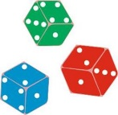
Activities for students

ACTIVITY 1: Thinking about sustainable fashion
Students stand in the middle of the classroom and, if necessary, adjust the classroom space so that they can move from one end of the classroom to the other. The teacher asks students the following eleven questions:
- Do you have a lot of clothes?
- Do you buy things you don’t really need?
- Have you ever bought something you’ve only worn once or twice?
- Do you often buy clothes?
- Do you shop on discounts?
- Do you shop in second hand shops?
- Are you ashamed of shopping in second hand shops?
- Did you know about the unethical nature of the fashion industry and its impact on the environment?
- Do you look at the material your clothes are made of?
- Do you look at the country of origin of the clothes you buy?
- Is the brand of your clothes important to you as a sign of prestige?
Students relocate in the classroom according to their answers. Those who answer YES will be at one end of the classroom, those who say NO will be at the other end. The teacher will comment on their answers and observe whether the majority of the class agrees on or differs with the answers. The teacher can encourage discussion, but does not force students to share their own experiences if they do not want to (some questions may be sensitive to them).
ACTIVITY 2: Anti-advertisement
The teacher divides students into groups of four. The task for each group is to create an advertising leaflet that aims to discourage others from buying the product. During this activity, students will use paper, crayons and markers. The aim is to develop students’ creativity, to make them realise that there are downsides to the product, and to improve their ability to discuss in a group. Each group will then present their anti-advertisement to the other groups.
ACTIVITY 3: The world in the wardrobe
As part of homework, students will explore what they have in their wardrobe. Students write down on a piece of paper several types of clothes they have in their wardrobe. They will look at the tags to find out the origin and materials of each piece of clothing. They will also write down the brand if any. They will choose their two favourite pieces of clothing and find out where the materials are grown/produced, the country of origin and the country in which they bought the piece. If they purchased their clothing on an e-shop, they can also write down what e-shop it was.

(12)

SKLENÁKOVÁ, Diana. Trvale udržitelný rozvoj a ekonomický růst [online]. [cit. 2022- 10-10] Retrieved from: https://is.muni.cz/th/osi5a/DIPLOMOVA_PRACE.pdf. Diplomová práce. Masarykova univerzita.
https://heyfomo.cz/udrzitelna-moda-co-to-je-a-jak-muze-pomoci-zachranit-planetu
BARTLOVÁ, Ada. Vše, co jste chtěli vědět o módě. Brno, Vyd. 1. 2018. [cit. 2022-10-10] ISBN 978-80-7565-330-7
https://www.futurelearn.com/info/courses/sustainable-fashion/0/steps/13558
https://www.cr2030.cz/magazin/kvalita-zivota/10-tipu-pro-udrzitelnou-modu/
https://www.futurelearn.com/info/courses/sustainable-fashion/0/steps/13558

