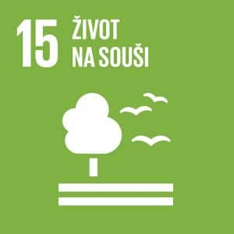
Life on land

Author: David Trčka
Keywords: Ecosystem, protection, management, forest, deforestation, deserts, desertification, soil degradation, biodiversity, sustainable development, invasive species, protected species, poaching, smuggling.
Objective: Protect, restore and promote sustainable use of terrestrial ecosystems, sustainably manage forests, combat desertification, and halt and reverse land degradation and halt biodiversity loss
The diversity of nature and the quality of the natural environment is declining faster than at any other time in human history. Every year, forests larger than Slovakia disappear from the Earth. Human activity has changed almost 75% of the Earth’s surface and is continuing to do so. Approximately 1 million animal and plant species are threatened with extinction. Many of them in just a few decades. The aim is to use the Earth’s ecosystem sustainably and in accordance with international agreements.


THEORETICAL PREPARATION
Forest ecosystems and oxygen
Forests currently cover about 30% of the land and are invaluable to life on Earth. They play an indispensable role in shaping the climate by producing oxygen and, in turn, absorbing carbon dioxide – one of the main gases whose increased concentration contributes to the intensification of the greenhouse effect and possible global climate change. Mankind has used forests as a source of valuable raw materials for several millennia. More than half of harvested wood is used as fuel, as well as in the construction, furniture, pulp and paper industries. Some tree species are sources of cork (cork oak), latex from rubber trees, quinine from the bark of the cinchona tree, which is used against malaria, resin from pine trees, etc. If properly managed, forests are a renewable resource. A forest destroyed by fire has the capacity for natural regeneration. In the case of large-scale clearing of tropical rainforests, or when forest ecosystems are damaged by emissions, forest biomass cannot be easily restored and forests decline. Deforestation can have very serious consequences for climate conditions at local, regional and global scales. As a result of deforestation and changes in the nature of the active surface, climate extremes may be increasing and the spatial distribution of many meteorological elements may be changing. Another serious consequence of deforestation is the intensification of erosion processes, where water is not absorbed sufficiently in deforested areas, erosion furrows are formed, and water that has accumulated in the forested landscape quickly disappears. These processes may result in the gradual desertification and expansion of desert areas. Accelerated runoff in deforested areas can lead to catastrophic flooding. Changes in biodiversity in forest ecosystems and soil degradation processes are also closely related to deforestation processes (sci.muni.cz).
The forest is not just trees and shrubs, but above all an important and complex ecosystem that allows us to breathe. One large mature deciduous tree, such as an oak, produces as much oxygen per day as it takes 50 people to breathe. On average, humans consume around 350 litres of oxygen per day, and a hectare of normal forest will generate oxygen for dozens of people. A hectare of forest produces an average of 10 tonnes of oxygen (700,000 litres) per year. Add to that the fact that oxygen is not only needed by humans and animals, but also by cars, and it becomes clear that trees have life-giving power for all of us (ahrend.cz).
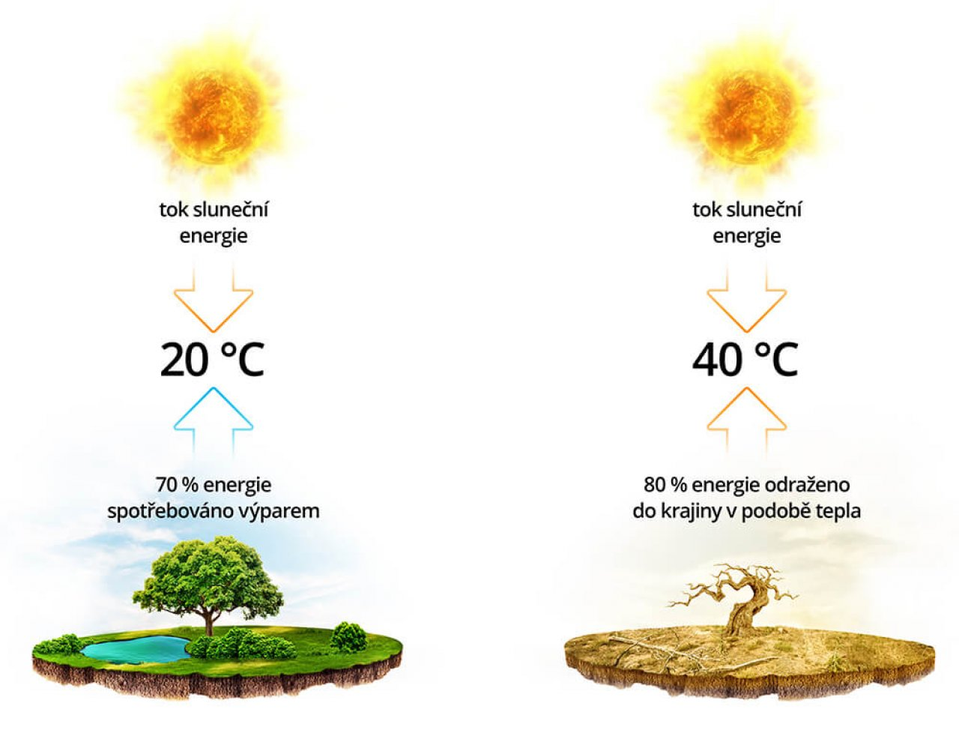
https://prerovsky.rej.cz/images/var/prerov/article-internal/2021/05/internalView/evapotranspirace.jpeg
solar energy flow: 70% of energy consumed by evaporation; 80% of the energy reflected into the landscape in the form of heat

Destruction of tropical rainforests
Although tropical rainforests have been cleared for several centuries, it has become so intense in the 20th century that if it were to continue unabated at this rate, they would disappear completely within the next 100 years. Deforestation has many causes. One of the main ones is extensive agriculture and the desire to acquire new areas for growing crops and grazing cattle. Another reason is the clearing of forests for logging. In some areas, only rare timber species are harvested, while others are subject to clear-cutting. Heavy machinery is often used during logging, which irreversibly destroys not only the forest but also the soil, thereby disrupting the water cycle or causing the erosion processes (sci.muni.cz).
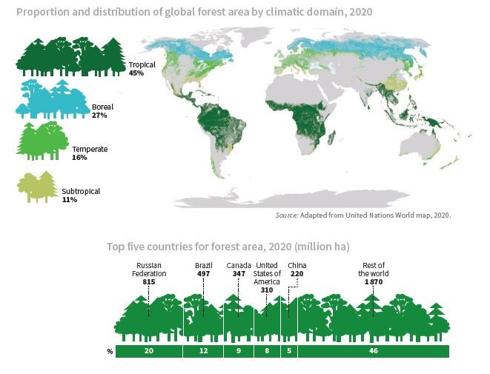

The climate crisis manifests itself on many different levels, but as research by scientists at King’s College London and Imperial College London has shown, air pollution can also be a problem for humans. Exposure to higher levels of air pollution can lead to an increased risk of developing serious mental health problems, according to research published in the British Journal of Psychiatry. Higher levels of airborne nitrogen dioxide (most massively produced by diesel vehicles) have been shown to be associated with a higher risk of mental health problems. Patients with psychotic disorders and various related diagnoses such as schizophrenia, bipolar disorder or depression who were exposed to more air pollution were then more likely to be hospitalised or needed further intensive treatment. A similar (albeit lower) relationship has been shown for higher levels of nitrogen oxide and other particulate pollutants (King’s College London, 2021).
Soil degradation and desertification
Desertification refers to land degradation in arid, semi-arid and dry sub-humid areas due to various factors including climate variability and human activities. Desertification can lead to poverty, health problems related to wind-borne dust and a decline in biodiversity. It can also have demographic and economic consequences, forcing populations to migrate from affected areas. Soil degradation refers to the reduction or loss of biological or economic productivity. This is a phenomenon that makes fertile land less productive. It is usually caused by human activity. In addition to fertility, soil degradation can be assessed by other factors such as landscape cover, soil erosion or soil organic carbon. Other definitions of soil degradation highlight the deterioration of biodiversity and ecosystems (European Court of Auditors, 2018).
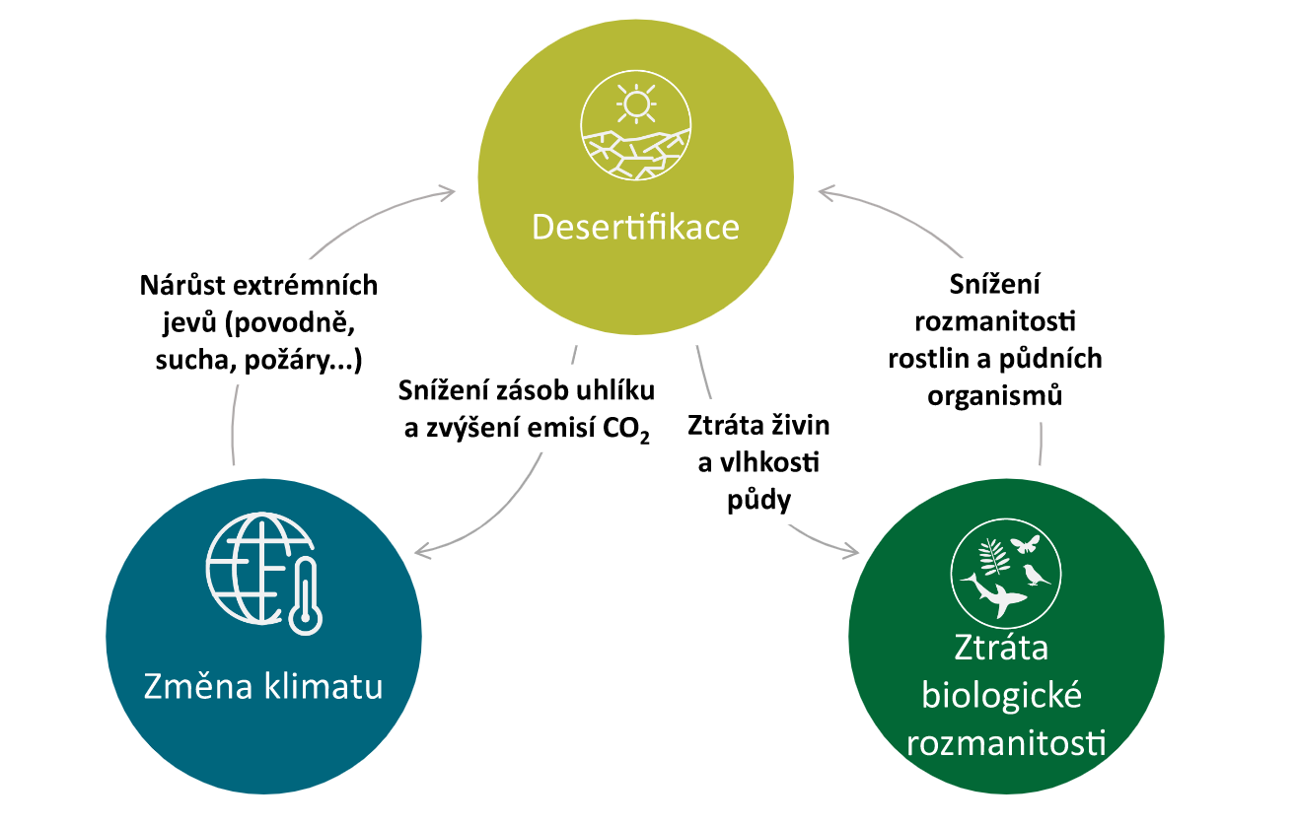
Source: EÚD, na základě Institutu pro světové zdroje, Ecosystems and Human Well-being: Desertification Synthesis (Ekosystémy a dobré životní podmínky pro lidstvo: shrnutí problematiky desertifikace), 2005, s. 17.
Desertification
Změna klimatu: Climate change
Ztráta biologické rozmanistosti: Loss of biological diversity
Nárůst extrémních jevů (povodně, sucha, požáry..):Increase in extreme events (floods, droughts, fires, etc.)
Snížení zásob uhlíku a zvýšení emisí CO2: Decreased carbon stocks and increasing CO₂ emissions
Ztráta živin a vlhkosti půdy: Loss of nutrients and soil moisture
Snížení rozmanitosti rostlin a půdních organism: Reduced diversity of plants and soil organisms

The reality of today’s fields:
Poor and infertile soil contains so little humus and life that all of the levels of the pyramid of life on it are almost non-existent. Unfortunately, humans are constantly depleting arable soil through intensive cultivation, which is also losing nutrients and soil mass through erosion, with the natural replenishment cycle remaining disconnected. So far, it works because we are using the last of the soil reserves that have accumulated over the past millennia, plus huge amounts of artificial fertilisers are being supplied to the fields to replace the missing soil life and natural nutrients. But unlike nature’s healthy cycle, here we are creating a vicious circle that keeps shrinking and tightening like a noose around the necks of people dependent on the products of agriculture. Chemistry is not good for nature and not good for humans. This will not stop soil depletion; the amount fertilizers must constantly increase. It is killing the last of the soil life that could still survive. Many people are already aware of this, which is why so-called organic (bio) farms are springing up, where chemicals are not used or only those approved as less harmful. Unfortunately, heavy machinery is still there which burns oil and by choking and ploughing destroys the soil structure, which is also essential for soil health. One of the main subjects that children will one day be taught in school should be (besides how to think with their own heads) soil improvement and how to make compost (ekozahrady.com).
Farmers regularly return three essential nutrients to the soil in the form of synthetic fertilisers, namely nitrogen (N), phosphorus (P) and potassium (K). And often calcium (Ca). They are well aware that these elements are the first to be depleted from soil and without them, yields go down quickly. However, they do not usually care much about most other nutrients. Every year, a certain amount of trace elements is lost from the soil. Billions of atoms of nitrogen, phosphorus, potassium and calcium, as well as iron, magnesium, copper, sulphur, zinc, selenium, boron and other trace elements escape unnoticed from many gardens in the harvested crop. Often without any replacement. Not surprisingly, most of agricultural soil today suffers from nutrient imbalance. Mineral deficiencies in soil, whether in fields or gardens, are no exception today (potravinovezahrady.cz).

What is the impact on human health?
In her study Historical Change in the Mineral Content of Fruits and Vegetables, Anne Marie-Mayer claims that the content of minerals in fruit and vegetables significantly decreased in the UK between 1930 and 1980. For example, the content of iron in fruit fell by 32%, while potassium decreased by 20%. In vegetables, the content of sodium decreased by 43% and copper fell by 81%. Millions or even billions of people around the world suffer from nutrient deficiency diseases. Iron deficiency anaemia affected 1.62 billion people in developing and developed countries in 2008. Mild zinc deficiency affects about twenty percent of the world’s population. It is manifested by reduced immunity and delayed growth. Iodine deficiency was also quite widespread, which was solved in our country and in other countries by adding iodine to salt. And that is not all. All this in a situation where, thanks to the globalized food market, we do not fully experience local soil deficits, as we consume food grown on different soils in different regions of our planet. However, if for some reason most of our diet came from one garden, one plot or one area, then the effects of mineral deficiencies on our health could be much more severe (potravinovezahrady.cz).
Poaching and smuggling of protected species
According to statistics, the exploitation of wildlife for international trade is the second most serious cause of species loss on our planet, after the destruction of natural habitats. The main export areas for CITES-protected animals and plants are mostly developing countries, for which wildlife exports often represent a significant economic resource. Globally, the European Union is the largest importer of wildlife products, followed by the USA, the Far East (China, Japan, Korea), Arab countries and Australia. Most commonly traded are reptile skins, furs and wool, live exotic birds and tropical ornamental fish, caviar, shells and sea coral, cacti, orchids and wild bulbs (snowdrops) and rare tropical woods (rosewood, mahogany, ramin, etc.). However, there is a significant illegal trade with ‘endangered wildlife’, which CITES signatory states are trying to curb with varying degrees of success. An acute problem is smuggling of endangered species or their killing in the wild to obtain various products from them: e.g. ivory, fur of felines and carnivores, ‘traditional Chinese medicines’ made from tiger bones, rhino horns, pangolin scales, bear gall bladders, trading apes (orangutans, gorillas, chimpanzees) and other primates, rare species of parrots, reptiles, etc. (Klouček O., 2020).
Zoonoses - animal diseases transmissible to humans
Diseases that are common to animals and humans are generally referred to as zoonoses. There are almost 150 potential zoonoses in dogs and cats, but apart from rabies, only some types of parasitosis, bacterial infections and dermatophytosis (fungal diseases) are of current importance in Europe (svscr.cz).
Rabies
Rabies is an acute viral disease of the central nervous system of all warm-blooded animals, transmissible to humans It is manifested by behavioural changes, increased irritability, aggressiveness, paresis and paralysis, and is fatal. A significant shift in the control of rabies in wildlife was brought about by oral immunisation of foxes introduced in the 1980s in a number of Western European countries. The principle is to administer a vaccine hidden in a plastic vial inside a suitable bait. When the bait is eaten and the plastic wrapper is chewed through, the live vaccine virus comes into contact with the mucous membranes of the mouth and pharynx and induces a state of immunity. Rabies, unlike in the Czech Republic, continues to occur in some European countries. Several positive cases are reported annually from Poland and Romania. Turkey has long been a country at risk, with positive findings reported from virtually the entire territory (svscr.cz).


DRAFT LESSON PLAN

Estimated time: 45 min.
Teaching stage | Activity description | Teaching method | Teaching form | Time
Motivation | Brainstorming – Introduction | Activation, discussion | Mass | 5 min.
Exposure | Worksheet | Discussion, using a worksheet | Mass, individual | 20 min.
Fixation | Verbal revision of the topic | Discussion | Mass | 5 min.
Application | Creation of a simple mind map on the topic | Work in groups | Mass, pair work | 15 min.

Motivation
At the beginning of the lesson, the teacher involves students in brainstorming. The teacher writes some concepts related to the topic on the board and then students go to the board and write their ideas on the concept maps (suitable concepts: forest, air, agriculture, respiratory and mental diseases, vitamins and minerals in food, animal-borne diseases).
Exposure
The teacher gives students worksheets. They complete them together. The teacher gives students time and space to read the assignment and generate answers, which they subsequently evaluate together. For each question there is also room for possible discussion. If students do not want to discuss, the teacher can ask additional questions: Where do we find more life – in the forest or in the desert, and why? Do you have an animal at home? What would happen if it escaped into the wild?
Fixation
A short verbal revision of the topic will be part of fixation. Students answer the following questions:
- Are forests replaceable? Why are they important?
- What diseases can we get from polluted air?
- What are you doing to improve your neighbourhood?
- What is one of the main problems of today’s agriculture?
- What diseases can domestic animals transmit to humans?

Application
Students are divided into pairs or groups of three and make a simplified mind map of diseases discussed in class (allergies, asthma, anxiety, depression, rabies), or diseases discussed with the teacher in class (could be toxoplasmosis, tularaemia, cat scratch disease, hantavirus, Lyme disease). When creating mind maps, students can use the internet to search for information. The mind map should include the disease, symptoms, manifestations and treatment.


Worksheet

- What are trees good for? Think about the role of trees and write down your ideas.
What comes to your mind?

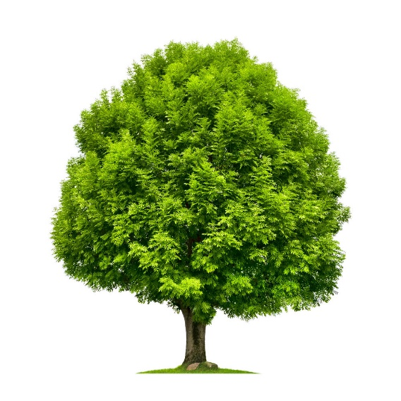

- Trees also clean the air. Without clean air, various respiratory and mental illnesses can arise. Match what belongs together.

Allergy mental disorder, low mood, pathological sadness
Asthma unpleasant emotional state, heart palpitations, fear, nausea
Anxiety rash, breathing difficulties, sneezing
Depression attacks of shortness of breath and coughing, narrowing of the airways

- Think of 10 activities to improve the air around you.

- Poor and infertile soil is a problem in the world today. Minerals are disappearing from the soil. Otherwise, they would be contained in crops. Using the hint, identify the mineral that is most abundant in each crop.
Hint: MANGANESE (Mn), IRON (Fe), CHROMIUM (Cr), MAGNESIUM (Mg), ZINC (Zn)

Note: Other minerals are also found in these foods but in smaller amounts.
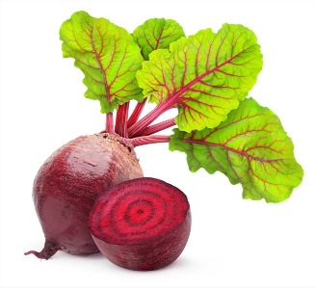
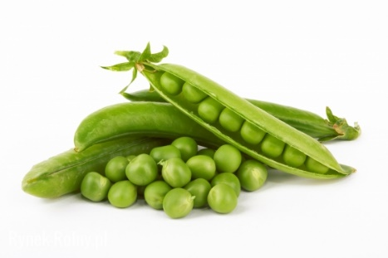

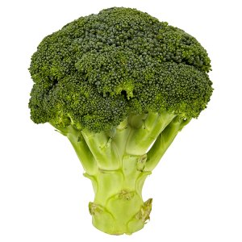
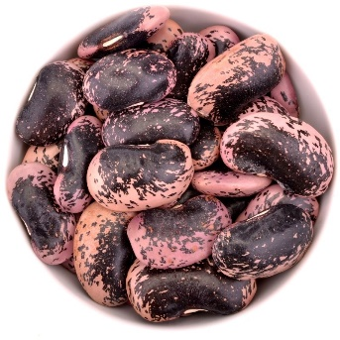

- Rabies is a viral infectious disease that affects the central nervous system. Can you identify the signs and symptoms that are characteristic of people after infection?

aggressiveness shivering anxiety attacks frequent urination
breathing difficulties bloodthirstiness increased production of tears and saliva
sleeplessness muscle spasms



- Could you identify which animals can transmit rabies to humans if they are infected? What made you decide in this way?


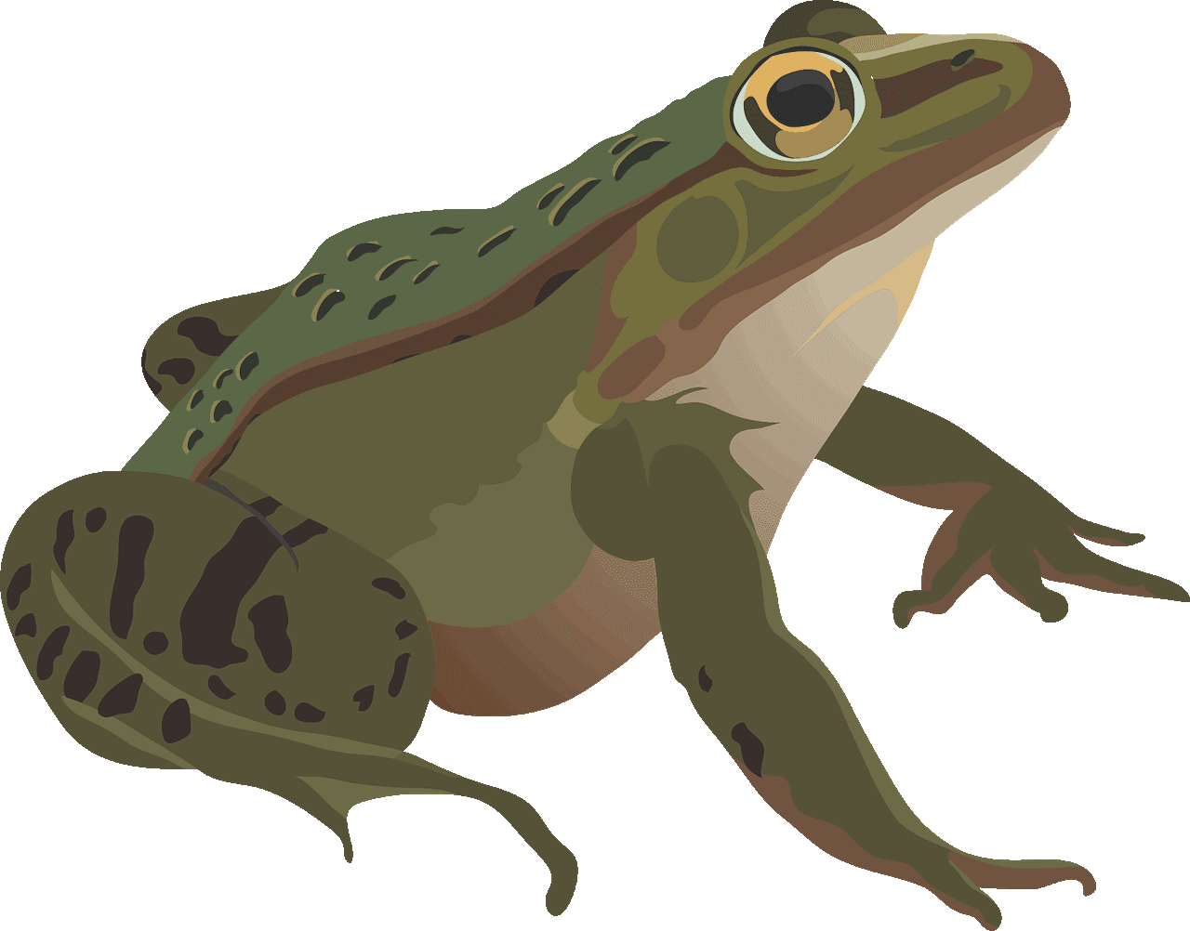

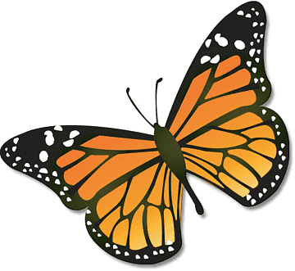



Worksheet – Key

- What are trees good for? Think about the role of trees and write down your ideas.
What comes to your mind?

They produce oxygen and absorb carbon dioxide
They regulate temperature (e.g. on the streets in summer)

They increase air humidity
They clean air

They prevent soil erosion
That help decrease global warming

- Trees also clean the air. Without clean air, various respiratory and mental illnesses can arise. Match what belongs together.

Allergy mental disorder, low mood, pathological sadness
Asthma unpleasant emotional state, heart palpitations, fear, nausea
Anxiety rash, breathing difficulties, sneezing
Depression attacks of shortness of breath and coughing, narrowing of the airways

- Think of 10 activities to improve the air around you.
Use public transport | Clean energy sources (solar panels)
Limit car rides | Take more people when you drive a car
Do not smoke in closed areas | Do not use poor quality material for heating
Plant trees | Use wood for heating
Do not burn waste | Plant flowers

- Poor and infertile soil is a problem in the world today. Minerals are disappearing from the soil. Otherwise, they would be contained in crops. Using the hint, identify the mineral that is most abundant in each crop.
Hint: MANGANESE (Mn), IRON (Fe), CHROMIUM (Cr), MAGNESIUM (Mg), ZINC (Zn)
Note: Other minerals are also found in these foods, but in smaller amounts.

Magnesium Mg
Manganese Mn
Chromium Cr

Zinc Zn
Iron Fe

- Rabies is a viral infectious disease that affects the central nervous system. Can you identify the signs and symptoms that are characteristic of people after infection?

aggressiveness shivering anxiety attacks frequent urination
breathing difficulties bloodthirstiness increased production of tears and saliva
sleeplessness muscle spasms

- Could you identify which animals can transmit rabies to humans if they are infected? What made you decide in this way? – it is mostly mammals that can bite humans

References:
Evropský účetní dvůr. (2018). Desertifikace v EU: boj s touto rostoucí hrozbou vyžaduje více opatření. Retrieved from: https://op.europa.eu/webpub/eca/special-reports/desertification-33-2018/cs/
OSN. (2022). United Nations. Retrieved from: https://www.osn.cz/sdg-15-chranit-obnovovat-a-podporovat-udrzitelne-vyuzivani-suchozemskych-ekosystemu-udrzitelne-hospodarit-s-lesy-potirat-rozsirovani-pousti-zastavit-a-nasledne-zvratit-degradaci-pudy-a-zastavit-u/
Ministerstvo školství, mládeže a tělovýchovy. (2022). RVP ZV 2021. Retrieved from: https://www.edu.cz/rvp-ramcove-vzdelavaci-programy/ramcovy-vzdelavacici-program-pro-zakladni-vzdelavani-rvp-zv/
Evropská rada a Rada EU. (2022). Biologická rozmanitost: Jak EU chrání přírodu. Retrieved from: https://www.consilium.europa.eu/cs/policies/biodiversity/
Evropská agentura pro životní prostředí. (2020). Biologická rozmanitost – ekosystémy. Retrieved from: https://www.eea.europa.eu/cs/themes/biodiversity/intro
sci.muni.cz. Monitorování lesních ekosystémů. Online z: https://www.sci.muni.cz/~dobro/zemsky_povrch_lesy.html
sci.muni.cz. Invazní druhy rostlin v ČR. Retrieved from: https://www.sci.muni.cz/bot_zahr/media/pdf/clanky/Invaze.pdf
Klouček O. (2020). Ministerstvo životního prostředí. CITES. Retrieved from: https://www.mzp.cz/cz/cites_obchod_ohrozenymi_druhy
Agentura ochrany přírody a krajiny ČR. (2022). Invazní druhy. Retrieved from: https://invaznidruhy.nature.cz/
Ahrend.cz (2022). Sázíme stromy. Retrieved from: https://ahrend.cz/blog/sazime-stromy/
Ekozahrady.com (2003). Půda pro přežití. Retrieved from: http://www.ekozahrady.com/puda.htm
Státní veterinární zpráva. Vzteklina. Retrieved from: https://www.svscr.cz/zdravi-zvirat/vzteklina/
Potravinové zahrady (2022). Zvyk, který ničí půdu a lidské zdraví. Retrieved from: https://www.potravinovezahrady.cz/zvyk-ktery-nici-pudu-a-lidske-zdravi/
King’s College London (2021). Exposure to air pollution linked with increased mental health service-use. Retrieved from: https://www.kcl.ac.uk/news/exposure-to-air-pollution-linked-with-increased-mental-health-service-use-new-study-finds

