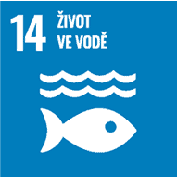
Life below water

Authors: Ludmila Handlířová, Iveta Strašáková
Keywords: Oceans, seas, environmental protection, health, nutrition, air, water, pollution, plastics, marine animals, climate change, fishing

Objective: Conserve and sustainably use the oceans, seas and marine resources for sustainable development

Seas and oceans cover three quarters of the Earth’s surface and contain 97% of all the water on Earth. They produce half the oxygen we breathe. They trap about 30% of CO₂ from human activity, thereby buffering the effects of global warming. Approximately 11 million tonnes of plastic enter the ocean every year, and over the same period, more than one million seabirds and 100,000 marine mammals are killed by plastic waste.
The aim is to significantly reduce marine pollution and overfishing and to address the impacts of ocean acidification caused by excessive CO₂ inputs.



Theoretical preparation

Seas and oceans
The world ocean is all the water concentrated in the oceans and seas, covering about three quarters of the Earth’s surface. All species known today evolved from life forms in the ocean, and a large number still live there today. Oceans are also of irreplaceable importance as regulators of the Earth’s temperature, dampening seasonal variations that would otherwise be more pronounced and short-term, and have ocean currents that cool or warm the land, thus shaping the climate into its present form (the most famous is the Gulf Stream, which warms Western Europe). Its marine plants, algae, coral reefs and phytoplankton (which produce up to 50% of the Earth’s oxygen) help mitigate climate change by trapping carbon dioxide and producing oxygen. The ocean also absorbs up to 85% of incoming solar radiation, providing a huge heat reservoir for the planet. It is also involved in the Earth’s water cycle, affecting coastlines. Without oceans, life on Earth would not be possible.

Significance for humans
Oceans provide wide economic benefits for humanity – source of mineral resources, energy, food and drinking water. It is a transport route for ships and is used for mining oil, coal, iron ore, copper, nickel and many other minerals. The oceans produce 1/3 of table salt, 2/3 of magnesium and 9/10 of bromine. Fishing is also important for humans, both for catching fish and for employment (marine fisheries directly or indirectly employ over 200 million people). Due to their constant movement, oceans have a great potential for energy production (currently, there are tidal power plants, for example, in France and Russia). By distillation, drinking water can be extracted from the oceans, which is very important for humans. Global trade depends on the ocean as the transport artery, both for container transport and tanker transport.

Threat to the world’s oceans
Climate change
Climate change is causing ocean temperatures to rise, leading to increased acidity and lower oxygen levels in seawater – making it harder for marine animals to breathe. The solution is to reduce our carbon footprint = slowing climate change (thinking about what we eat, where and how we travel).

Ocean pollution
Oceans are polluted by nutrients from sewage, agriculture, the atmosphere and burning of fossil fuels (nitrogen, phosphorus). This results in the so-called water flower – excessive growth of seaweed (depletion of oxygen kills other organisms). However, oceans are also polluted by soil particles – soil erosion by mining, excavation, forestry and agriculture. Soil particles sludge water, prevent photosynthesis in depth, suffocate fish and are carriers of toxic substances and nutrients. Other pollutants are toxins – PCB, DDT, heavy metals. Their source are herbicides, pesticides and leachate from landfills. They result in food contamination, may accumulate in fats and in the food chain, and have a long-term effect. They can also enter water where they pose a threat to aquatic animals. Oil is another pollutant in seas and oceans – about half comes from cars, industry, land-based machines, a third from usual operation of tanker ships and only 13% from tanker accidents. The solution could be to ban single-use plastics.

Plastics
Plastics come mostly from fishing nets, waste from boats, waste from the land – they hurt marine animals, they concentrate, for example, as the Great Pacific Garbage Patch. Floating plastic islands are places in the seas and oceans where plastic waste accumulates due to ocean currents. Plastic waste can cause deformation of the bodies of marine and other organisms as they become trapped in this waste (various forms of disfigurement or injury, e.g. deformed fins and shells in sea turtles).

Unsustainable fishing
Fishing for fish and marine animals is too intensive and stocks are not replenished naturally. Illegal fishing is also common. There are also ghost nets, which are discarded or lost fishing nets floating in the seas and oceans. These free-floating nets pose a risk to fish and other marine animals or birds that can easily become entangled in them. The solution is to avoid eating endangered species.

Marine protected areas
A small number of marine protected areas functioning as safe havens for marine animals (currently about 2% of these areas are available). The solution is to increase these areas up to 30% and prefer local products.

Coastal damage
Coastal zones are the most valuable for their abundance of food and because they serve as breeding grounds for marine animals, but they are also the most threatened. Tens of millions of people migrate from the inland to inhabited areas near the sea. In cities, oceans are being damaged by construction and pollution, and fish and shrimp farms are springing up in the countryside. Wetlands, canals, estuaries and coastal lagoons are being eliminated. The solution could be not to inhabit areas around seas and oceans.

Ocean acidification
The increasing concentrations of carbon dioxide in the atmosphere cause ocean acidification. The negative consequences for ocean-dwelling organisms may damage the economies of specific coastal areas dependent on tourism and affect the way of life of indigenous populations.

Death zone
An area in the marine ecosystem where, due to the presence of excessive nitrogen fertilisers, certain species of algae and cyanobacteria overgrow and oxygen deficiency occurs. This environment is incompatible with life for most organisms.

Oceans and climate change
Climate change – represents a change in the Earth’s long-term weather regime. It is responsible for melting ice in the polar regions – shrinking glaciers and rising sea levels in the long term, can lead to shortages of drinking water, but also rising sea levels – coastal erosion, flooding, torrential rainfall, infiltration of tidal water into estuaries and river systems, contamination of drinking water supplies and agricultural crops. Climate change is also related to extreme weather events – rising sea water temperatures transfer more energy to storms that form at sea – more intense tropical storms. Climate change also causes displacement – a rise in sea level of half a metre could cause displacement.

What can we do to reduce sea and ocean pollution
Use less plastic – carry reusable bottles instead of buying plastic bottles or cups, use reusable and cloth bags instead of plastic bags, avoid single-use plastics (e.g. straws, plastic utensils, balloons), recycling (the process of using waste that leads to reuse). Buy food that does not harm fish – when + shopping, check if the seafood is from a sustainable fishery. Make an effort to keep the beach clean – when you are on holiday by the sea, help clean the beach, take part in organised clean-ups or clean up plastics found in the water and on the beach. Do not touch plants, corals or marine animals when swimming or snorkelling.
To help fight climate change, we can help the oceans and seas by: cycling, walking, travelling by train, bus, turning off lights, chargers, TVs, reducing heating.

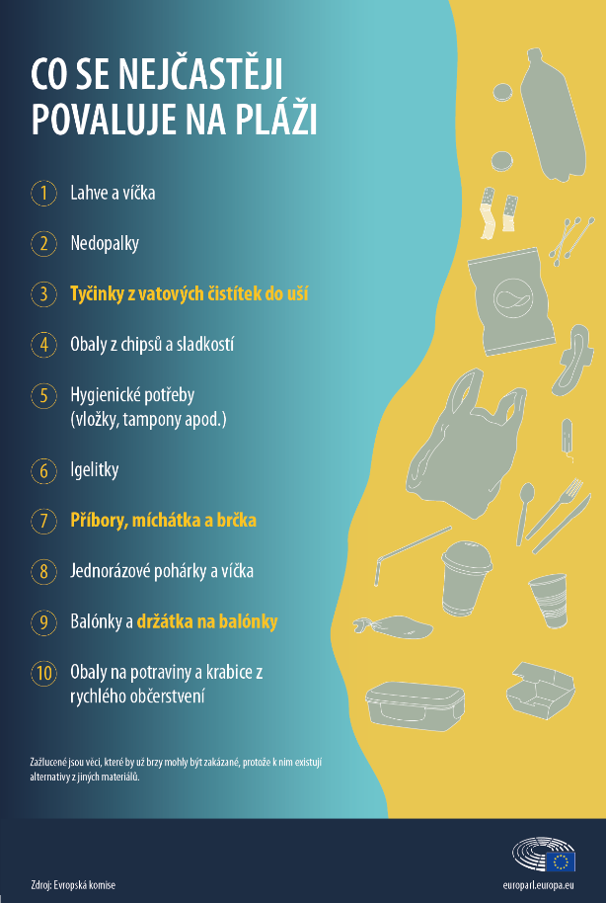
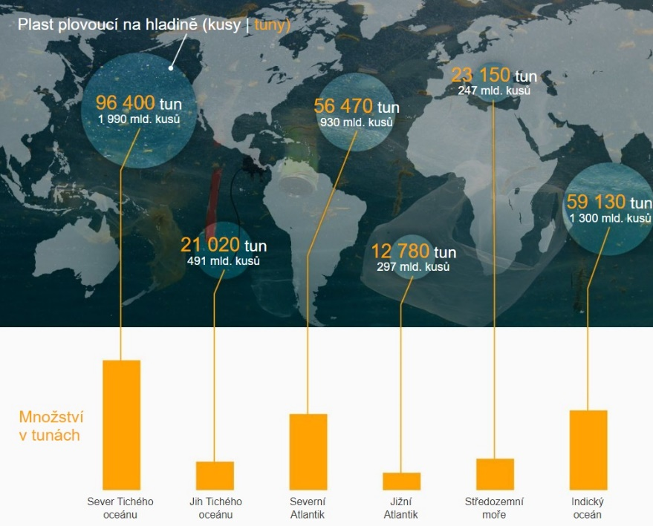

The largest producers of plastic waste are Asian developing countries such as China, Indonesia, the Philippines, Thailand and Vietnam. Of developed countries, the United States is the biggest producer.



What is most often found on the beach
- Bottles and caps
- Cigarette butts
- Cotton buds
- Crisps and sweets packaging
- Toiletries (pads, tampons, etc.)
- Plastic bags
- Cutlery, stirrers and straws
- Disposable cups and lids
- Balloons and balloon holders
- Food packaging and fast-food boxes
Items in yellow are those that could soon be banned because there are alternatives to them from other materials.
Source: European Commission

Plastic floating on water (pieces ⏐ tonnes)
XX tonnes
YY billion pieces
Quantity in tonnes
North Pacific Ocean
South Pacific Ocean
North Atlantic Ocean
South Atlantic Ocean
Mediterranean Sea
Indian Ocean

Draft lesson plan

Estimated time: 45 min.
Lesson stage | Activity description | Teaching method | Teaching form | Time
Motivation | Statements | Discussion | Mass, group | 5 min.
Exposure | Worksheet  Task 1: Select words for the text  Task 2: Find information in the article  Task 3: Matching | Worksheet, discussion, pair work | Individual, group | 15 min.
Fixation | Worksheet  Task 4: Add suitable alternatives  Task 5: Find errors in the text | Worksheet, discussion | Individual, group | 10 min.
Application | Activity 1 – Game on the board  Activity 2 – Video (3:24 min.), links | Activation | Group, individual | 15 min.

Motivation
Place three papers around the classroom with statements about ocean pollution. The task for each student is to go around all three statements and choose the one that is of interest. The class will form three groups to discuss the statement and its negative impact on our health. Each group will then choose a spokesperson to read their statement to the whole class and describe how they discussed the ocean issue.

We have produced more plastic in the last 10 years than in the previous century. By 2050, fish pollution will exceed our landfilled plastics.
For every tonne of tuna we fish out of the sea, about a kilogram of plastic is dumped back into the sea.
The carbon impact of eating one steak is greater than driving a low-emission car from Los Angeles to New York.

Exposure
The motivation stage is followed by the Worksheet. In exercise 1, students choose the correct option from the three words in the menu that best fits the text. By completing this exercise, they also receive general information about seas and oceans. In exercise 2, students draw information from the text or discuss the issue together. In exercise 3, students match the right and left columns to correctly link ocean threats to their possible causes. They then try to figure out how the threat affects human health. After each exercise the teacher checks the correct answers with students.

Fixation
Students continue in the worksheet with exercises 4 and 5. In Exercise 4, the task is to replace things that pollute seas and oceans, and thus harm our health, with suitable alternatives. In exercise 5, the task is to correct the text. The teacher again checks the exercises with students.

Application
At the end of the lesson, students play a game – Activity 1. The teacher writes on the board one phrase each time related to the seaside and its effects on health, but with the letters in the middle of the word omitted. Students then guess which letters are missing in the words. Activity 2 can be assigned as homework, but if there is time, the teacher can play a short video about ocean pollution and then recommend a film that might be of interest to students.


Worksheet: Why are oceans and seas important for our health?

Task 1: Add the word a, b or c to the text describing the importance of oceans and seas. Only one answer is correct.
The world ocean is all the 1) _____________ concentrated in oceans and seas, it occupies about three quarters of the Earth’s surface. All 2) ___________ species known today have evolved from forms of life in the ocean, and a large number of them live there to this day. Oceans are also of irreplaceable importance as regulators of 3) ___________ on Earth, dampening seasonal variations that would otherwise be more pronounced and short-term Sea currents cool or warm the land and shape the climate into its present form. The most famous is the 4) _______ Stream which warms Western Europe. Adverse climate has a 5) _________ effect on our health because it causes infections, injuries and has an impact on mental health. Marine 6) ____________ , algae, coral reefs and phytoplankton (which produce up to 50% of the Earth’s oxygen) help mitigate climate change by trapping carbon dioxide and producing 7) ___________. In the case of marine and ocean pollution there is a risk of air pollution, which could endanger human health and cause a 8) _________ in respiratory diseases.

- a) water
b) vapour
c) soil

- a) organism
b) sea
c) continent

- a) pressure
b) revolutions
c) temperature

- a) Labrador
b) Gulf
c) Peruvian

- a) positive
b) negative
c) neutral

- a) turtles
b) plants
c) whales

- a) oxygen
b) nitrogen
c) hydrogen

- a) decrease
b) rise
c) change

Task 2: Read the following article and complete the tasks below
A sea turtle tangled in fishing nets, a beached whale with a stomach full of plastic bags, a seahorse holding onto a cotton bud. Similar cases occur more and more often. Oceans are full of plastic waste. Every year, hundreds to thousands of animals tangled in plastic bags and garbage are washed up on the beach. In the same way, one million seabirds die every year from getting tangled in or ingesting garbage and clogging their digestive tracts. Last year, scientists also found plastics in drinking water and in the stomachs of deep-sea animals. According to the UN, this is a ‘planetary crisis’.

- Read the following article and try to think of a suitable title for it.

- What organisms are found in the oceans and seas? Try to list some first according to the article and then add others.

- What is the main theme of the article?
In pairs, discuss what you have learned in the article and try to identify what the issue is.

- Why might the facts in the article pose a problem for the health of the human population?

- What do you think about this topic? Share your thoughts in pairs again.

Task 3: Match some of the biggest threats to the oceans and seas with their possible causes. Then, for each of the pairs, try to think of ways in which the threat could affect human health.
Pollution by oil
Cars, machines, boats

Coastal damage
Plastics, fishing
Increasing ocean temperature
Burning of fossil fuels

Ocean acidification
Climate change

Extinction of marine animals
Settlement in coastal areas

Task 4: Try to think of alternatives to the things in the pictures that are polluting the oceans, resulting in the deterioration of our health. What other products could we replace them with? Can you think of anything else not listed here that could be replaced with a better alternative? Write it on the line below, or share it with the whole class.
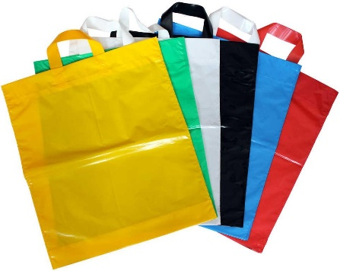
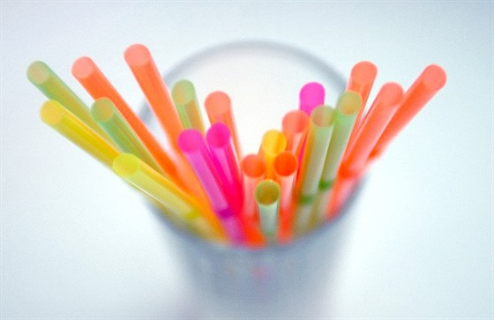

a)__________________________ b) ______________________________

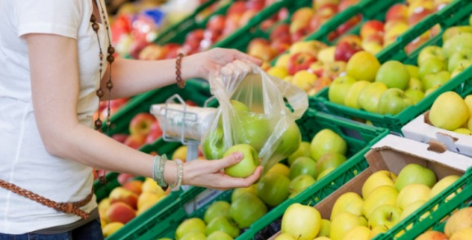

c)______________________________ d) _______________________________

Task 5: The following story describes how to behave on holiday by the sea. But not everything in it is right. Try to identify which parts of the text are inconsistent with ocean protection and correct them.

On holiday
I love going on holiday to the seaside. The best transport is the aircraft, because it has a great impact on the air which is then better to breathe. To get to know as much of the surrounding nature as possible, I borrow a car. I also love snorkelling, but I do not touch sea animals and plants because I could harm them. After snorkelling I go sunbathing and to have enough fluids, I go for water to the beach bar. When I drink all the water, I throw the plastic bottle next to the lounger, because plastics decompose very quickly. I like to spend the evenings in local restaurants, but I choose only those whose seafood is caught sustainably and contains the necessary nutrients that have a positive effect on my health.


Worksheet: Why are oceans and seas important for our health?

Task 1: Add the word a, b or c to the text describing the importance of oceans and seas. Only one answer is correct.
The world ocean is all the 1) _____________ concentrated in oceans and seas, it occupies about three quarters of the Earth’s surface. All 2) ___________ species known today have evolved from forms of life in the ocean, and a large number of them live there to this day. Oceans are also of irreplaceable importance as regulators of 3) ___________ on Earth, dampening seasonal variations that would otherwise be more pronounced and short-term Sea currents cool or warm the land and shape the climate into its present form. The most famous is the 4) _______ Stream which warms Western Europe. Adverse climate has a 5) _________ effect on our health because it causes infections, injuries and has an impact on mental health. Marine 6) ____________ , algae, coral reefs and phytoplankton (which produce up to 50% of the Earth’s oxygen) help mitigate climate change by trapping carbon dioxide and producing 7) ___________. In the case of marine and ocean pollution there is a risk of air pollution, which could endanger human health and cause a 8) _________ in respiratory diseases.

- a) water
b) vapour
c) soil

- a) organism
b) sea
c) continent

- a) pressure
b) revolutions
c) temperature

- a) Labrador
b) Gulf
c) Peruvian

- a) positive
b) negative
c) neutral

- a) turtles
b) plants
c) whales

- a) oxygen
b) nitrogen
c) hydrogen

- a) decrease
b) rise
c) change

Task 2: Read the following article and complete the tasks below
A sea turtle tangled in fishing nets, a beached whale with a stomach full of plastic bags, a seahorse holding onto a cotton bud. Similar cases occur more and more often. Oceans are full of plastic waste. Every year, hundreds to thousands of animals tangled in plastic bags and garbage are washed up on the beach. In the same way, one million seabirds die every year from getting tangled in or ingesting garbage and clogging their digestive tracts. Last year, scientists also found plastics in drinking water and in the stomachs of deep-sea animals. According to the UN, this is a ‘planetary crisis’.

- Read the following article and try to think of a suitable title for it.
Own solution

- What organisms are found in the oceans and seas? Try to list some first according to the article and then add others.
Sea turtles, whales, seahorse, seabirds, deep-sea animals, different solutions

- What is the main theme of the article?
In pairs, discuss what you have learned in the article and try to identify what the issue is.
The article discusses plastics in the seas and oceans and its impact on life in these waters.

- Why might the facts in the article pose a problem for the health of the human population?
Polluted seas and oceans have an adverse effect on our health, especially when swimming on holiday (e.g. skin problems).
Fishing produces the seafood we eat – it may contain harmful plastic pollutants.
Drinking water pollution in our homes.

- What do you think about this topic? Share your thoughts in pairs again.
Own solution

Task 3: Match some of the biggest threats to the oceans and seas with their possible causes. Then, for each of the pairs, try to think of ways in which the threat could affect human health.

Pollution by oil
Cars, machines, boats

Coastal damage
Plastics, fishing
Increasing ocean temperature
Burning of fossil fuels
Ocean acidification
Climate change

Extinction of marine animals
Settlement in coastal areas

Own solution

Task 4: Try to think of alternatives to the things in the pictures that are polluting the oceans, resulting in the deterioration of our health. What other products could we replace them with? Can you think of anything else not listed here that could be replaced with a better alternative? Write it on the line below, or share it with the whole class.

- Metal straws b) Canvas bags, net bags

c) Own cup, reusable d) Textile eco food bags

Own solution

Task 5: The following story describes how to behave on holiday by the sea. But not everything in it is right. Try to identify which parts of the text are inconsistent with ocean protection and correct them.

On holiday
I love going on holiday to the seaside. The best transport is the aircraft, because it has a great impact on the air which is then better to breathe. (Better transportation is train or bus) To get to know as much of the surrounding nature as possible, I borrow a car. (A better alternative is for example bicycle.) I also love snorkelling, but I do not touch sea animals and plants because I could harm them. After snorkelling I go sunbathing and to have enough fluids, I go for water to the beach bar. When I drink all the water, I throw the plastic bottle next to the lounger because plastics decompose very quickly. (Plastic bottles should be disposed of in sorted waste). I like to spend the evenings in local restaurants, but I choose only those whose seafood is caught sustainably and contains the necessary nutrients that have a positive effect on my health.


Activity 1: Blue sea, good for our health


Staying by the sea has beneficial effects on our health. Play ‘hangman’ with students – write a phrase on the board, showing only the first and last letter of each word. Students then take turns and guess the letters of the phrase. Add correct letters into the phrase, in the case of an incorrect letter, draw a line. These lines should gradually form a gallows.
Once students guess the phrase, explain to them how exactly it affects our health.
Phrases for the game:
C - - - - - - G T - E L - - - S W - - H S - A A - R
Cleaning the lungs with sea air – fewer attacks (e.g. in asthmatics), reduced need for antibiotics, easier breathing, recommended for respiratory diseases

A - - - - - - - - - - - L S - - T C - - - - S T - E S - - N
Antibacterial salt cleans the skin – acne, scratches, ulcers, internal inflammations heal faster

S - - T W - - - R F - - - S T - E W - - H M - - - - - - - M
Salt water fills the skin with magnesium – very important for muscle function, blood coagulation and nutrient metabolism

P - - - - - - E E - - - - T ON H - - - - N P - - - - E
Positive effect on human psyche – relaxation, pleasant feelings

Activity 2: Even more information!

If you have some time left at the end, you can play a video about plastics in the oceans, or recommend the film Seaspiracy on Netflix, which deals with life in the seas and might be interesting for students.

Video about plastics in the oceans:

Version in English:
How We Can Keep Plastics Out of Our Ocean | National Geographic (3:11 min.)
https://www.youtube.com/watch?v=HQTUWK7CM-Y

Seaspiracy:
Document: https://www.netflix.com/cz/title/81014008?source=35
Content of the document, rating: https://www.csfd.cz/film/995121-seaspiracy-prava-tvar-udrzitelneho-rybolovu/prehled/

References:
Pražský studentský summit [online]. Copyright ©6 [cit. 14.10.2022]. Retrieved from: https://www.studentsummit.cz/wp-content/uploads/2019/02/PSS-Ochrana-morskych-ekosystemu-UNEA.pdf
Fakta o znečištění moří a oceánů – OSN Česká republika. OSN Česká republika – Poskytujeme informace o činnosti a prioritních cílech organizace, včetně specializovaných agentur a programů. [online]. Retrieved from: https://www.osn.cz/fakta-o-znecisteni-mori-a-oceanu/
Scientific paper: Poklady hlubin. Metodický portál / Odborné články [online]. Retrieved from: https://clanky.rvp.cz/clanek/s/G/1856/POKLADY-HLUBIN.html
Znečištění moří a oceánů – CCBC. CCBC – Česká koalice pro ochranu biodiverzity [online]. Copyright © CCBC 2022 [cit. 14.10.2022]. Retrieved from: https://ccbc.cz/ccbc-do-skol/znecisteni-mori-a-oceanu/
Moře, oceány. Voda, příroda a lidé [online]. Retrieved from: https://voda235.webnode.cz/more/
Oceány a změna klimatu – OSN Česká republika. OSN Česká republika – Poskytujeme informace o činnosti a prioritních cílech organizace, včetně specializovaných agentur a programů. [online]. Retrieved from: https://www.osn.cz/oceany-a-zmena-klimatu/
Jak můžeš TY pomoct zachránit oceány? - LEGO.com pro děti. [online]. Retrieved from: https://www.lego.com/cs-cz/kids/articles/friends/how-you-can-help-save-the-oceans-68576b64d1224cc394729538cbd20b00
14. Chránit a udržitelně využívat oceány, moře a mořské zdroje pro zajištění udržitelného rozvoje – OSN Česká republika. OSN Česká republika – Poskytujeme informace o činnosti a prioritních cílech organizace, včetně specializovaných agentur a programů. [online]. Dostupné z: https://www.osn.cz/sdg-14-chranit-a-udrzitelne-vyuzivat-oceany-more-a-morske-zdroje-pro-zajisteni-udrzitelneho-rozvoje/
Pět největších hrozeb pro světový oceán a jak jim čelit - Flowee. Flowee [online]. Copyright © Flowee s.r.o. Publication or redistribution of the server content is prohibited without written consent. [cit. 14.10.2022]. Retrieved from: https://www.flowee.cz/planeta/4575-pet-nejvetsich-hrozeb-pro-svetovy-ocean-a-jak-jim-celit
Světový oceán – Wikipedie. [online]. Retrieved from: https://cs.wikipedia.org/wiki/Sv%C4%9Btov%C3%BD_oce%C3%A1n
Co je světový oceán? | Zeměpisec.cz. Geografické předpeklí studijních materiálů | Zeměpisec.cz [online]. Copyright ©2019 [cit. 14.10.2022]. Retrieved from: https://zemepisec.cz/hydrologie/svetovy-ocean/
Moře a zdraví | Rehabilitace.info. Zdravotní magazín a katalog rehabilitací | Rehabilitace.info [online]. Copyright © 2022 [cit. 14.10.2022]. Retrieved from: https://www.rehabilitace.info/tag/more-a-zdravi/

Pictures:
https://www.idnes.cz/ekonomika/zahranicni/plastova-brcka-nemaji-ekonomicky-smysluplnou-nahrazku.A180205_102804_eko-zahranicni_nio
https://www.stoplusjednicka.cz/doba-kelimkova-patri-papirove-kelimky-do-trideneho-odpadu-lze-je-recyklovat
https://www.galax.sk/tasky/
https://hobby.instory.cz/3743-skladujete-ovoce-ci-zeleninu-z-obchodu-v-mikrotenovem-sacku-delate-obrovskou-chybu.html
https://www.europarl.europa.eu/news/cs/headlines/society/20181005STO15110/plasty-v-oceanech-fakta-dusledky-a-nova-opatreni-eu-infografika
https://zpravy.aktualne.cz/zahranici/more-plastu-grafika-plastovy-odpad-oceany-mikroplasty/r~a9f499305cf611e885e30cc47ab5f122/

