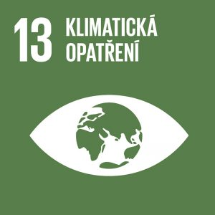
Climate action

Authors: Ludmila Handlířová, Iveta Strašáková
Keywords: Weather, climate, climate change, air, water, disease, health, recycling, environmental protection
Objective: Take urgent action to combat climate change and its impacts

We live in a time of climate emergency. Climate scientists warn that we are already dangerously close to tipping points that could lead to cascading and irreversible climate impacts. The climate crisis is caused by fossil fuels. The solution is renewable energy. Renewable energy is the peace plan for the 21st century.


Theoretical preparation

Weather is the instantaneous state of the atmosphere at a given place and time, the sum of meteorological phenomena and values.

Climate is the typical weather in a given area over a long period of time. It is mainly influenced by distance from the equator, altitude and distance from the ocean. Europe is heated by the warm Gulf Stream.

The Earth’s atmosphere is a layer of gases surrounding the planet Earth and is held in place by the Earth’s gravity. It contains approximately 78% nitrogen, 21% oxygen and 1% other gases.

Water in the atmosphere occurs in three states (water vapour, water droplets and ice crystals). Water vapour is crucial for the water cycle and energy transfer, affecting the formation of weather and climate. The atmosphere protects Earth life from dangerous solar and cosmic radiation and its thermal inertia reduces the temperature differences between day and night.

Greenhouse effect

However, the rapid development of human civilization and our population boom over the past 200 years have been linked to the development of energy-dependent technologies, which we obtain primarily by burning fossil fuels, mineral resources created from organic matter stored underground for millions of years. In this way, greenhouse gases are released into the atmosphere, changing its physical properties.
Greenhouse gases cause the so-called greenhouse effect. On the one hand, they let in solar radiation, which heats the Earth’s surface. On the other hand, they trap the heat radiation from the Earth’s surface so that it does not escape back into space. In this way, the Earth’s surface is protected from the inhospitable and life-threatening environment of space. However, the amplification of the greenhouse effect caused by increasing concentrations of greenhouse gases entering the atmosphere as a result of human activity is also leading to a dangerous overheating of the Earth.

Greenhouse gases occur in the atmosphere of the Earth or other celestial bodies and contribute most to the so-called greenhouse effect. The most important greenhouse gases of natural origin are water vapour, carbon dioxide, methane and nitrous oxide. It contributes up to one fourth of the total greenhouse effect (water vapour – max. 5%, CO₂ – 0.04%).
Climate change represents a change in the Earth’s long-term weather regime. The climate has been formed for many hundreds of millions of years. Over the past 10,000 years, thanks to the development of human civilization, the climate has been extremely stable, plants and algae have played and continue to play an important role (in the distant past they took large amounts of carbon dioxide from the air, enriched the air with oxygen and stored carbon in their bodies). The stored carbon turned into fossil fuel reserves, so-called coal, oil and natural gas. Over the past 10,000 years, green plants on the mainland and algae in the seas have consumed a lot of carbon dioxide from the atmosphere – in total, they have produced as much oxygen as has been consumed by the respiration and decomposition of living matter. The balance essential for a stable climate on Earth is now being disturbed by human activity.

Global warming vs climate change: Global warming (and cooling) refers to any change in average surface temperature and is only one manifestation of climate change. An increase in the average global temperature of the planet induces changes in the global circulation, causing different parts of the planet to warm differently; some areas may even cool down.
Climate change and health: The main impacts of climate change on health are related to extreme weather events, changes in the spread of climate-related diseases and changes in environmental and social conditions. River and coastal flooding has affected millions of people in Europe over the past decade. Related health effects include injuries, infections, exposure to chemical hazards and mental health impacts. Heatwaves are more frequent and intense, causing tens of thousands of premature deaths in Europe. This trend is projected to increase and intensify unless appropriate adaptation measures are taken. The spread of various tick species, the Asian tiger mosquito and other disease vectors increases the risk of Lyme disease, tick-borne encephalitis, West Nile fever, dengue fever, chikungunya disease and leishmaniasis.
Direct and indirect impacts of climate change on human health: Climate change will affect human health, either directly, through the physiological effects of heat and cold, or indirectly, through changes in human behaviour (e.g. forced migration, people spending more time outdoors, etc.), increased transmission of food-borne or vector-borne diseases, or other effects of climate change such as flooding. Recent decades have already seen an increase in some of these impacts in Europe.
Morbidity and mortality: Mortality and morbidity related to the constantly rising average annual temperatures and extreme heat are of greatest concern in Europe, although these problems are also linked to socio-economic changes caused by population growth, age distribution (Europe’s population is ageing) and other factors such as migration. The elderly, who have a reduced ability to control and regulate body temperature, are the most at risk population group for death due to heat stroke, cardiovascular events, kidney failure, respiratory and metabolic problems. While the total number of deaths is closely linked to the size of the population, the change in mortality rates may be much larger in areas where conditions for greater warming exist.
Foodborne diseases: In addition, the number of temperature-sensitive infectious diseases such as foodborne infections (Salmonella sp. and others) is likely to increase.
Diseases of bacterial, viral or parasitic origin: These are diseases that are transmitted to humans and animals by the bite or sting of infected vectors, such as insects, for example mosquitoes or ticks. According to the Intergovernmental Panel on Climate Change, climate change will lead to shifts in the transmission of infectious disease vectors, such as mosquitoes and ticks, due to variations in their geographical distribution, season of activity and population size. Changes in the distribution of ticks were also detected. In the EU, there has been a shift of the tick distribution boundary northwards and also to higher altitudes; milder winters can also lead to an expansion of tick populations and, as a consequence, put people at risk of Lyme disease and tick-borne encephalitis.
Water related questions: The increased incidence of water-borne diseases is attributed to high rainfall, which causes sewage flushing and thus pathogen mobilization or widespread water contamination. Lowering water levels in summer can increase the risk of bacterial and chemical pollution. Higher water temperature can also result in increased occurrence of harmful algae. Increased faecal bacteria contamination is likely to affect drinking water and water bodies used for recreation. In addition, the lack of adequate water used for routine hygiene that is essential for maintaining health (such as thorough hand washing) can contribute to a higher incidence of infectious diseases.
Air quality: Air pollution levels have declined significantly in Europe in recent decades, but still pose high health risks (particle concentrations and ozone). However, it is very likely that further potential increases in respiratory diseases and deaths will depend on the future air quality and climate (mitigation) measures.
Aero-allergens: It is possible that the seasonality and duration of allergic disorders (hay fever, asthma) will increase, which would lead to an increase in direct costs for health care, medication and loss of working time. Climate change affecting other health factors such as indoor and outdoor air quality, air pollution levels and the nature, intensity and timing of aero-allergens such as pollen and moulds can also lead to other indirect health impacts. The most vulnerable groups include children and the elderly. However, the most at risk group will be people who already suffer from chronic respiratory diseases such as asthma, severe allergies or chronic obstructive pulmonary disease.
Ultraviolet radiation: Higher ambient temperatures have already been shown to affect dressing and the length of time spent outdoors, which in some areas can lead to increased exposure to ultraviolet radiation (related to skin cancer).
Mental disorders: Disasters can have severe mental health impacts on the most vulnerable groups (children).

Manifestations of change in the world

Climate change in the world is manifested by the scarcity of fresh water, extreme weather events such as severe storms, downpours and increasingly frequent hurricanes with consequent flooding, forest fires, rising ocean levels, extinction of animal and plant species such as polar bears, penguins, water birds, koalas, and dead coral reefs, whose extinction affects the entire marine ecosystem.
Climate change and the future
We are now only at the beginning of a crisis situation which, without a fundamental change in our way of life, will continue to deepen and will drastically affect today’s young generation. Vast areas of the world will be flooded by the sea, turned into deserts, or made uninhabitable by high temperatures. Agriculture will be severely disrupted by other extreme weather events, including pest invasions. Extreme fires, similar to those now plaguing Australia and California, will be frequent. Devastating floods, landslides, or extreme storms and hurricanes will also become increasingly common. Hurricanes or tornadoes will not only increase in intensity and frequency, but will also increasingly occur outside their normal locations.
With a disrupted climate system, our food security will be at risk and famine will occur in many parts of the world. Millions or hundreds of millions of people will be on the move, trying to travel to places that will still be habitable. Other risks include chemical transformation of the oceans (acidification, loss of oxygen) incompatible with most marine life, rise in global sea levels and flooding of many coastal settlements, island states, as well as parts of arable land, acceleration of biodiversity loss and species extinction leading to ecosystem collapse, as well as pandemic spread of diseases.
What can we do with climate change
However, the current climate change differs both in speed and its cause, which is global change caused by human activity. Households account for about a quarter of all direct CO₂ emissions produced in the EU.

Energy and heating

In winter, it is better to put on more clothes instead of overheating, not to heat or light rooms where we do not spend time, buy energy-saving light bulbs and appliances, prefer air-drying to tumble-drying, use a fan rather than air conditioning in summer, reduce the amount of sunlight on hot days by closing curtains, blinds or shutters, and replace ordinary or halogen bulbs with more energy-efficient models.

Home energy saving

Turn the washing machine on when it is full, not when there are only a few pieces of laundry, choose the lowest suitable temperature. Today, washing powders are already so effective that they can wash clothes even at low temperatures. If possible, do not use a laundry dryer. One drying cycle can consume twice as much energy as an average washing cycle. Buy energy-efficient appliances. Many common products, such as fridges, dishwashers and cookers, have an EU energy label on them so you can choose an energy-efficient model. The markings range from A+++ (highest efficiency) to G (lowest efficiency). For example, an A+++ dishwasher uses half the energy of a D model. If you have a dishwasher, do not wash dishes by hand. Modern dishwashers consume less water and energy because most of them have an ‘eco’ function. Turn on the dishwasher when it is full. In a kettle, boil only as much water as you need. If some hot water is left in the kettle for only a few minutes, it does not need to be reheated.

Transport

Reduce the use of cars and aircraft to a minimum by using public transport (buses, trams, trains), choose cars on natural gas or electricity and avoid those powered by diesel, when people use a car, they should do it effectively, that is, to take as many people as possible.

Consumption and recycling

Reduce the number of the things you use and use what you already have for as long as possible, buy less, buy second-hand things more often, repair things, try to buy locally sourced things that are not transported over long distances, focus on buying or donating things with a small carbon footprint (home products, experiences).

Active protection of nature

If one has a garden, it is good to grow crops, take care of trees, keep the soil rich in nutrients, support soil life (the so-called living component of the soil – earthworms, insect larvae) and thus increase the ability of the soil to retain water and fix carbon, build birdhouses, insect hotels, get a beehive, retain water through ponds, retain rainwater, and set up green roofs.

Waste – energy is also consumed in the production and recycling of packaging

Buy as little packaging and disposables as possible, buy mostly primary crops that are not packaged, use reusable containers or bags (in shops, restaurant food or takeaway drinks), sort household waste, food scraps or vegetable waste should not end up in a landfill or incinerator but in a compost or brown bin.

Green jobs

Refuse to work for companies that contribute to climate and environmental devastation, choose a job where we can contribute to climate and environmental protection, actively seek to green the operations of the company or organisation you work for, reduce paper consumption, recycle, choose food with a lower carbon footprint, employees should not be forced to travel on unnecessary business trips and should be allowed to work remotely as much as possible.

Education and volunteering

Talk to people about the climate crisis and how to protect the climate (at home with parents, outdoors with friends, at school with classmates), set an example for others with your lifestyle and activities.

Foodstuff

Globally, food waste is a huge problem, with up to a third of food currently wasted. In developing countries, it is due to lack of storage capacity, in developed countries it is due to overconsumption and unnecessary throwing away of what people have bought but not eaten. Also, do not throw away food and choose mostly food that has a smaller carbon footprint (with the least emissions from production and transport). In most cases, local food is preferable to imported food.



Draft lesson plan
Estimated time: 45 min.
Lesson stage | Activity description | Teaching method | Teaching form | Time
Motivation | Mind map | Discussion | Mass, group | 5 min.
Exposure | Activity 1 – Matching concepts | Work with a text | Individual, discussion, presentation | 10 min.
Fixation | Worksheet | Worksheet, discussion | Individual, group, work with a text | 15 min.
Application | Activity 2 – Poster | Activation method | Group | 15 min.

Motivation

At the beginning, the teacher hands out a blank A4 sheet to each pair, draws a bubble in the middle of the board and writes ‘Climate Change and Health’ in large letters. The teacher asks students to draw an identical bubble on their papers. Then students work in pairs and try to come up with as many things as possible that relate to the topic of climate change. After 5 minutes, each pair reads out what they have written next to the bubble and the others listen carefully and tick off the things that they also have and then add things that have not been mentioned. In this way, we can see to what extent students are already familiar with the topic, but also ensure that they first think about the topic without any prior context that might limit their imagination.

Exposure
The motivation phase will be followed by Activity 1, in which students are first be asked to get up from their desks, walk around the classroom and find two categories of papers, one with terms describing the impacts of climate change on human health, the other with specific diseases that these impacts may be responsible for. Both categories of papers are placed in visible locations in the classroom. Students read them first and then try to find the correct pair for each concept and then write down the correct counterpart. They leave the papers in their place. When students are finished, the correct answers are be checked together and the teacher explains the concepts and other theory needed to understand the nature of climate change.

Fixation
During this stage, students are asked to complete the Worksheet focusing on climate change and its negative impacts on human health, as well as to suggest possible solutions to mitigate the impacts of climate change from an individual perspective. Exercise 1 includes a crossword puzzle including the concepts from the previous activity. In exercise 2, students select words related to climate change only in their country and list possible negative impacts on human health for each change. In exercise 3, they try to determine what climate change is. In exercise 4, students in pairs discuss what specific aspects of climate change affect human health and write the proposals. In exercise 5, students circle which groups of the human population could be more at risk from climate change than others. They again compare the answers in pairs and try to suggest possible reasons. In exercise 6, students determine whether these statements about climate improvement are true or false. In exercise 7, students try to come up with other true statements that are related to improving the climate and our health and that can be implemented at home.
Application
At the end of the lesson, as part of Activity 2, students work in groups of 4-5 to create posters on one of the topics (energy and heating, home energy saving, transport, consumption and recycling, active conservation, waste, food) that they are assigned. The poster should be interesting at first sight and should contain useful information on how students in the sector can act as individuals to combat climate change and mitigate its impact on human health. Each group then presents their posters to the class and after the lesson they can post them on the notice board to remind themselves every day of the importance of this topic and to remember their own role in fighting climate change and promoting health.



Worksheet: Negative impacts of climate change on human health:

Task 1: What does climate change contribute to when considering human health?
Answer questions 1-6, write the answers to the crossword according to the numbers to find out the solution.

- The proportion of sickness or of a specific disease in a geographical locality.
- Which parasite can transmit an infection to humans?
- What is one of the most common respiratory diseases?
- A liquid that constitutes rain, oceans, lakes, rivers, but also rainfall.
- One of the components that climate change has a negative impact on.
- The gaseous envelope surrounding the earth.
- What type of disorders can be triggered by disasters?

¹

²

³

⁴

⁵

⁶

⁷

Task 2: From the words below, select those that relate to climate change only in the Czech Republic and list them in the left column. In the right column, add for each manifestation how it can negatively affect human health.

Manifestations: Dead coral reefs, fresh water shortages, hurricanes, forest fires, penguin extinction, famine, chemical changes in the oceans, pandemic spread of disease, floods, bark beetles, landslides, forest disappearance

Climate change manifestations in your country
Negative impact on human health

_________________________ ___________________________

_________________________ ___________________________

_________________________ ___________________________

_________________________ ___________________________

_________________________ ___________________________

_________________________ ___________________________

_________________________ ___________________________

Task 3: Name the aspects of climate change is in the pictures.

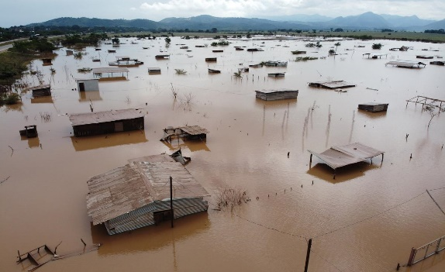
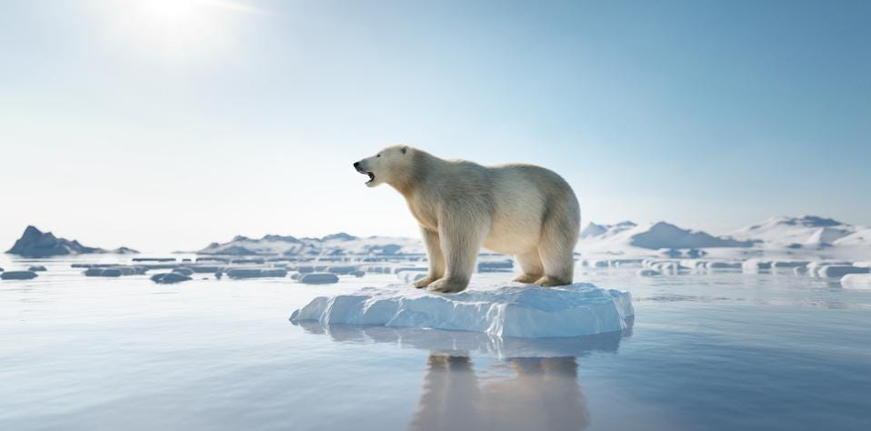

a) _______________________________ b) _______________________________

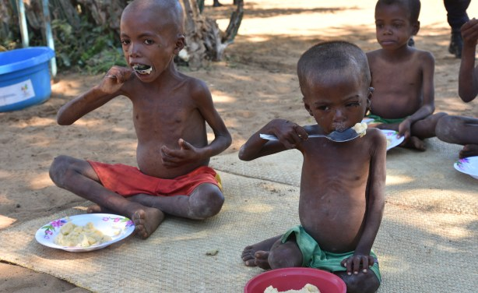
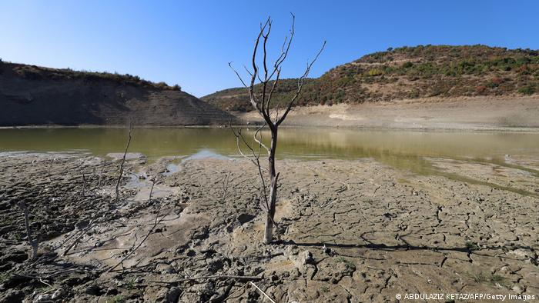

c)______________________________ d) _______________________________
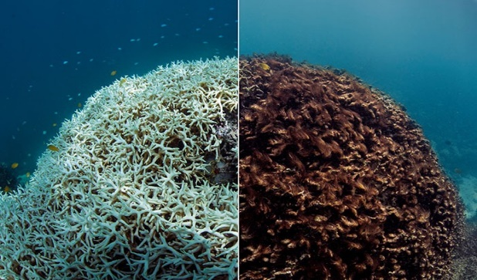
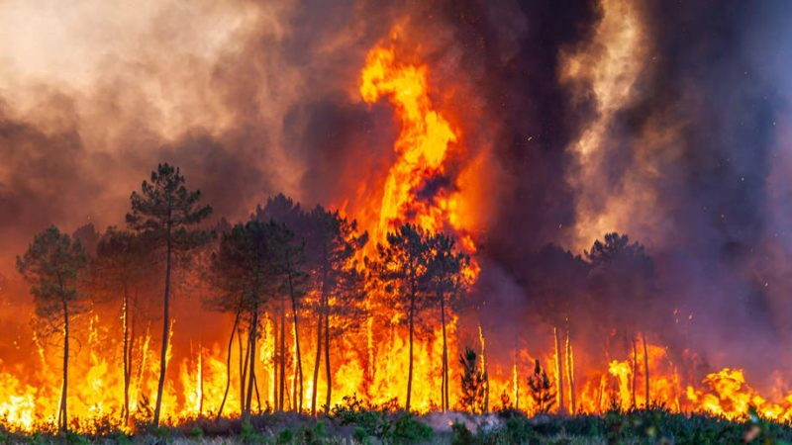

e) _______________________________ f) _______________________________

Task 4: Look at the pictures in the previous exercise and discuss with a classmate how these particular climate changes can affect our health. Summarize your ideas on the lines below.

Task 5: Circle which of the following human population groups are most vulnerable to climate change. Compare in pairs which groups you have selected and why.
People living on the coast
High-ranking people
People living in large cities
Pregnant women
Migrants
Socially weaker groups
Teenagers
Healthy people
Children
Middle-aged people
People with high immunity
People with chronic diseases
Ethnic minorities
People with low income
Seniors
People living in rural or remote communities

Task 6: Decide whether the statements below are true or false.

- To improve the climate, it is better to use air conditioning than a fan on hot days.
TRUE/FALSE

- No matter what bulbs we use, they all have the same effect on the climate.
TRUE/FALSE

- The washing machine should be switched on when it is sufficiently full.
TRUE/FALSE

- It is better to buy second-hand things or repair things.
TRUE/FALSE

- It does not matter whether we use a plane or a bus for transport.
TRUE/FALSE

- It is useful to build birdhouses and insect hotels.
TRUE/FALSE

- Throwing away food that we do not consume has no effect on the climate.
TRUE/FALSE

Task 7: Try to think of other true statements related to improving the climate and our health that you can implement in your own home.


Worksheet: Negative impacts of climate change on human health:

Task 1: What does climate change contribute to when considering human health?
Answer questions 1-6, write the answers to the crossword according to the numbers to find out the solution.

- The proportion of sickness or of a specific disease in a geographical locality.
- Which parasite can transmit an infection to humans?
- What is one of the most common respiratory diseases?
- A liquid that constitutes rain, oceans, lakes, rivers, but also rainfall.
- One of the components that climate change has a negative impact on.
- The gaseous envelope surrounding the earth.
- What type of disorders can be triggered by disasters?

¹  M | O | R | B | I | D | I | T | Y
 |  |  |  | ²  T | I | C | K
 |  |  |  | ³  A | S | T | H | M | A
 |  | ⁴  W | A | T | E | R
 |  |  |  |  | ⁵  A | I | R
 | ⁶  A | T | M | O | S | P | H | E | R | E
 |  |  |  | ⁷  M | E | N | T | A | L

Task 2: From the words below, select those that relate to climate change only in your country and list them in the left-hand column. In the right column, add for each manifestation how it can negatively affect human health (these examples refer to the Czech Republic, adapt them to your country).

Manifestations: Dead coral reefs, fresh water shortages, hurricanes, forest fires, penguin extinction, famine, chemical changes in the oceans, pandemic spread of disease, floods, landslides, forest disappearance

Climate change manifestations in your country
Negative impact on human health

For example: Injuries; own solution
Hurricanes
_________________________ ___________________________
For example: Respiratory problems; own solution
Forest fires
_________________________ ___________________________
For example: Lack of medical supplies; own solution
Pandemic spread of diseases
_________________________ ___________________________
For example: Water pollution – insufficient hygiene; own solution
Floods
_________________________ ___________________________
For example: Loss of natural habitat for wildlife – destruction of the ecosystem; own solution
Disappearance of forests
_________________________ ___________________________
For example: Injuries, destruction of dwellings; own solution
Landslides
_________________________ ___________________________

Task 3: Name the aspects of climate change is in the pictures.

Melting glaciers, extinction of polar bears
Floods
a)_______________________________ b) _______________________________

Famine
Dryness
c)_______________________________ d)_______________________________

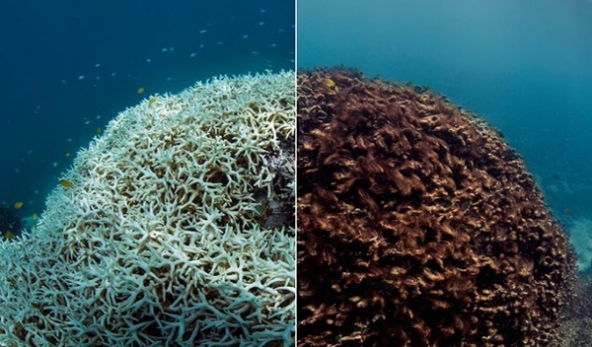

Dead coral reefs
Forest fires
e)_______________________________ f)_______________________________

Task 4: Look at the pictures in the previous exercise and discuss with a classmate how these particular climate changes can affect our health. Summarize your ideas on the lines below.

Own solution

Task 5: Circle which of the following human population groups are most vulnerable to climate change. Compare in pairs which groups you have selected and why.

People living on the coast
High-ranking people
People living in large cities
Migrants
Socially weaker groups
Teenagers
Pregnant women
Children
Healthy people
Middle-aged people
People with high immunity
People with chronic diseases
Ethnic minorities.
Seniors
People with low income
People living in rural or remote communities

+Own solution

Task 6: Decide whether the statements below are true or false.

- To improve the climate, it is better to use air conditioning than a fan on hot days.
TRUE/FALSE

- No matter what bulbs we use, they all have the same effect on the climate.
TRUE/FALSE

- The washing machine should be switched on when it is sufficiently full.
TRUE/FALSE

- It is better to buy second-hand things or repair things.
TRUE/FALSE

- It does not matter whether we use a plane or a bus for transport.
TRUE/FALSE

- It is useful to build birdhouses and insect hotels.
TRUE/FALSE

- Throwing away food that we do not consume has no effect on the climate.
TRUE/FALSE

Task 7: Try to think of other true statements related to improving the climate and our health that you can implement in your own home.

Own solution


Activity 1: Climate change as a cause of disease

There are two categories of papers around the classroom, one with terms containing the impacts of climate change on human health, the other with specific diseases that these impacts may be responsible for. The task for students is to find the right counterpart for each concept and write it down. Students leave the papers with the concepts in their place. Once students have finished, the teacher tells the whole class the correct answers, which they write down in their notebooks and explain the concepts in the context of the next theory.
Ultraviolet radiation – skin cancer
Air pollution – respiratory diseases
Disasters – mental disorders
Aero-allergens – hay fever, asthma
Drinking water pollution – infectious diseases
Diseases of bacterial, viral or parasitic origin – Lyme disease
Extreme heat – heatstroke
Food infections – salmonella
1. Ultraviolet radiation | Skin cancer
2. Polluted  air | Respiratory diseases
3. Disasters | Mental disorders
4. Aero-allergens | Hay fever, asthma
5. Drinking water pollution | Communicable diseases
6. Diseases of bacterial, viral or parasitic origin | Lyme disease
7. Extreme heat | Heatstroke
8. Food infection | Salmonella

Activity 2: Save your planet!

Make groups of four. Each group is assigned one topic – Energy and heating, home energy saving, transport, consumption and recycling, active protection of nature, waste, food. The task of each group is to create a poster that is both engaging and contains useful information about how we as individuals can act to combat climate change and mitigate its impact on human health. Each group presents its poster in front of the class, or students can place them on the board.

References:
European Commission | Choose your language | Choisir une langue | Wählen Sie eine Sprache [online]. Copyright ©0T [cit. 16.10.2022]. Retrieved from: https://ec.europa.eu/health/ph_threats/climate/docs/com_2009-147_cs.pdf
[online]. Copyright © [cit. 16.10.2022]. Retrieved from: https://ekoskola.cz/_files/userfiles/Materialy/9-Klimaticke-zmyny.pdf
13. Přijmout bezodkladná opatření na boj se změnou klimatu a zvládání jejích dopadů – OSN Česká republika. OSN Česká republika – Poskytujeme informace o činnosti a prioritních cílech organizace, včetně specializovaných agentur a programů. [online]. Retrieved from: https://www.osn.cz/sdg-13-prijmout-bezodkladna-opatreni-na-boj-se-zmenou-klimatu-a-zvladani-jejich-dopadu/
RVP ZV - Rámcový vzdělávací program pro základní vzdělávání - edu.cz. edu.cz - Jednotný metodický portál MŠMT [online]. Copyright © 2022 [cit. 16.10.2022]. Retrieved from: https://www.edu.cz/rvp-ramcove-vzdelavaci-programy/ramcovy-vzdelavacici-program-pro-zakladni-vzdelavani-rvp-zv/
Co dělat - Klimatická koalice. Klimatická koalice - Klimatická koalice [online]. Retrieved from: https://klimatickakoalice.cz/co-delat/?fbclid=IwAR1NsqINj1paLAeELTRvYCy_A7103Y0nuSe2z-To0SiBiGJW_k-C90OlNiY#sppb-addon-wrapper-1586350116681
Co můžete proti změně klimatu udělat vy u sebe doma. Redirecting to /select-language?destination=/node/1 [online]. Retrieved from: https://climate.ec.europa.eu/citizens/climate-tips/tips-your-home_cs?fbclid=IwAR1JFcnQbzNybf24IPu-ZB7a8x5U7f1c9rrq8oi3aAB2YqJtBl5-7Mne2ig
Klimatická změna. Fakta o klimatu [online]. Copyright © 2022 Otevřená data o [cit. 16.10.2022]. Retrieved from: https://faktaoklimatu.cz/temata/klimaticka-zmena?fbclid=IwAR2IBCP8-sF8y6BSh_0w0AFOl65KrQm47MoXYIYF0pYOH8oSDDTH6sAkBbY
Fakta - Klimatická koalice. Klimatická koalice - Klimatická koalice [online]. Retrieved from: https://klimatickakoalice.cz/fakta/?fbclid=IwAR2v0PH-2KhdMf6pnBD3hMzQqJexwGhfuRRACfMhzHmASMipLeZC2_-Dgj8#budouci-projevy
Co je klimatická změna?: Ekologický institut Veronica. Ekologický institut Veronica [online]. Copyright © [cit. 16.10.2022]. Retrieved from: https://www.veronica.cz/co-je-klimaticka-zmena?fbclid=IwAR3AitsBF4LSu8kkWZgsgN2Y0_2Iu0hKw3pfigdxOer7Osbx1efyo2AvAsE
AMO.cz - Asociace pro mezinárodní otázky [online]. Copyright © [cit. 16.10.2022]. Retrieved from: https://www.amo.cz/wp-content/uploads/2019/06/AMO_Boj-s-klimatickou-zmenou_AMO_web.pdf?fbclid=IwAR2IBCP8-sF8y6BSh_0w0AFOl65KrQm47MoXYIYF0pYOH8oSDDTH6sAkBbY
nadhernl/globální oteplování. [online]. Retrieved from: https://web.vscht.cz/~nadhernl/chi/globalni_oteplovani.html
Klimatická změna – Wikipedie. [online]. Retrieved from: https://cs.wikipedia.org/wiki/Klimatick%C3%A1_zm%C4%9Bna
Skleníkový efekt – Wikipedie. [online]. Retrieved from: https://cs.wikipedia.org/wiki/Sklen%C3%ADkov%C3%BD_efekt
[online]. Retrieved from: https://www.eea.europa.eu/cs/highlights/zmena-klimatu-prinasi-stale-zavaznejsi
Úvodní stránka - Ministerstvo životního prostředí [online]. Copyright © [cit. 16.10.2022]. Retrieved from: https://www.mzp.cz/C1257458002F0DC7/cz/zmena_klimatu_adaptacni_strategie/$FILE/OEOK-Adaptacni_strategie-20151029.pdf

Pictures:
https://allafrica.com/view/group/main/main/id/00078059.html?fbclid=IwAR0S8Gl8NXyAydfqoT8OAHQ-FWOC_tcNoA8MwFKo6DwkBcG3TPp6PaEI3_g
https://www.dw.com/en/middle-east-running-out-of-water/a-60509788?fbclid=IwAR3nTbkGB1zX6WBDl42xdN0XiJp4zQWZgKRI11gFJfLcnOKT4oM8HXWyG6U
https://www.euractiv.com/section/energy-environment/news/fires-in-south-west-france-spiral-out-of-control/?fbclid=IwAR0gOTS-F9WdZvi47uA_w_QAMXhSt4TNiqiXBk7NPWTnROvNHif3_RCgDDI
https://www.lutheranworld.org/content/climate-change-and-human-rights?fbclid=IwAR1YqJ-12Gx3ucqOtYIYtUb-PwubbSud8ZoH4H_uq_vmdPNAqphFuIw2NOg
https://www.forbes.com/sites/edwardsegal/2022/01/01/heres-how-climate-change-crisis-could-impact-business-operations-and-policies-in-2022/?sh=541ead815689&fbclid=IwAR1NsqINj1paLAeELTRvYCy_A7103Y0nuSe2z-To0SiBiGJW_k-C90OlNiY
https://thebulletin.org/2016/10/a-changing-climate-for-coral-reefs/?fbclid=IwAR3dKcayjqZ_2nYBvIt1dTO5KwEcFL-JCMOuJU_h2oMx4bdTdWeMkSKKEeI

