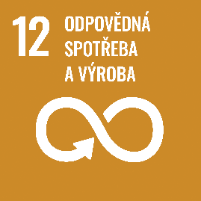
Responsible consumption and production

Author: Kristýna Matoušková
Keywords: Sustainability, waste, food, food production, food imports, water, water consumption, soil, air, chemicals, pesticides, fossil fuels, environmental pollution and health, waste reduction, world hunger
Objective: Ensure sustainable consumption and production patterns
If the world’s population reaches 9.6 billion in 2050, it will take about three Earths to have the natural resources needed to sustain current lifestyles. The aim is to manage natural resources sustainably and reduce food waste by half. Today, we throw away or otherwise waste a third of all food produced. If people around the world switched to energy-efficient light bulbs, we would save 120 billion USD.

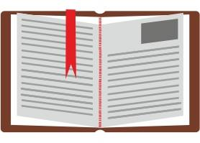
Theoretical preparation
For the purpose of introducing sustainability in relation to students’ daily activities, we use the topic of food waste because it is a topic that affects everyone and all households. We buy, consume (and throw away) food every day. Some of us can even produce food – grown at home, on the balcony or in the garden.
Facts about waste production
In 2020, a total of 2,151,000 tonnes of waste was generated in EU countries, an average of 4.8 tonnes of waste per capita. Of this, 39.2% was recycled and 31.3% was landfilled. In the Czech Republic, every citizen produces 3,598 tonnes of waste per year on average. The countries that produce the most waste are Finland (20.9 tonnes/person), Bulgaria (16.7 tonnes/person), Sweden (14.6 tonnes/person), Luxembourg (14.6 tonnes/person) and Estonia (12.1 tonnes/person). On the other hand, the least waste is produced by Hungary (1.6 tonnes/person), Portugal (1.6 tonnes/person), Latvia (1.5 tonnes/person), Croatia (1.5 tonnes/person), Kosovo (1.5 tonnes/person), Turkey (1.3 tonnes/person) and North Macedonia (0.7 tonnes/person).
The ratio of recovered waste to landfilled waste has been increasing positively since 2004. Compared to 2004, 40.3% more waste was reused. The most common forms of recovery are sorting for further use (39.2%), backfilling (14.6%) and energy production (6.4%). In the Czech Republic, half of the waste is sorted, more than a third is used for generating energy, the rest is burned without further use, and the least waste is used for backfill (Eurostat, 2022).
Food waste:
The total amount of food waste is estimated at 1.6 trillion tonnes. Of this, 1.3 trillion tonnes is edible food. This waste represents 3.3 trillion tonnes of CO₂ in the form of greenhouse gases sent into the atmosphere. 28% of the world’s agricultural land is used annually for food that is thrown away or destroyed. In developing countries, most food is wasted during agricultural production, while in developed countries, most food is wasted during sales and in households (FAO, 2013).
World hunger and nutrition:
1.9 trillion adults are overweight, while 462 million are undernourished. About 45% of deaths in children under 5 years of age are caused by malnutrition. These cases occur mainly in developing countries (WHO, 2022).
Unfortunately, data show that on current trends, world hunger will not be ended by 2030; instead, the situation is now worsening. The number of undernourished people on the planet increased from 8.4% in 2019 to 9.9% in 2020, i.e. one in ten people. As many as 811 million people faced hunger in 2020. In the long term, however, the number of undernourished people has been declining since 2005, especially in Asia. The situation in Africa and South America has improved over the years, but the current situation is very similar to that of 2005.
In addition to food shortages, one in three people do not have access to adequate quality food, resulting in a lack of essential nutrients such as vitamins and minerals. This situation is caused by, among other things, rising prices, low incomes, higher costs of healthy food and, more recently, the Covid-19 pandemic. For this reason, 22% of children are stunted, 6.7% are malnourished and 5.7% are overweight. Conflicts, economic inequality, epidemics and climate extremes have a major negative impact on the nutritional status of the population and world hunger. Most children affected by malnutrition and inadequate growth live in regions and countries that also exhibit several of the above-mentioned factors affecting the nutritional status (FAO, 2021).
Water consumption in food production:
The most water-intensive foods are animal products, and in some cases exotic crops such as cocoa or coffee.
Product | Water requirement (l) to produce 1 kg | Country of origin of the data
Potatoes | 174 | Czech Republic
Peaches | 1348 | Czech Republic
Onions | 270 | Czech Republic
Chickpea | 2732 | Czech Republic
Sugar | 920 | International average
Beans | 1585 | Czech Republic
Peas | 1050 | Czech Republic
Grapes | 790 | Czech Republic
Pears | 205 | Czech Republic
Apples | 257 | Czech Republic
Strawberries | 723 | Czech Republic
Goat meat | 5521 | International average
Corn | 606 | Czech Republic
Chicken meat | 4325 | International average
Poppy seeds | 1168 | Czech Republic
Raspberries | 685 | Czech Republic
Butter | 5553 | International average
Cow milk | 1020 | International average
Carrots | 163 | Czech Republic
Cucumbers | 278 | Czech Republic
Sheep meat | 10412 | International average
Oats | 989 | Czech Republic
Peppers | 203 | Czech Republic
Wheat | 946 | Czech Republic
Tomatoes | 235 | Czech Republic
Rape | 2324 | Czech Republic
Lettuce | 323 | Czech Republic
Sunflower seeds | 1836 | Czech Republic
Soya | 2451 | Czech Republic
Dried milk | 4745 | International average
Cheese | 5060 | International average
Spinach | 146 | Czech Republic
Veal meat | 15415 | International average
Cherries | 547 | Czech Republic
Eggs | 3265 (1 egg = 196) | International average
Pork meat | 5988 | International average
Walnuts | 3661 | Czech Republic
Rye | 685 | Czech Republic

(Mekonnen, M.M. and Hoekstra, A.Y., 2011; Mekonnen, M.M. and Hoekstra, A.Y., 2010)
Environmental pollution caused by food production:
The production of greenhouse gases in food production can come from various sources. However, food is the source of 26% of all greenhouse gases produced and thus accounts for a significant amount of them, which has an impact on the environment and global warming. Of these, livestock production, growing crops for livestock production and land use for livestock production contribute the most (52%). 29% of emissions come from growing crops directly for human consumption. The remaining 18% comes from crop processing, transport, packaging and sales. Transport is generally a negligible source of emissions in terms of food production. However, transporting food by air is many times more emissions-intensive than other modes. The least demanding transport is by water, then by rail and road (Poore, J., & Nemecek, T., 2018). In the EU, 14% of greenhouse gas production comes from the use of artificial fertilisers, 3% from natural fertilisers, 24% from faeces, 22% from methane emitted by animals, 6% from transport and 30% from land management (Sandström, V., Valin, H., Krisztin, T., Havlík, P., Herrero, M., & Kastner, T., 2018)
78% of water pollution (rivers, lakes, seas) is caused by nutrient-rich substances from agriculture. The most production-intensive crops in terms of land use are generally livestock products, and in some respects cocoa. Dietary changes can lead to a reduced carbon footprint, especially when animal products are reduced (Poore, J., & Nemecek, T., 2018). Of the total number of animals on earth (excluding humans), 94% are livestock (Bar-On, Y. M., Phillips, R., & Milo, R., 2018).
Health consequences of environmental pollution (not only) due to food production:
Environmental pollution affects the health of the human population in several areas. This includes air, water and soil pollution.
Air pollution can cause serious health problems, especially in the elderly and children. In 2019, 307,000 children died prematurely in Europe due to air pollutants (European Environment Agency, 2022).
In extreme cases, air pollution can result in respiratory diseases, impaired immune status, reproductive disorders, tumour incidence, coughing, burning eyes, breathing difficulties, worsening of difficulties in chronically ill people, increased morbidity from respiratory diseases, chronic lymph node changes and effects on growth parameters, and increased mortality in people who are weakened by chronic respiratory and cardiovascular diseases (SZÚ, 2005)
Other risks arise from water pollution. More than 2 trillion people live in areas with limited or no access to drinking water. Water is often contaminated with chemicals, mostly animal excrements. There is also an increasing risk from water contaminated with microplastics and pesticides, substances commonly found in the food production and distribution cycle. Contaminated water can cause diseases such as cholera, diarrhoea, polio, parasitic diseases and others. 485,000 people die annually from diarrhoeal diseases (WHO, 2022).
Artificial pesticides in soil and water have negative effects on human health and the environment. Some types of pesticides can contribute to or cause infertility, cancer, premature infant death, organ failure, hyperactivity in children, birth defects, bronchitis and other diseases. Serious air pollution in a particular area can result in many deaths both in the short term and in the long term (Nicolopoulou-Stamati P, Maipas S, Kotampasi C, Stamatis P, Hens L., 2016; B., A., & C., N., 2011).
Projects that focus on reducing food waste in the Czech Republic:
‘Nesnězeno’ is an app used to save food just before it expires or to sell food that has not been sold in restaurants on a given day. The app, which must be installed on a mobile phone, shows businesses in the area that have not managed to sell all their food on a particular day. The remaining meals are offered with a minimum discount of 30% (https://nesnezeno.cz/).
‘Zachraň jídlo’ is an organisation working to change the fact that up to a third of all food in the world is thrown away. It works for changes in the food donation system, organizes awareness campaigns, happenings and offers educational workshops in companies. The organization has also published a cookbook that focuses on saving food in the kitchen, and is active, for example, in collecting vegetables or fruits that do not meet the appearance or shape requirements of supermarkets (https://zachranjidlo.cz/)
References:
B., A., & C., N. (2011). Pesticides and Human Health. In (Ed.), Pesticides in the Modern World - Effects of Pesticides Exposure.
Bar-On, Y. M., Phillips, R., & Milo, R. (2018). The biomass distribution on Earth. Proceedings of the National Academy of Sciences, 115(25), 6506-6511.
European Environment Agency (2022). Air pollution: how it affects our health. Retrieved from: https://www.eea.europa.eu/themes/air/health-impacts-of-air-pollution
Eurostat (2022). Waste statistic. Retrieved from: https://ec.europa.eu/eurostat/statistics-explained/index.php?title=Waste_statistics#Total_waste_generation
FAO (2013). Food wastage footprint, Impact on natural resources: Summary report. Retrieved from: https://www.fao.org/3/i3347e/i3347e.pdf
FAO (2021). The state of food security and nutrition in the world 2021. Retrieved from: https://www.fao.org/3/cb4474en/online/cb4474en.html
FAO. (2011). The state of the world’s land and water resources for food and agriculture (SOLAW) – Managing systems at risk. Food and Agriculture Organization of the United Nations, Rome and Earthscan, London.
Mekonnen, M.M. & Hoekstra, A.Y. (2010). The green, blue and grey water footprint of crops and derived crop products. Value of Water Research Report Series No.47, UNESCO-IHE.
Mekonnen, M.M. & Hoekstra, A.Y. (2011). The green, blue and grey water footprint of crops and derived crop products. Hydrology and Earth System Sciences, 15(5): 1577-1600.
Nesnězeno. Nesnězeno [online]. Retrieved from: https://nesnezeno.cz/
Nicolopoulou-Stamati P, Maipas S, Kotampasi C, Stamatis P, Hens L. (2016). Chemical Pesticides and Human Health: The Urgent Need for a New Concept in Agriculture. Front Public Health, 18;4:148.
Poore, J., & Nemecek, T. (2018). Reducing food’s environmental impacts through producers and consumers. Science, 360(6392), 987-992.
Sandström, V., Valin, H., Krisztin, T., Havlík, P., Herrero, M., & Kastner, T. (2018). The role of trade in the greenhouse gas footprints of EU diets. Global Food Security, 19, 48-55.
SZÚ (2005). Faktory zevního prostředí, vliv na zdraví, prevence. Retrieved from: http://www.szu.cz/uploads/documents/czzp/manual/Manual%20souhrn-2.pdf
WHO (2022). Drinking-water. Retrieved from: https://www.who.int/news-room/fact-sheets/detail/drinking-water
WHO (2022). World health statistics 2022, monitoring health for the SDGs, sustainable development goals. Retrieved from: https://www.who.int/publications/i/item/9789240051157
Zachraň jídlo. Zachraň jídlo [online]. Retrieved from: https://zachranjidlo.cz/

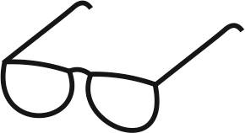
Draft of the 12th teaching lesson

Estimated time: 45 min.
Teaching stage | Activity description | Teaching method | Teaching form | Time
Motivation | - Activity 1 – Creation of a mind map based on pictures  - Discussion, additional questions of the teacher concerning the mind map | Discussion, brainstorming, activation | Group, frontal | 10 min.
Exposure | - Watching a video https://www.youtube.com/watch?v=IqfD3p8Fn-g  - Clarification of any issues arising from the video  - Worksheet, exercises 1-4 – students work in pairs  - Checking of the worksheet, exercises 1-4 | Video, working with the worksheet, checking of the worksheet, discussion | Frontal, group (pairs) | 20 min.
Fixation | - Activity 2 – Projects and organizations that help reduce food waste – Creation of a poster in groups  - Brief presentation of the project  - Revision | Internet work, group work, presentation | Group, frontal | 15 min.
Application | - Worksheet: homework – What do I throw away? | Activation | Individual

Motivation
At the beginning of the lesson, the teacher prints out the pictures in sufficient size (Activity 1 – Creation of a mind map) and places them on the board, or the pictures can be projected using a data projector. The mind map will also be created on the board. The teacher writes the topic of the lesson ‘Food waste’ on the board in the middle and gives students time to look at the pictures and write their thoughts on the board. Students can consult their ideas in pairs or groups.
The teacher then reads what is written on the board and asks additional questions about the words or sentences and develops a discussion with students. It is advisable to choose questions depending on how the discussion in the class develops. Here are some examples of questions that can be used:
What is most wasted in the world? What makes up most of your waste at home? What do you throw away most often? Why do you throw it away? How can you prevent throwing food away? How is food waste reflected in our health? What are the consequences of overproduction and waste? Why are we talking about food? What is the journey of food before it reaches our table? Why is so much food wasted? Do you also waste food?

Exposure
In the main part of the lesson, use Worksheet 12 a UN video (https://www.youtube.com/watch?v=IqfD3p8Fn-g). First, the teacher plays the video. After watching the video, the teacher gives room for questions. Then students work in pairs on tasks 1-4 from the worksheet, the teacher walks around the classroom and observes how students are doing and looks for possible problems. Once the tasks have been completed, the worksheet is checked and the teacher completes the worksheet with an explanation of information that was not mentioned in the video or is unclear to students, or if the teacher notices that it causes problems.
Fixation
The teacher divides students into 4 groups and explains Activity 2 – Projects and organisations that help reduce food waste. Students are given the name of one organisation that is working to reduce food waste in their country – in the Czech Republic, for example, Nesnězeno and Zachraň jídlo. Students search for information about various organizations on the internet, they also have links to short videos and social networks related to the organizations Nesnězeno and Zachraň jídlo. Students write down the basic information about these organizations and describe how they help to meet the UN goal of reducing food waste. They will use the information to create a simple poster which they can then display in the classroom. Students in groups then briefly introduce some of these organizations. Groups with the same organization take turns and complement each other.

Find organizations that are working to reduce food waste in your country.
In the Czech Republic for example:
Zachraň jídlo: https://www.youtube.com/watch?v=2BlDIhGDD9s, https://www.youtube.com/watch?v=xqaCWcLzDiw (4:14)
Nesnězeno: https://www.youtube.com/watch?v=RIFrl26IO-4

Tip for the teacher: It is advisable to choose organizations that are active in students’ place of residence. Ideally in the nearest city. You can select a larger number of organizations so that each group has a different theme.
After posters are presented, the teacher briefly repeats the basic information from the lesson and, if there is enough time, asks students questions to briefly summarize the important information from the whole lesson.

Application
The teacher assigns homework – exercise 5 in Worksheet 12. During the following week, pupils write in a table what food they threw away, how much they threw away and estimated price of the food that they threw away. After completion of the table, students answer two additional questions. In the next lesson, the teacher revises the homework with students in the form of discussion.


Worksheet 12 – FOOD WASTE
1. Write down the journey of food (meat) from production to consumption. Get inspired by the pictures below. (Source of pictures: pixabay.com)
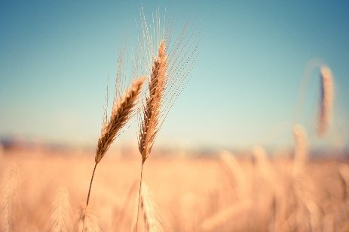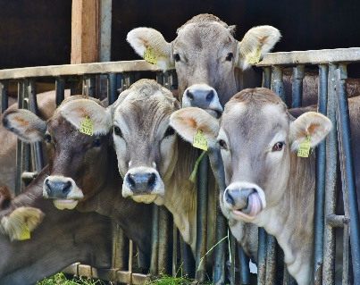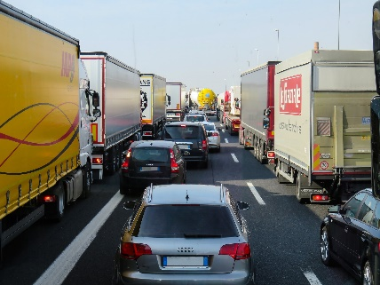
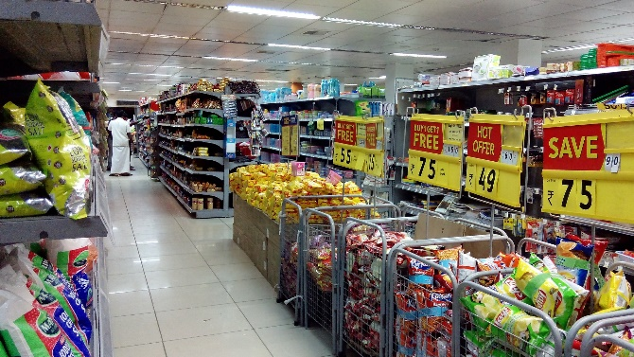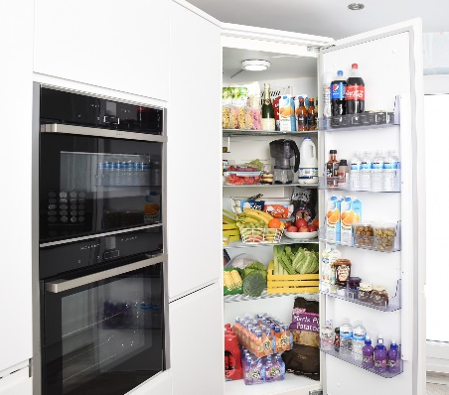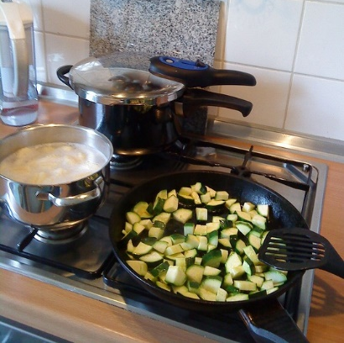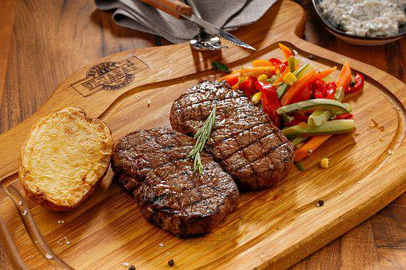
______________________________________________________________________________________________________________________________________________________________________________________________________________________________________________________________________________________________________________________________________________________________
- How can we ensure that the food we eat is not transported all over the world?
____________________________________________________________________________________________________________________________________________2. Water consumption – try to guess how much water is needed to produce the following foods:
1 kg of apples
1 kg of pork meat
1 kg of potatoes
1 kg of chocolate
1 l cow milk
1 egg
1 kg of sugar
17,196 litres of water
196 litres of water
5,988 litres of water
257 litres of water
1,020 litres of water
920 litres of water
174 litres of water

3. Food waste and health. What diseases can be caused by environmental pollution due to food production?
Air pollution from fossil fuel combustion and non-renewable energy production:
________________________________________________________________
Soil and water full of pesticides and other chemicals:
________________________________
4. What can we do to avoid throwing food away?
________________________________________________________________________________________________________________________________________________________________________________________________________________________________________________________________________________________________________________________________________________________________________________________________________________________________________________________________________________________________________________________________________________________________________________

5. Homework – What do I throw away?
Food thrown away | Amount of food | Price of food | Why did I throw it away? | Comments

- Was it necessary to throw it away? Why?
____________________________________________________________________
____________________________________________________________________
____________________________________________________________________

- Was it possible to prevent throwing food away? How?
____________________________________________________________________
____________________________________________________________________
____________________________________________________________________

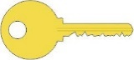
Worksheet 12 – FOOD WASTE
1. Write down the journey of food (meat) from production to consumption. Get inspired by the pictures below. (Source of pictures: pixabay.com)
Students can write for example the following: To obtain meat, it is first necessary to grow grain and other crops to feed the animals. This requires a lot of soil, water and also fertilizers or pesticides. When the animal grows to the desired size and age, it must be killed. The meat is then packaged and transported to supermarkets. It needs to be stored at a low temperature, which requires a lot of energy. Then the meat is cooked or baked, which also requires energy.
______________________________________________________________________________________________________________________________________________________________________________________________________________________________________________________________________________________________________________________________________________________________
- How can we ensure that the food we eat is not transported all over the world?
Consume locally produced food.

____________________________________________________________________________________________________________________________________________2. Water consumption – try to guess how much water is needed to produce the following foods:
1 kg of apples
1 kg of pork meat
1 kg of potatoes
1 kg of chocolate
1 l of cow milk
1 egg
1 kg of sugar
17,196 litres of water
196 litres of water
5,988 litres of water
257 litres of water
1,020 litres of water
920 litres of water
174 litres of water

3. Food waste and health. What diseases can be caused by environmental pollution due to food production?
Air pollution caused by the burning of fossil fuels and the production of energy from non-renewable sources: respiratory diseases, impaired immunity, reproductive disorders, tumours, coughing, burning eyes, breathing difficulties, etc.
Soil and water full of pesticides and other chemicals: infertility, cancer, premature death of children, organ disorders, hyperactivity in children, birth defects, bronchitis, etc.
4. What can we do to avoid throwing food away?
________________________________________________________________________________________________________________________________________________________________________________________________________________________________________________________________________________________________________________________________________________________________________________________________________________________________________________________________________________________________________________________________________________________________________________
Buy food that you like; buy only as much food as you eat; store food properly; check expiry dates, etc.

5. Homework – What do I throw away? – OWN SOLUTION
Food thrown away | Amount of food | Price of food | Why did I throw it away? | Comments

- Was it necessary to throw it away? Why?
____________________________________________________________________
____________________________________________________________________
____________________________________________________________________

- Was it possible to prevent throwing food away? How?
____________________________________________________________________
____________________________________________________________________
____________________________________________________________________

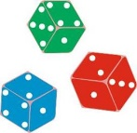
Activities for students

ACTIVITY 1: Creation of a mind map
At the beginning of the lesson, the teacher prints out the pictures in sufficient size (Activity 1) and places them on the board, or the pictures can be projected using a data projector. The mind map will also be created on the board. The teacher writes the topic of the lesson ‘Food waste’ on the board in the middle and gives students time to look at the pictures and write their thoughts on the board. The teacher then reads what is written on the board and asks additional questions about the words or sentences and develops a discussion with students. It is advisable to choose questions depending on how the discussion in the class develops. Here are some examples of questions that can be used:
What is most wasted in the world? What makes up most of your waste at home? What do you throw away most often? Why do you throw it away? How can you prevent throwing food away? How is food waste reflected in our health? What are the consequences of overproduction and waste? Why are we talking about food? What is the journey of food before it reaches our table? Why is so much food wasted? Do you also waste food?
Tip for the teacher: If students work better in groups and do not like to come to the front of the classroom, make groups of 4-5 students to discuss the topic in 5 minutes. Then the spokesperson of each group reads out the points the group has come up with.
Pictures on the board:
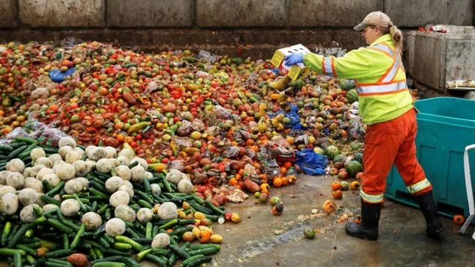https://www.rcinet.ca/en/2021/03/06/new-report-provides-numbers-on-how-much-food-is-wasted-in-canada/

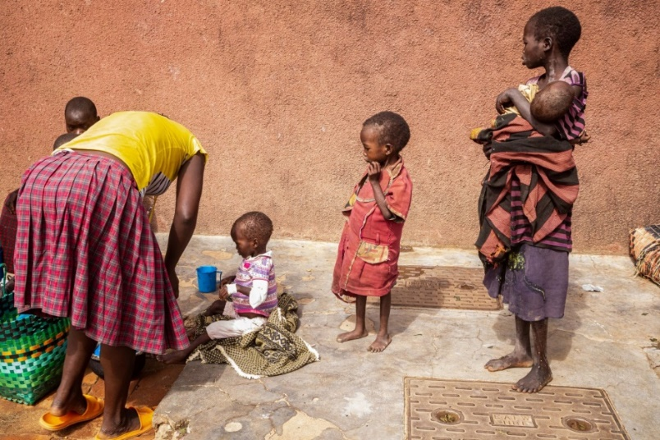
https://www.aljazeera.com/gallery/2022/6/15/photos-hunger-killing-children-in-forgotten-corner-of-uganda
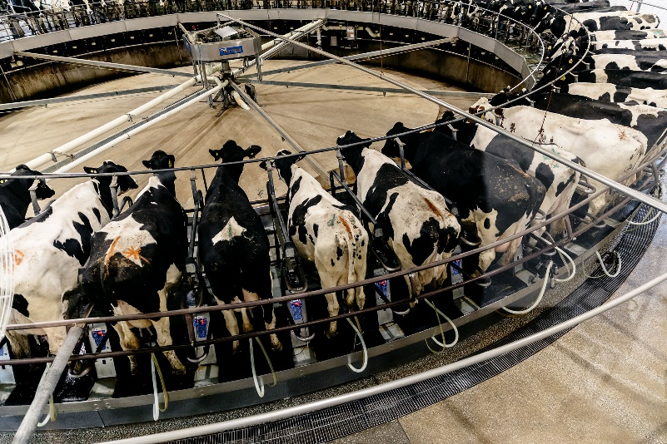
https://www.bloomberg.com/news/features/2020-02-28/the-dairy-farm-of-your-imagination-is-disappearing
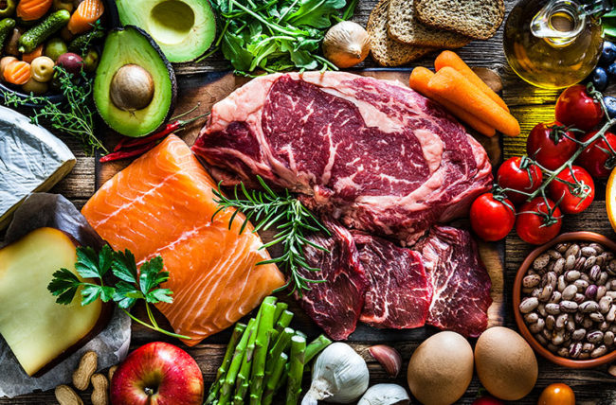
https://health.clevelandclinic.org/allergy-or-intolerance-how-to-tell-the-difference/
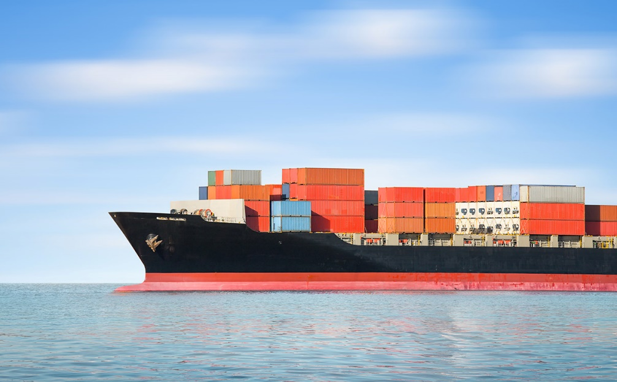
https://www.alimentarium.org/en/fact-sheet/transporting-food

ACTIVITY 2: Projects and organizations that help reduce food waste
The teacher divides students into 4 groups and explains the next activity. Students are given the name of an organization that is working to reduce food waste in their country. Students search for information about various organizations on the internet, they also have links to short videos and social networks related to the organizations. Students write down the basic information about these organizations and describe how they help to meet the UN goal of reducing food waste. They will use the information to create a simple poster which they can then display in the classroom. Students in groups then briefly introduce some of these organizations. Groups with the same organization take turns and complement each other.
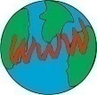
Zachraň jídlo:
https://zachranjidlo.cz/
https://www.youtube.com/watch?v=2BlDIhGDD9s, https://www.youtube.com/watch?v=xqaCWcLzDiw (4:14)
Nesnězeno:
https://nesnezeno.cz/
https://www.youtube.com/watch?v=RIFrl26IO-4

