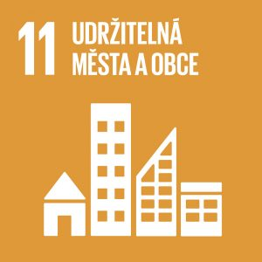
Sustainable cities and communities

Authors: Kristýna Drábková, Tereza Dohnalová
Keywords: Air pollution, smog, air quality, waste, landfill, recycling

Objective: Make cities and human settlements inclusive, safe, resilient and sustainable

People have been moving from rural to urban areas for a long time. Today, almost 60% of people live in cities. Cities and metropolitan areas are drivers of economic growth. Their share of global GDP is approximately 60%. At the same time, they produce around 70% of global carbon emissions and consume more than 60% of global resources. According to WHO, 99% of the world’s urban population breathes polluted air.


Theoretical preparation
Almost half of humanity (3.5 billion people) live in cities. Although cities occupy only 2% of the Earth’s surface, they use 60 to 80% of its energy and produce 75% of its greenhouse gas emissions. Rapid urbanisation places high demands on drinking water supplies, sanitation, the environment and the health system.
The main sources of air pollution in cities are transport, related processes and emissions from small sources.

Air pollution

The effect of air pollution on human health
The health effects of air pollutants depend on the amount of pollutants in the air and the length of time people are exposed to them. The occupation and lifestyle of individuals also have an influence as concentrations vary in different locations and environments.
Pollutants enter the human body through the respiratory system. The effects are acute, sub-chronic to chronic, and late according to the time it takes for subjective discomfort and objective signs of disease to appear. These effects can be local or general.
The occurrence of acute effects depends on the composition of the substances contained in the inhaled air. The effects of these pollutants on the respiratory tract lining are influenced by their solubility in water, including body fluids. The region of exposure is influenced, for example, by the presence of dust aerosol and the size of the particles that make up the aerosol.
If harmful substances come into contact with the respiratory tract lining, a burning sensation, irritation, reflex coughing and bronchoconstriction may occur. Prolonged exposure to these substances causes functional changes in surface cells, e.g. changes in ciliary activity, increased production of mucous glands, etc. The effects on the body may include, but are not limited to, effects on lung function. Consequently, this may lead to a decrease in the vital capacity of the lungs and prolonged expiration. Other functions may also be affected.

Selected harmful substances and their effect on human health
Sulphur dioxide is released into the air when fossil fuels, especially coal, are burned. It has an irritating effect on the respiratory tract lining. Sensitivity to sulphur dioxide considerably varies between healthy individuals and asthmatics. Through irritation and increased mucus production, the airways narrow and this causes an increase in breathing resistance. Almost always, the organism is affected by the simultaneous action of sulphur trioxide and sulphate anion, which are formed from sulphur dioxide by reactions in the air. These substances are more irritating than sulphur dioxide.
Dust aerosol enters the air from natural sources and human activities (transport, industry). Its effects on the body vary according to the size of the particles. Particles between 100 and 10 µm are usually trapped in the upper respiratory tract, while particles smaller than 10 µm enter the lower respiratory tract. Smaller particles are partly removed and partly stored in the body. Therefore, the self-cleaning mechanisms of the lungs are under increased pressure. Particles smaller than 2.5 µm reach the lung chambers. Dust particles also contribute to the transport of gaseous pollutants, which are better transported to the lower respiratory tract. The effects of dust can be irritant, toxic, fibrogenic, genotoxic or carcinogenic depending on the composition and the substances adsorbed.
Carbon monoxide enters the air through combustion processes. The main mechanism of action is the formation of carboxyhaemoglobin, which limits the oxygen-carrying capacity of the blood. In the case of acute poisoning, headaches, dizziness, heart problems and malaise occur. Carbon monoxide also binds to other proteins and different symptoms occur depending on the organ affected. If concentrations are lower, cardiovascular and neurological disorders may occur. Higher concentrations are particularly dangerous for individuals sensitive to oxygen deficiency (pregnant women, developing foetus, young children, anaemic patients) and those with chronic cardiovascular or respiratory diseases. The level of COHb in the blood should not exceed 2.5%.
Small amounts of ozone occur naturally in the air after a storm or in mountainous areas. There are no significant sources of ozone. However, ozone in the ground layer of air is created by human activity. It causes irritation of the conjunctivas and the respiratory tract. If its concentrations are higher, irritation causes the airways to constrict. Short-term exposure to ozone causes significant lung function impairment along with respiratory and other symptoms such as coughing, dry throat, increased mucus production, chest pain, fatigue and nausea. Prolonged exposure to ozone results in increased hospital admissions for respiratory reasons and sudden worsening of asthma. People with chronic obstructive lung disease and asthma are more sensitive to ozone. It appears that women are likely to be more sensitive to ozone than men, and also children and adolescents compared to the elderly.

Smog
The word smog (smoke + fog) was originally used to describe heavily polluted air under certain meteorological conditions in winter. The term winter smog is currently used. It forms mainly in autumn and winter in the morning hours in industrial areas. The main components of the pollutant mixture are sulphur oxides and dust particles.
Later, the term smog started to be used for critical air pollution typical of the summer season. Summer (photochemical) smog is composed of nitrogen oxides and hydrocarbons, which come mainly from car exhaust fumes. When solar radiation is strong, ground-level ozone, aldehydes and peroxyacyl nitrates are formed. The tricky thing about summer smog is that it forms on hot summer days. Its concentration peaks in the afternoon, when most people spend time outdoors and are unaware of summer smog because it does not look like the traditional ‘fog and smoke’.
Smog can cause eye irritation to conjunctivitis, inflammation of the airways, increased asthma attacks and respiratory problems, more deaths and, with frequent recurrence, reduced life expectancy. Risk groups are mainly young children, the elderly, asthmatics, cardiac patients and people with reduced immunity.

Air quality in the Czech Republic
For health and environmental reasons, systematic monitoring of air pollution by measuring the most common pollutants has been introduced almost worldwide. The results of the measurements are then used to assess the level of pollution, to define measures to be followed by operators of pollution sources and their subsequent control, to assess health risks, etc.
Special air pollution limits (alert limits) are used to protect against pollution levels which, if exceeded, could cause immediate damage to health or the ecosystem. Air quality is regularly reported by the Czech Hydrometeorological Institute. If a smog situation occurs, the air protection authorities (i.e. the Ministry of the Environment, regional and municipal authorities) must inform the public.
The most polluted areas in the Czech Republic are North Moravia, North Bohemia and Prague. Higher concentrations of pollutants can also occur in the immediate vicinity of busy roads and around local sources of pollution. In winter, there may be temporarily higher levels of air pollution anywhere (e.g. in small villages with many local heating systems with low chimneys, especially in combination with poor dispersion conditions).

What to do in poor air quality
A person who lives in a place with poor outdoor air quality should focus on strengthening the body’s overall non-specific immunity, especially by means of:
- a healthy diet with enough vitamins and other protective factors
- an adequate daily regimen with enough sleep
- non-smoking and careful consumption of alcoholic beverages
- adequate fitness and mental well-being
It is not recommended to do sports activities near roads with heavy car traffic or around chemical factories.
If people live in areas with poor outdoor air quality, they should try to support community programmes aimed at reducing pollution. They should also contribute to improving the situation through their behaviour, e.g. by not using stoves to burn household waste containing plastic.
Prolonged smog can have negative effects on the health of chronically ill people (chronic bronchitis, asthma, cardiovascular diseases). People under 5 and over 70 years of age are particularly at risk. The following recommendations are intended especially for these groups:
- Limit staying outdoors, especially from 6 am to 10 am and from 4 pm to 8 pm.
- When staying outdoors, do not engage in excessive physical activity that would lead to increased pulmonary ventilation.
- Do not practice physical education and sports in outdoor sports areas.
- Ventilate rooms where people are present by opening windows for short periods (3 to 5 minutes) but not more than 3 to 4 times a day.
- Do not stay in smoky rooms, do not smoke in living rooms.
- Do not use products with organic solvents and sprays with propellants.
- Do not carry out painting and similar activities that increase the need for ventilation.
- Do not use fireplaces, do not burn any materials on open fires, do not burn garbage in stoves.
- Limit car rides.
- Do not overheat living rooms; instead, lower the heating temperature in living rooms by at least 2°C compared to the normal level.
Municipalities, towns and their residents could implement the following measures.
- Reduce local heating with solid fuels and replace it with gas, electricity or district heating.
- Reduce air pollution from industrial and commercial establishments (consistent support from air inspection authorities).
- Restrict burning of domestic and industrial waste in open spaces, in gardens, in domestic heating installations and in incinerators not designed for this purpose.
- Appropriate traffic organisation, reducing traffic congestion in residential areas.
- Dust-free road surfaces, sprinkling streets and pavements, paving or grassing of dusty areas and landfills, etc.
- Measures to reduce dust during construction activities, excavations, etc.
It is important to take care not to create excessive fear or even panic in the population. For some people, this fear could be more harmful than airborne pollutants.

Waste
Waste is generated by virtually everything humans do (industry, construction, agriculture, transport, everyday life). Due to their specific characteristics and the different risks to the environment, each waste stream needs to be treated separately. In the Czech Republic, the basic rules for waste management are laid down in Act No. 541/2020 Coll., on waste and its implementing legislation.
In waste management, waste records are kept to provide detailed information on waste production and management in accordance with European regulations. These records are also used for regular evaluation of waste management and as a basis for administrative and control activities.
In the Czech Republic, according to the Waste Catalogue (https://www.katalogodpadu.cz/#top), there are 20 types of waste, e.g. waste from inorganic chemical processes, waste from the photographic industry, construction and demolition waste or municipal waste.
Increased attention should be paid to the so-called hazardous waste. This can harm both human health and the environment. Hazardous waste can have a negative impact at the place where it is generated, transported or treated, in particular during disposal. These include, for example, polychlorinated biphenyl (PCB) waste, infectious waste from health and veterinary care, mercury-containing waste or waste including hazardous chemicals, mainly from manufacturing processes. These wastes must have at least one hazardous characteristic (indicated by the letters HP and a number). A total of 15 hazardous properties are determined (e.g. HP 1 = explosive, HP 2 = oxidizing, HP 3 = flammable, etc.). These include toxicity, carcinogenicity, mutagenicity, infectivity, ecotoxicity, etc.
Municipal waste is (according to Act No. 541/2020 Coll. on waste) mixed and sorted waste from households, e.g. paper, cardboard, glass, metals, plastics, biological waste, wood, textiles, waste electrical and electronic equipment, etc. It also includes mixed and segregated waste from other sources if similar in nature and composition to household waste. The municipality becomes the generator of this waste from the moment the individual deposits waste in a place designated by the municipality for this purpose. The municipality must take over all municipal waste generated on its territory during the activities of non-business individuals and is obliged to designate sites for separate collection of municipal waste. The municipality can provide these places by means of collection bins for sorted waste, by bag collection or by designating a place for disposal of individual components of municipal waste within a collection yard. The separately collected components of municipal waste include hazardous waste, paper, plastics, glass, metals, biological waste and edible oils and fats. From 1st January 2025, this will also apply to textiles.

Waste disposal
In order to be environmentally friendly, it is important to separate all waste produced. Mixed waste that is not sorted then ends up in landfills or incinerators (waste-to-energy facilities – WtE), where it serves as an energy source. This process is called waste energy recovery (WER). It converts mixed or residual waste into thermal or electrical energy. Modern incinerators are proving to be less harmful to the environment than generally assumed. According to current findings, they are safer and more environmentally friendly than coal-fired power plants, heating plants or home burning stoves. In modern incinerators, residues from incineration (slag and ash) are also treated. Disposal of mixed waste through incinerators is thus a preferable option to landfilling.
If landfills are used to dispose of mixed waste, strict rules must be followed. Landfill can only be established in sites with suitable geological subsoil and must be isolated. Landfills must not endanger the environment or human health. Depositing waste in landfills is a paid service. This is one of the reasons why people, municipalities and companies should take care to sort their waste to reduce residual waste and save money.

Impact of landfills on the environment
(A properly established and managed landfill should adequately cover these risks.)
- Physical risks
  - organic compounds in landfill gas – dichloromethane, benzene, vinyl chloride, toulene, xylenes, ethylbenzene, etc.
  - heavy metals – Cr, As, Cd, Cr, Hg, Pb
  - dust
  - microbial pathogens in the air at landfills and waste containers, higher concentrations of microorganisms (fungi, moulds, bacteria) have been detected – e.g. in Italy approx. 2.5x higher values
  - pests, vermin, insects
  - inorganic substances (hydrogen sulphide=H2S)
  - increased traffic, increased probability of accidents
  - fires and explosions
- Psychosocial risks
  - quality of life – nuisance factors such as smells all year round, waste flying into windows, in gardens, birds flying over landfill, noise, dust, mud, dirt, traffic, working hours
  - psychological factors – concerns, stress
- Economic factors
  - landfills create a minimum of jobs
  - decreased prices of land and real estates
- Environmental factors
  - greenhouse gas emissions
  - risk of groundwater contamination
  - wasting resources as opposed to minimising and recycling
Recycling
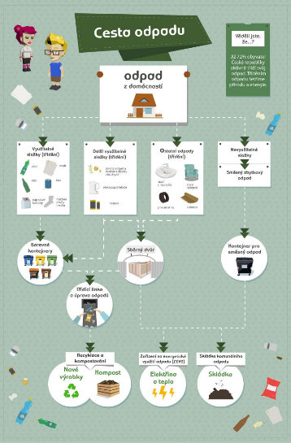
Recycling is a process that enables the production of new products from sorted waste or parts of waste that can be further processed. In this process, secondary raw materials are used to produce new products. Paper, plastics, glass, metals, beverage cartons, bulky waste, hazardous waste and biological waste (or otherwise recyclable components)can be sorted.
Source: https://www.samosebou.cz/2017/08/11/co-je-likvidace-odpadu/
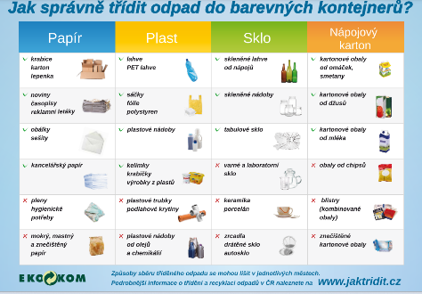
Source: https://www.jaktridit.cz/uploads/pdfka/co_kam.pdf

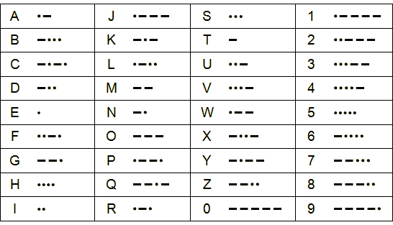

Source: https://militaryrange.com/novinka-historie-morseovy-abecedy--1

References:
https://www.osn.cz/sdg-11-vytvorit-inkluzivni-bezpecna-odolna-a-udrzitelna-mesta-a-obce/
http://www.szu.cz/uploads/documents/chzp/souhrnna_zprava/SZU_Report_19.pdf
http://www.szu.cz/uploads/documents/czzp/manual/Manual%20souhrn-2.pdf
https://www.mzp.cz/cz/odpady_podrubrika
https://www.samosebou.cz/2017/08/11/co-je-likvidace-odpadu/
https://www.komunalniekologie.cz/info/v-cem-jsou-skladky-pro-zivotni-prostredi-nebezpecne
https://www.samosebou.cz/2017/08/11/co-je-likvidace-odpadu/


Draft lesson plan

Estimated time: 45 min.
Teaching stage | Activity description | Teaching method | Teaching form | Time
Motivation | - Activity 1 – Clustering | Activation | Individual | 5 min.
Exposure | - Air pollution  - Worksheet, exercise 1, 2  - Video  - https://www.youtube.com/watch?v=e6rglsLy1Ys  - Worksheet, exercise 3  - Waste, landfills  - Worksheet, exercise 4, 5 | Presentation, using a worksheet, activation | Frontal  Individual / group | 25 min.
Fixation | - Activity 2 – Discussion web | Discussion | Mass | 12 min.
Application | - Activity 3 – Monitoring air quality  - Waste collection in the countryside or in the city | Activation | Individual | 3 min.

Motivation
At the beginning of the lesson, students carry out clustering, which is similar to free writing or mind maps (see Activity 1 - Clustering).
Exposure
In the main part of the lesson, the teacher gives students background information on the topic of the lesson. Next, students work on the exercises (exercises 1, 2) from the Worksheet. The solutions are continuously checked with the teacher. Then students watch a video about air pollution and then they work on exercise 3 in the Worksheet and check it with the teacher. This is followed by the teacher’s explanation of the topic of waste and waste management. After that, students work on exercises 4 and 5 in the Worksheet and check it again.
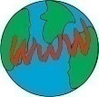
Video about air pollution:
https://www.youtube.com/watch?v=e6rglsLy1Ys (3:52)

Tip for the teacher: For exercise 2, it is advisable to give students Morse code for time reasons. If there is enough time, it is possible to discuss with pupils how they heat their homes, whether they sort their waste, etc.

Fixation
Students discuss the Disposable Plastics Act through a discussion web (see Activity 2).
Tip for the teacher: The teacher should first find out if students are aware of the Disposable Plastics Act.

Application
For the weekend, students’ task is to monitor how air quality changes in their country. They will record the data.
They will also look at whether they sort waste at home and whether they sort it correctly. They can also go for a walk in the countryside or in the city and collect, for example, a bag of waste. They will then sort the waste (be careful to follow the safety rules, e.g. use protective gloves).


Worksheet – ENVIRONMENTAL POLLUTION

1. Write what health problems a person can have if exposed to polluted air for a long time.
2. Discover harmful substances in polluted air hidden in Morse code.
a) .../..-/.-../.--./..../..-/.-.// -../../---/-..-/../-.././/

b) -../..-/.../-// .-/./.-./---/.../---/.-..//

c) -.-./.-/.-./-.../---/-.// --/---/-./---/-..-/../-.././/

d) ---/--../---/-././/

3. Correct the false statements:

- It is recommended to play sports near roads with heavy car traffic.

- People should not burn waste in stoves at home.

- We distinguish between autumn and winter smog.

- With prolonged smog, we should not go outside at all.

- Air quality is reported by the Czech Hydrometeorological Institute.

4. Circle the correct options:
Unsorted waste is processed in:
- landfill
- garbage truck
- incineration plant
5. Sort the following waste correctly:


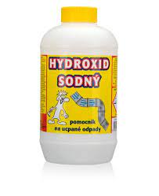
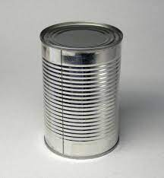

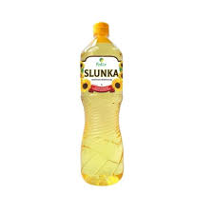

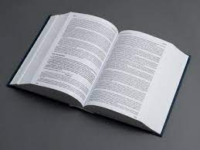
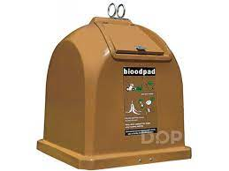
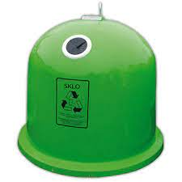
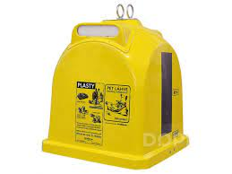
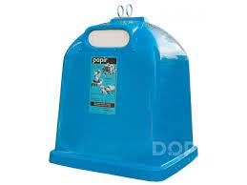

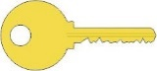
Worksheet – ENVIRONMENTAL POLLUTION
1. Write what health problems a person can have if exposed to polluted air for a long time.
difficulty breathing, eye irritation, coughing, dry throat, burning sensation in the airways,
bronchoconstriction (shortness of breath), conjunctivitis, airway inflammation, asthma attack
2. Discover harmful substances in polluted air hidden in Morse code.
a) .../..-/.-../.--./..../..-/.-.// -../../---/-..-/../-.././/
sulphur dioxide
b) -../..-/.../-// .-/./.-./---/.../---/.-..//
dust aerosol
c) -.-./.-/.-./-.../---/-.// --/---/-./---/-..-/../-.././/

carbon monoxide
d) ---/--../---/-././/

ozone
.
3. Correct the false statements:

- It is recommended to play sports near roads with heavy car traffic.
It is not recommended to play sports near roads with heavy car traffic.

- People should not burn waste in stoves at home.
Correct.

- We distinguish between autumn and winter smog.
We distinguish between winter and summer smog.

- With prolonged smog, we should not go outside at all.
It is only recommended to limit staying outside.

- Air quality is reported by the Czech Hydrometeorological Institute.
Correct.

4. Circle the correct options:
Unsorted waste is processed in:
- landfill
- garbage truck
- Incineration plant
5. Sort the following waste correctly:



Activities for students

ACTIVITY 1: Clustering
Students write the term ‘environmental pollution’ in the middle of the paper and make a circle around it. Immediately after writing the term on any space on the paper, they write words that come to their minds. The moment they no longer have any associations, they come back to the term. They circle around it with a pencil until another association comes to mind. This first phase takes about 2 to 3 minutes. This is followed by a logical classification of terms. Students circle the words that belong together with the same colour and connect them with lines. This creates a map of related connections.
Tip for the teacher: Students can then compare their associations in pairs and discuss their ideas.

ACTIVITY 2: Discussion web
Each student writes the following question at the top of the paper: ‘Is the approval of the Disposable Plastics Act the right thing to do?’ Under the question, students split the paper in two sections. They write ‘yes’ arguments in the left column and ‘no’ arguments in the right column. Each student comes up with two ‘yes’ arguments and two ‘no’ arguments. All four arguments need to be justified. Then students exchange their opinions with their neighbour. Any students’ ideas shall be written on the paper. Students do the same in fours (exchange arguments and add ideas to their list).
Students are then divided into two groups according to their preference for ‘yes’ or ‘no’ arguments. Each group writes down its views, reads them in turn and then defends them under the pressure of the other groups’ comments and arguments.
Finally, students consider whether they want to stay in their group or move to another group if they have changed their minds. Each student then writes which opinion they are inclined to and why. However, students also take into account the need to respect the views of others.

Tip for the teacher: Before starting this activity, the teacher should determine the rules of the discussion together with students. The teacher should be prepared to help if it is necessary to stir up discussion among students. At the same time, however, the teacher should not interfere too much, as long as the discussion takes place according to the set rules.

ACTIVITY 3: Monitoring air quality
On Saturday and Sunday, students will monitor how (or if at all) air quality changes in the Czech Republic. They will always record air quality data in the morning, afternoon and evening. They will also look at what parts of the country are experiencing any changes and try to think about why this is happening.
Find a website where you can monitor air quality in your country:

For example, the following is available in the Czech Republic:
https://www.chmi.cz/aktualni-situace/stav-ovzdusi/prehled-stavu-ovzdusi

Students can also go for a walk in the forest, in their town or village and pick up waste they find along the way.

(12)

https://www.osn.cz/sdg-11-vytvorit-inkluzivni-bezpecna-odolna-a-udrzitelna-mesta-a-obce/
http://www.szu.cz/uploads/documents/chzp/souhrnna_zprava/SZU_Report_19.pdf
http://www.szu.cz/uploads/documents/czzp/manual/Manual%20souhrn-2.pdf
https://www.mzp.cz/cz/odpady_podrubrika
https://www.samosebou.cz/2017/08/11/co-je-likvidace-odpadu/
https://www.komunalniekologie.cz/info/v-cem-jsou-skladky-pro-zivotni-prostredi-nebezpecne
https://www.samosebou.cz/2017/08/11/co-je-likvidace-odpadu/

