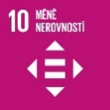
Reduced Inequalities

Authors: Tereza Maxerová, Marcela Lukášíková
Keywords: Discrimination, gender imbalance, inclusion in education, inclusion in employment, developing countries, migration policy

Objectives: Reduce inequality within and among countries
Some people have enough of everything, others do not even have the means to buy enough food or medicine. A fair world means that everyone has access to basic needs. Such a world is also safer.
The aim is to reduce inequalities within and among countries and to promote the social, economic and political inclusion of all.


Theoretical preparation
Between 1990 and 2010, income inequality in developing countries increased by an average of 11 percent (taking into account population size). A significant majority of households in developing countries (more than 75%) now live in societies where incomes are even more unequally distributed than in the 1990s. Children in the poorest 20 percent of the population are still three times more likely not to live to be five years old than children in the richest fifth of the population. Globally, social protection systems have improved significantly, but people with disabilities, for example, are still up to five times more likely to spend huge sums on healthcare. Despite an overall decline in maternal mortality in most developing countries, women in rural areas are up to three times more likely to die in childbirth than women in urban areas (UN, 2022).

Discrimination
Discrimination means unequal treatment of a person. It violates the person’s rights based on what his/her believes or who he/she is. Everyone has the right to equal treatment, regardless of nationality, race, ethnicity, gender, gender identity, age, status or health status (Diskriminace, undated). Nevertheless, tens of thousands of people in the Czech Republic face discrimination every year. People most often face discrimination when looking for a job. According to a 2015 questionnaire survey involving 2,079 respondents, about 66% of them had experienced difficulties in finding a job or at work (38%), mainly due to their older age or gender. However, the vast majority who had personal experience with discrimination never complained or resigned. This was due to the lack of confidence that their problem could be solved thanks to the relevant organisations and authorities, or they were discouraged by insufficient evidence and information. People do not know where to turn to with their complaints and are often prevented from reporting by shame or fear of retaliation. People who have experienced some form of discrimination are reluctant to revisit the subject because it is psychologically challenging and can leave them feeling that they are not full part of society and that it is not worth pursuing further. Older people do not want to resolve these situations through legal means, they do not have the finances or the energy that would certainly be needed to resolve these cases, and of course fear the consequences. Seniors in particular are at risk of discrimination. According to judges, inspectors and representatives of NGOs, other vulnerable groups are employees (especially of large private companies), people with low education levels and members of various minorities (Ochránce.cz, 2015).
Gender inequality
Gender inequality refers to unequal distribution of men and women in different positions. On 7th June 2022, the European Council and the European Parliament reached political agreement on new EU legislation to promote gender balance in management and supervisory bodies. Listed companies* should aim to have at least 40% of non-executive, supervisory board positions held by under-represented gender by 2026. While progress has been made in this area, development in the Member States has been uneven and slow. Women make up around 60% of graduates in the EU and are under-represented, especially in senior positions.
*listed companies = companies whose registered office is in a Member State and whose shares are admitted to trading on a regulated market in one or more Member States (Gender Balance on Corporate Boards, 2022).

Inclusion in education
An inclusive school accepts all children regardless of their race, ethnicity, religion or social situation and educates them individually according to their needs. This education has its principles. The teacher adapts the teaching process to the needs of the child. It is not just integration as in mainstream schools. Focus is on the quality of education and the benefits for both parties are emphasised.
The figure below shows the difference between integration in mainstream schools and inclusion in inclusive schools:
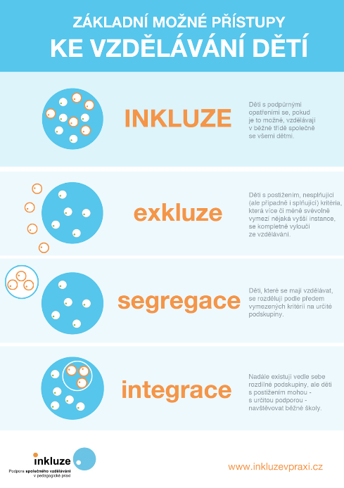
The principles of inclusive education include for example:
- Children are educated with their peers
- Attention is paid to the promotion of relationships between children
- Education takes place in catchment schools
- Included children and their classmates benefit from learning together (Inkluze.cz, undated)
- All learners are equally important
- Learners are involved in the school culture, the learning process and the community
Inclusive education therefore seeks to optimally educate children with disabilities, impairment and risks in the conditions of mainstream schools and educational institutions (Inkluze v praxi - Co je inkluze, undated).
Inclusion in employment
Supported employment agencies are concerned with the full integration of people into the open labour market. They support people with disabilities, both mental and combined. They teach them how to find their way to an employer who values their work. These agencies teach them related skills such as making phone calls, travelling or negotiating with the authorities. After getting a job, they help with on-the-job training in the form of job assistance (Začlenění v zaměstnání – Inkluze.cz, undated).
Developing countries
A developing country is characterised by an economy with a large agricultural component, low industrialisation and various economic problems. Although countries differ from each other, they exhibit a number of characteristics. These include:
- political instability
- low living standards, but higher than in underdeveloped countries
- high unemployment rate
- high level of crime
Migration policy
Migration policy emphasises the security aspects of migration. Migration policy strategies must lead to strengthening positive phenomena and reducing negative phenomena and potential risks. Priority topics include integration of foreigners, illegal migration and return policy, international protection, support measures of a humanitarian or assistance nature, free movement of persons within the EU, Schengen cooperation and interconnection with the migration policies of other EU countries. The migration strategy of the Czech Republic seeks primarily to respond to the current debate on these issues and the clear position of the Czech Republic. It also seeks to raise awareness of migration issues among the wider public. Based on the principles of the strategy, the Ministry of the Interior cooperates with other ministries.

Selected principles of the migration strategy:
- The Czech Republic has an obligation to ensure peaceful coexistence of its citizens with foreigners through effective integration, and to prevent the emergence of negative social phenomena.
- Meet its asylum commitments and ensure the capacity of the system.
- Strengthen activities to help refugees abroad, preventing further migration flows, and support countries in managing migration crises.
- Promote the benefits of free movement of people within the EU and the Schengen area
- Support legal migration.
- Actively engage in European debates and seek common solutions (mvcr.cz, undated).

Health risks of migration
Health risks differ mainly depending on the country from which migrants and refugees leave. Often, migrants are in good health in the country where they lived. The problem arises in transport or accommodation in the new country due to poor living conditions. In some refugee camps, capacity is completely exhausted, people live there at the expense of adequate hygiene, and infectious diseases are common. Nowadays, there is a problem with the spread of Covid-19 in refugee camps in Greece. Lice, scabies and bedbugs can also occur in refugee camps. These parasites cannot be effectively eliminated if there is insufficient hygiene in camps or other facilities (ct24, 2019; lekaribezhranic, 2020). It is also worth noting that non-infectious diseases are often present in lower numbers among refugees than in native populations. But if refugees live in poverty in a new country, their risk of cancer, stroke, type II diabetes or cardiovascular disease increases. The main contributors to chronic non-infectious diseases are poor diet and lifestyle changes such as less physical activity. Migrants and refugees are also more likely to suffer from depression and anxiety. Unfortunately, unaccompanied minors are often subjected to sexual abuse (ct24, 2019).
As far as infectious diseases are concerned, according to the WHO and the Chief Hygiene Officer of the Czech Republic, there is no cause for concern when people migrate to the Czech Republic and other countries. With the influx of new people, we are not experiencing any dangerous epidemics. Millions of tourists visit the Czech Republic every year. Most of the visitors came from Germany, Russia and China. It is true that one of the few real threats to the Czech Republic is the emergence of multidrug-resistant tuberculosis from the East. In our country, tuberculosis is no longer vaccinated due to very low numbers. But if someone has an outbreak of this resistant form of tuberculosis, it is very difficult to treat (Zdravotnický deník, 2015).
People from Ukraine are the most important group in terms of health risks because they are the largest minority in our country. They are not vaccinated for tuberculosis, which is why many cases in the Czech Republic are Ukrainians. Not only are they not vaccinated for tuberculosis, there are also cases of polio with paralysis in Ukraine. Only 50 percent of children are vaccinated for common childhood diseases. Back in 2008, the vaccination rate was 80%. Nowadays, about a third of Ukrainian parents oppose vaccination because of a false report about a boy’s death, which the media falsely linked to rubella and measles vaccination. It is not only the refusal to vaccinate that results in low vaccination rates, but also the failure of the drug supply, corruption in the health sector and war conflict, i.e. the economic situation (Zdravotnický deník, 2015). The Czech Republic publishes an annual report on HIV prevalence in the Czech Republic. There was an increase in the number of newly diagnosed HIV-positive persons in 2022 (292 newly diagnosed persons in 2022 and 233 newly diagnosed persons in 2021) due to the war in Ukraine. People coming from Ukraine were aware of their positivity (reported by 2/3 of Ukrainians; the total number of positive Ukrainians in 2022 was 89, but not necessarily only refugees), but they needed to be diagnosed in the Czech Republic to continue treatment.
During the migration of people from the Middle East and Africa in 2015, Germany announced over 50 infectious diseases for 2016. The report points to an increased incidence of conjunctivitis, botulism, chicken pox, cholera, meningococcus, mumps, mumps, paratyphoid, syphilis, HIV/AIDS, tuberculosis, pertussis, lice-borne recurring fever, malaria, measles, typhoid, hepatitis, E-coli and dengue fever. Fortunately, these tropical and exotic diseases have not spread through the population. Some 750,000 people applied for asylum, a large number of them from countries at high risk of contracting tuberculosis. Some 300,000 refugees have disappeared and it is not known whether they have been examined or which country they came from. This can be a potential problem as the disease may not become apparent until months or years after infection. For this reason, the German parliament tightened vaccination laws for children in 2017, so they do not die from measles, for example (Gatestoneinstitute, 2017).
When migrants are detained in our country, they go to a facility that also includes a medical facility. They have to go through an initial examination. If a foreigner applies for asylum in the Czech Republic, a free service is provided within the scope of services covered by health insurance. Foreign nationals who are detained by our police without proof of identity, without residence documents or who apply for asylum in another country are provided with urgent medical care for conditions that are life-threatening, may lead to death or deterioration of condition, sudden pain, suffering, or conditions related to pregnancy and childbirth, except for artificial termination of pregnancy. All care is covered by the state budget and takes place in the Foreigner Detention Facility (Zdravotnický deník, 2015).

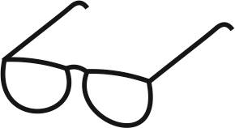Draft of the 10th teaching lesson:

Estimated time: 45 min.
Teaching stage | Activity description | Teaching method | Teaching form | Time
Motivation | - Discrimination  - Migration | Discussion  Discussion | Mass frontal | 5 min.
Exposure | - Discrimination – video  https://www.youtube.com/watch?v=jDVYUuN1u-A (3:41)  - Theoretical introduction  - Example pictures (Activity 1)  - Work with a worksheet | Static and dynamic projection  interview, demonstration of static pictures  Using literature | Mass frontal  Mass frontal, group  Mass frontal | 4 min.  4 min.  10 min.  15 min.
Fixation | - Discrimination – summary  - Migration – summary | Discussion  Interview | Mass frontal | 4 min.
Application | - Application in personal life |  | Individual | 1 min.

Motivation
At the beginning of the lesson, students will be asked the following questions:
- What is discrimination?
- Do you know anyone who faced it? Do you know a true story about discrimination?
- Is there discrimination in the Czech Republic?
- In which countries did/does discrimination occur and why?
Make students think about this topic as much as possible.
Exposure
In the main part of the lesson, play a video that explains the concept of discrimination and related topics.
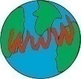 Video on discrimination: https://www.youtube.com/watch?v=jDVYUuN1u-A (3:41)

Tip for the teacher: During the video, the teacher can distribute random draw cards (Annex 1) to students to avoid any discrimination when forming groups for the first activity.
After the video, try to summarize the basic ideas and information about the topic with students. Ask the following questions: Who is the ombudsman? (public defender of rights). Who are the people that this person helps? There should be a short conversation with students on the topic of discrimination, who is affected, what the situation is in the Czech Republic, how to solve discrimination.

Smooth transition to Activity 1 with pictures.
Guiding questions: What does the picture show? Who do you see in the picture? Why did they/did they not choose a specific person? What can the person do? What does the woman’s and man’s ladder represent in the picture? (Pictures available in Activity 1)
(Students return the pictures and sit at their desks)
Discuss the following topic: Migration. Ask the following questions: What does migration mean? Has anyone encountered migration? It is a very topical issue for us now. We can discuss this issue in connection with the war in Ukraine.

The teacher distributes worksheets, one for each student. In the meantime, the teacher places boards around the classroom and this way creates information points. Exposure takes place by means of individual work. The teacher prepares the information points with data required to complete the worksheet. A good idea is for students to visit the information points without the worksheet and then return to their desks to complete it. They will have to memorize the information and transform it to the paper. This will also increase their physical activity. Students should complete the worksheet within 15 minutes.
Tip for the teacher: Some classes like to discuss different topics. If there is not much time left, they can fill in the worksheet directly at the information points. If there is still not much time left, the worksheet can be completed in a group to save time. However, if it is a class that does not like to communicate and engage in discussion, they can complete their worksheet using a tablet or their own mobile phones.

Tip for the teacher: It is better to print multiple copies of datasheets for the information points so that students are not discouraged by long waits. Always arrange the same copies next to each other in a single location – they form one information point.

Fixation
Discrimination: A brief summary of students’ or the teacher’s thoughts. Anyone in the class takes the floor and comments on what they see in the picture and gives their opinion about it. Any student can comment on each picture, because all the pictures have been passed through the class.
Migration: The teacher asks similar questions that students have just completed. Check work effectiveness in the class. The summary should take place by means of an interview.
Application
The most appropriate application of this lesson would be to look more favourably on refugees (at this time, mainly from Ukraine). Try to understand their concerns and problems and be a support for them, for example for your classmates. Also, do not be blind to discrimination among students and adults. Find out where to turn to in such cases.

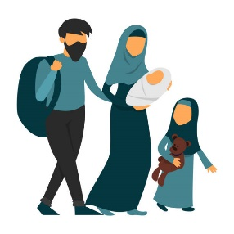
Worksheet on migration (including a completed worksheet for students) + information point:

WORKSHEET – MIGRATION
1. In your own words, explain the concept of migration.
___________________________________________________________________________
2. Give an example when people:
- Are forced to migrate _____________________________________________________________________
- Want to migrate _____________________________________________________________________


3. Write and explain in your words what health risks these people face and why?
Mental diseases: _______________________________________________________.
What is the reason for these diseases? ________________________________________
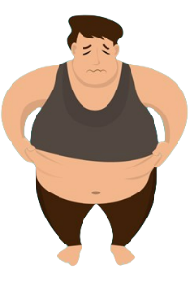
___________________________________________________________________________.
Chronic non-communicable diseases: ______________________________________________________________________________________________________________________________________________________.
What is the reason for these diseases?
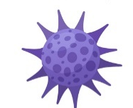
___________________________________________________________________________.
Communicable diseases: ________________________________________________________.

What is the reason for these diseases? ________________________________________
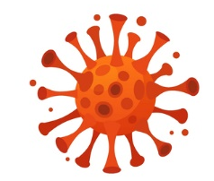
___________________________________________________________________________.

WORKSHEET – MIGRATION COMPLETED

1. In your own words, explain the concept of migration.
For example, leaving one’s own country, people moving across borders, etc.
2. Give an example when people:
- Are forced to migrate – because of war, danger, etc.
- Want to migrate – because of prosperity in other countries, better system, establishment, etc.

3. Write and explain in your words what health risks these people face and why?
Mental diseases: depression, anxiety.
What is the reason for these diseases? Leaving one’s home, loss of loved ones – death or loss in migration, injury, fear of the future, uncertainty, not belonging anywhere, no friends, fear, post-traumatic stress disorder, etc.
Chronic non-communicable diseases:
Type II diabetes, cardiovascular diseases, cancer, stroke.
What is the reason for these diseases?
Insufficient physical activity, poor diet, inappropriate eating, stress.
Communicable diseases: Tuberculosis, jaundice, HIV virus, conjunctivitis, chickenpox.
What is the reason for these diseases? Too many people gathered in one place, low vaccination rate, untreated diseases, lack of medical diagnosis, etc.

Information point 1: Print out multiple copies (so that there are no queues at the information points and students are not limited) and distribute them around the classroom. Create 3 information points (communicable diseases, mental diseases and chronic non-communicable diseases).
  - Information point – communicable diseases that can affect migrants. These are very simplified and incomplete lists of diseases and causes without any correlations. It is up to the teacher to master the theory and to be able to explain to students the context of the diseases and their causes and consequences.
Infekční nemoci = infectious diseases, zánět spojivek = Conjunctivitis, příušnice, spalničky = mumps, measles, nedostatečná hygiene = Insufficient hygiene, žloutenka =hepatitis, ekonomická situace země = Economic situation of the country, tuberkulóza = TBC, Tuberculosis,
nedostatečný osobní prostor = insufficient personal space, nechráněný sexuální styk = Unprotected sexual intercourse/sexual abuse, špatná lékařská dostupnost = Insufficient supply of medicines, černý kašel = Pertussis, chybějící očkování = missing vaccination, nedostatečné poučení osob = Lack of personal instruction, tyfus = Typhoid

Insufficient supply of medicines

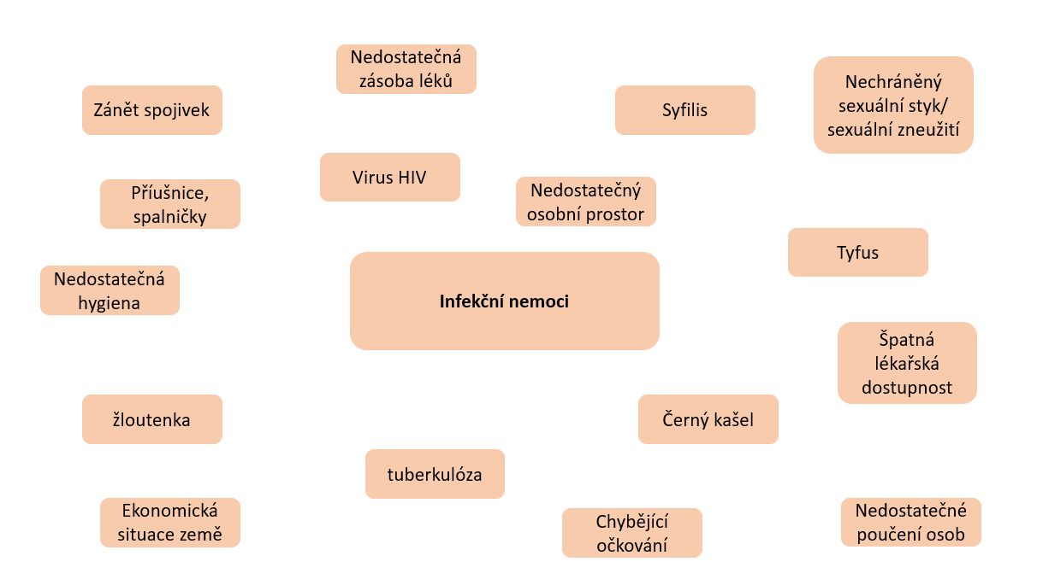

  - Information point – Mental diseases
Only selected mental diseases without causes, students must reveal those themselves.
Posttraumatická stresová porucha = Post-traumatic stress disorder, úzkostné stavy = Anxiety, nespavost = Sleeplessness, deprese = Depression

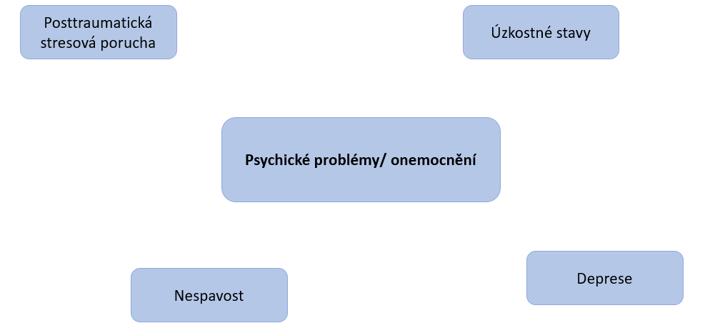

  - Information point – Chronic non-communicable diseases
Kardiovaskulární onemocnění = cardiovascular disease(heart and blood vessel diseases), cukrovka II.typu – diabetes 2, špatná životospráva = poor lifestyle. rakovina = cancer, nedostatek pohybu = Insufficient physical activity, mozková mrtvice = stroke, nevyvážená strava = unbalanced diet., Stres= Stress

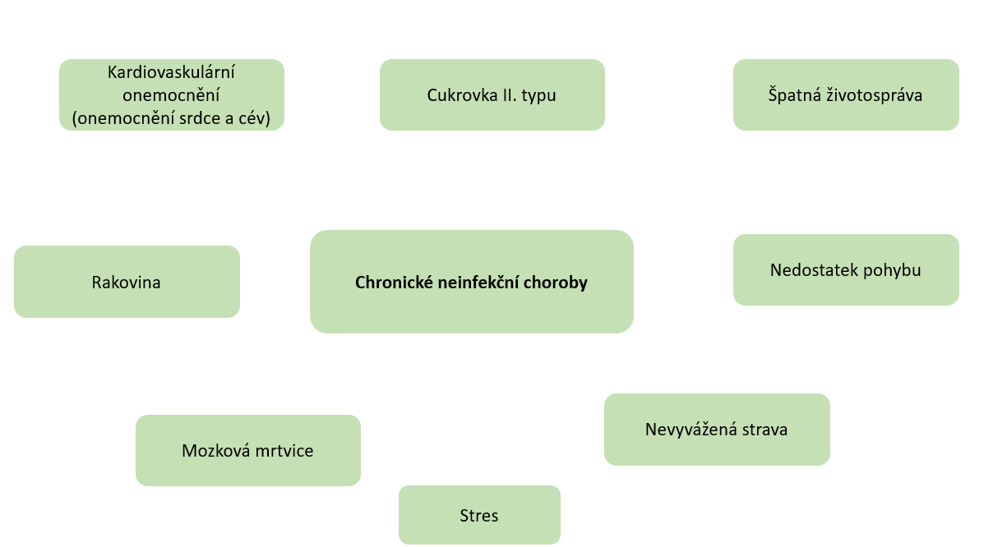
Diseases with possible causes.

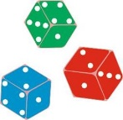 ACTIVITIES FOR STUDENTS
Activity 1: Students are divided into five groups according to draw cards. The teacher gives each group one picture. Students discuss the picture and come up with arguments, gradually exchanging all five pictures between the groups, always following the teacher’s instructions.
Students collect pictures and cards, the teacher takes them over, students sit at their desks.
Fixation takes place at the end of the lesson. One group or student takes a word and explains the meaning of the picture, others listen and add information. Others follow, the teacher then closes the discussion

Picture 1:
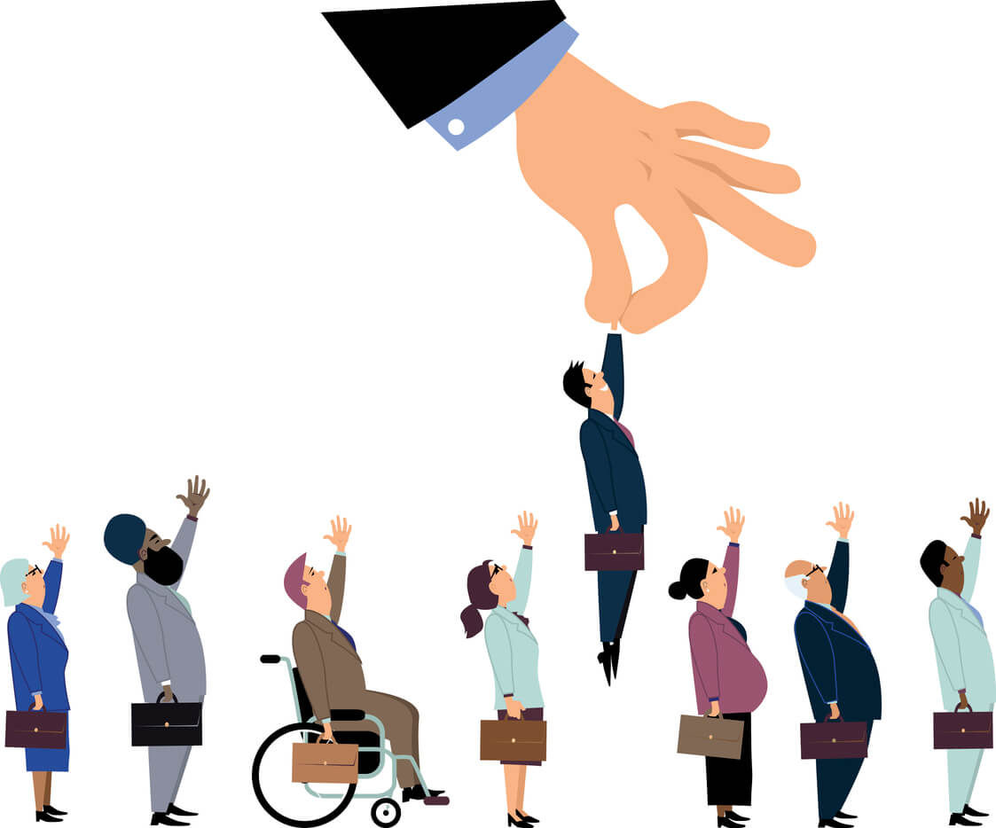
Source: https://www.i-sight.com/resources/how-do-the-worlds-most-ethical-companies-prevent-discrimination/

Picture 2:
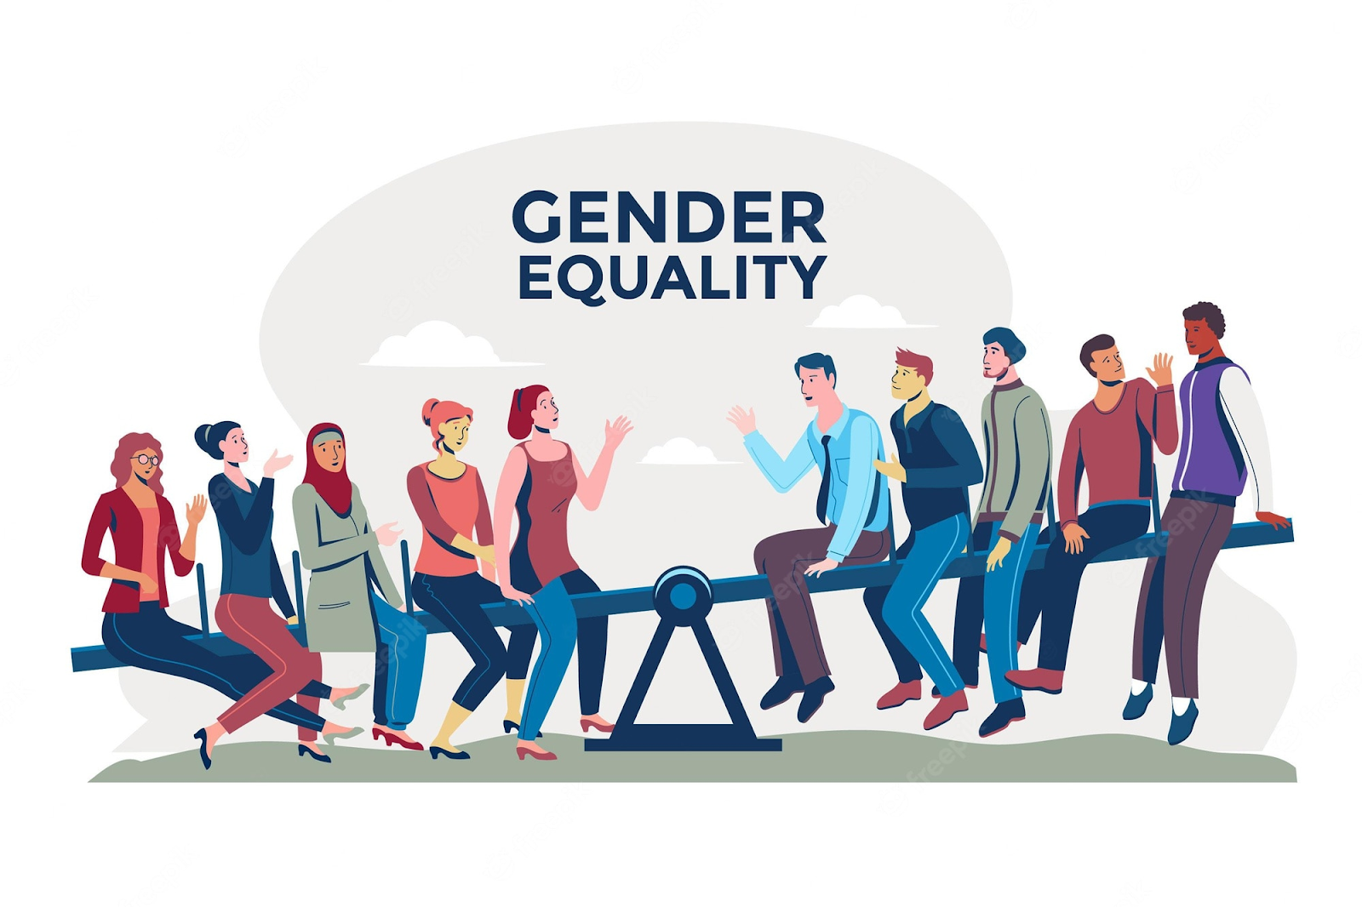
EQUALITY
GENDER
Source: https://www.freepik.com/free-photos-vectors/discrimination
Picture 3:

Source: https://wegate.eu/grow/legislation-taxation/gender-based-discrimination

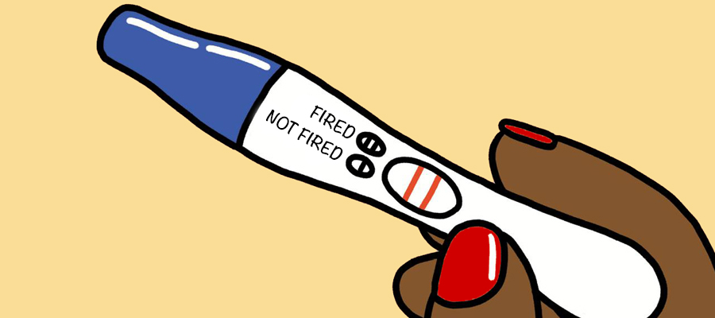
Picture 4:

Fired
Not fired

Source: https://www.umass.edu/employmentequity/pregnancy-discrimination-workplace-1
Picture 5:
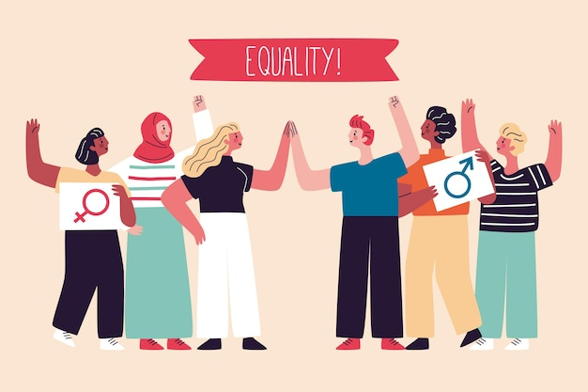
EQUALITY!
Source: https://www.freepik.com/free-vector/equality-movement-discrimination-concept_8846348.htm

References:
OSN. (2022). Cíle udržitelného rozvoje. Retrieved from United Nations: https://www.osn.cz/osn/hlavni-temata/
Diskriminace. (undated). Amnesty International. Retrieved on September 28, 2022, from https://www.amnesty.cz/diskriminace
Home. (2018, December 5). YouTube. Retrieved on September 28, 2022, from https://www.ochrance.cz/uploads-import/DISKRIMINACE/Vyzkum/CZ_Diskriminace_v_CR_shrnuti.pdf
Genderová vyváženost v řídících a dozorčích orgánech společností. (2022, September 12). Consilium.europa.eu. Retrieved on September 28, 2022, from https://www.consilium.europa.eu/cs/policies/gender-balance-corporate-boards
Začlenění ve školách – Inkluze.cz. (undated). Inkluze.cz. Retrieved on September 28, 2022, from https://inkluze.cz/inkluze/skola/
Inkluze v praxi - Co je inkluze. (undated). Podpora společného vzdělávání v pedagogické praxi. Retrieved on September 28, 2022, from http://www.inkluzevpraxi.cz/apivb/co-je-inkluze
Začlenění v zaměstnání – Inkluze.cz. (undated). Inkluze.cz. Retrieved on September 28, 2022, from https://inkluze.cz/inkluze/prace/
Rozvojová země - co to je, definice a koncepce - 2021 - Economy-Wiki.com. Retrieved on October 1, 2022, from https://cs.economy-pedia.com/11039316-developing-country#menu-1
Zásady migrační strategie - Aktuální informace o migraci. (undated). Ministerstvo vnitra. Retrieved on October 1, 2022, from https://www.mvcr.cz/migrace/clanek/zasady-migracni-strategie.aspx
Ct24. (2019). Retrieved on 16.10. 2022AD, from https://ct24.ceskatelevize.cz/veda/2712377-migranti-nesiri-nemoci-doklada-zprava-who-jejich-zdravi-se-ale-v-evrope-zhorsuje
Zdravotnický deník. (2015). Retrieved on 16.10. 2022AD, from https://www.zdravotnickydenik.cz/2015/09/jaka-jsou-realna-rizika-migrace-pro-zdravi-cechu/
Lékařibezhranic. (2020). Retrieved on October 16, 2022, from https://www.lekari-bez-hranic.cz/recko-koronavirus
Gatestoneinstitute. (2017). Retrieved on October 16, 2022, from https://www.gatestoneinstitute.org/10676/germany-migrants-infectious
Zdravotnický deník. (2015). Retrieved on October 16, 2022, from https://www.zdravotnickydenik.cz/2015/09/jaka-jsou-realna-rizika-migrace-pro-zdravi-cechu/
Pictures in the Worksheet adopted from:
Viruses: https://www.google.com/search?q=virus+picture&sxsrf=ALiCzsYa-NNJW3Vlp8zv8zG5aCrRayC91w:1666353056576&source=lnms&tbm=isch&sa=X&ved=2ahUKEwirmIfwoPH6AhV-if0HHcPBB00Q_AUoAXoECAIQAw&biw=1536&bih=746&dpr=1.25#imgrc=sZSZNsXeU-6_kM&imgdii=rDkdzlMKPGzfkM
Obesity: https://www.google.com/search?q=obesitypicture&tbm=isch&ved=2ahUKEwjuwv7woPH6AhUQqRoKHd67Cr4Q2-cCegQIABAA&oq=obesitypicture&gs_lcp=CgNpbWcQA1CSF1ijIWDaImgAcAB4AIABVIgBmwSSAQE4mAEAoAEBqgELZ3dzLXdpei1pbWfAAQE&sclient=img&ei=oodSY-7pH5DSat73qvAL&bih=746&biw=1536#imgrc=rQLPnrTDdQiiVM
Sadness: https://www.google.com/search?q=cartoon%20sad%20person&tbm=isch&hl=cs&sa=X&ved=0CB0QtI8BKABqFwoTCIjN_uWi8foCFQAAAAAdAAAAABAH&biw=1519&bih=688#imgrc=P1IiGg-ihNSXPM&imgdii=W1Jo8ariYKL44M
Migration: https://www.google.com/search?q=cartoon+sad+migration%C2%A8&tbm=isch&ved=2ahUKEwipxqi2o_H6AhUI-BoKHU-WCjcQ2-cCegQIABAA&oq=cartoon+sad+migration%C2%A8&gs_lcp=CgNpbWcQA1D8BljIC2DVDWgAcAB4AIABggGIAcoDkgEDMy4ymAEAoAEBqgELZ3dzLXdpei1pbWfAAQE&sclient=img&ei=TIpSY6nwL4jwa8-sqrgD&bih=688&biw=1519&hl=cs#imgrc=P0GVQDbSBn6brM

Annex 1: Draw cards - the teacher cuts them in advance and gives them to students on the desk, the colour facing down.

