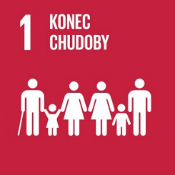
No Poverty
Authors: Lukáš Cík, Michal Hanzl
Keywords: poverty, lack of resources, poverty line, living minimum, subsistence minimum, material deprivation
UN Goal: End poverty in all its forms everywhere
More than 650 million people in the world live in extreme poverty – they have less than 50 crowns per day. The goal is to ensure that by 2030 no human being will live in such degrading conditions. This can be achieved, for example, through protection against unemployment, access to social services and social policy. This will allow even less affluent people to find work, own land or start small businesses.


Theoretical preparation

Poverty is a state of emergency. People living in poverty do not have enough resources to ensure their existence in a given society. The definition of poverty varies according to different perspectives, as it can be seen from both objective and subjective points of view. In terms of the objective perspective, poverty can be absolute and relative (Krebs, 2015).
The term relative poverty refers to the product of social inequality whose assessment criteria vary according to a country’s level of development.
Absolute poverty is defined as a lack of the basic necessities of life (food, drinking water, health care, shelter, education). Voluntary poverty means that a person gives up their full access to resources and services for political, religious or other reasons (Tomeš, 2010).
Extreme poverty is a serious case of poverty – it is defined by the threshold of 1.25 USD (about 31 CZK) per day. Currently, about 836 million people fall below this threshold. In developing countries, one in five people live below this threshold. In the EU, extreme poverty is eliminated through state interventions (UN, undated).
Poverty is affected by many different factors. The first of these are economic and social causes – cultural and religious traditions, wealth of the state, its indebtedness and others. Other factors affecting poverty are political, for example government instability or armed conflicts. Poverty is also influenced by demographic factors such as overpopulation in some countries, high birth rates and others. The last factors include natural disasters, climate change or, for example, soil or air pollution – environmental causes.
These factors contribute to the three root causes of poverty, which are low earnings, unemployment and differences in wealth across countries. Poverty is most often monitored using the following two instruments:
- Consumption – measures goods and services consumed;
- Income – measures the amount of income and assumes a direct impact on consumption (may not always be perfectly valid).
Poverty can be measured objectively by absolute and relative methods. Absolute methods include determining whether one’s basic human needs are met or whether and how much one can afford certain goods and services. Other absolute methods are based on food ratios – they examine the relationship between total expenditure and food expenditure. Relative methods of measurement include determining the specific amount of money necessary to meet the basic human needs. Subjective methods of measuring poverty include asking about a person’s living situation and assessing the minimum satisfactory income (Krebs, 2015).
In addition to poverty, material deprivation is an important concept that can be considered in more advanced societies. If someone cannot afford at least three of the following items, they are suffering from material deprivation. In the Czech Republic, this deprivation affects about 16% of the population. Severe material deprivation affects 6% of the population – the inability to afford at least four things on the list:
- Ability to cope with unexpected expenses (9,600 CZK in 2014);
- Ability to pay for one-week holiday away from home per year;
- No arrears (mortgage or rent payments, utility bills, repayment of purchased goods in instalments or other loan repayments);
- Ability to have a meat meal, chicken, fish or vegetarian equivalent every other day;
- Ability to provide adequate heating;
- Ownership of a washing machine;
- Ownership of a colour television;
- Ownership of a mobile phone;
- Ownership of a passenger car (Šustová, 2015).
In the Czech Republic, the poverty line is determined by the Act on Living and Subsistence Minimum. The living minimum means the minimum socially recognized threshold of monetary income to ensure food and other basic life needs – as of 1 July 2022, the amount was 4,620 CZK. The subsistence minimum is the minimum threshold of this income to ensure survival – as of the same date the amount was 2,980 CZK. These minima do not include housing costs. The number of households with income below the poverty line in the Czech Republic increased from 9% at the end of 2021 to 16% in mid-2022 (cf. Košlerová, 2022 & Ministry Labour and Social Affairs, 2022).









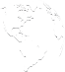

Calculation of the living and subsistence minimum:
https://www.mpsv.cz/zivotni-a-existencni-minimum

Draft lesson plan
Estimated time: 45 min
Teaching stage | Activity description | Teaching method | Teaching form | Time
Motivation | - Activity 1 – Situations in different parts of the world  - Wealth in different parts of the world | Discussion | Group, joint | 7 min
Exposure | - Activity 2 – How do these people probably live?  - Exploring the standard of living in different socio-economic classes  - Activity 3 – Material deprivation  - What income do people in different parts of the world have to get along with?  - Poverty line  - Living and subsistence minimum  - Material deprivation  - Completion of worksheet | Worksheet, activation, discussion | Group, joint, pair work | 25 min
Fixation | - Activity 4 – Living on a subsistence minimum income  - What can poor people afford? | Activation,  discussion | Group, joint | 10 min
Application | - Activity 5 – How do people with different incomes live?  - Possible monthly expenses for people with different incomes  - Homework | Activation | Individual | 3 min

Motivation
During the motivation phase, the teacher introduces the topic of the lesson and starts a discussion on the different lifestyles of people in the world through Activity 1 (Pictures from different parts of the world).
Exposure
The teacher shifts the focus to the daily life of poor people through Activity 2 (Pictures of people from different socio-economic classes). The discussion is followed by Activity 3 (Cards with goods from the definition of material deprivation), by means of which the students understand how socio-economically weaker individuals live in the Czech Republic.
This is followed by a short discussion between the teacher and the students, the purpose of which is to provide the basic information on poverty in the world required for the worksheet.
In the last part of the exposure phase, the teacher distributes the worksheet which students complete in groups assisted by the teacher and using the internet. After completion, a joint check is performed.
Fixation
During the fixation phase, students complete Activity 4 (Living on a subsistence minimum income) which consolidates their knowledge and broaden their awareness of the life possibilities of poor people in the Czech Republic.
Application
For homework, the teacher assigns Activity 5 (Life in different socio-economic classes) in which students use the information gained. The teacher completes the activity in the next lesson.




Worksheet – No Poverty

- Match countries with average monthly wage:
1/ Czech Republic | a/ 6,012 CZK
2/ Germany | b/ 6,886 CZK
3/ Brazil | c/ 100,247 CZK
4/ India | d/ 34,000 CZK
5/ Cuba | e/ 7,783 CZK
6/ Nicaragua | f/ 1,156 CZK
7/ Zambia | g/ 114,000 CZK
8/ Sweden | h/ 9,930 CZK
2. Write at least four things how insufficient income can affect a person’s life:
____________________________________________________________________________________________________________________________________________________________________________________________________________________________________________________________________________________________________________
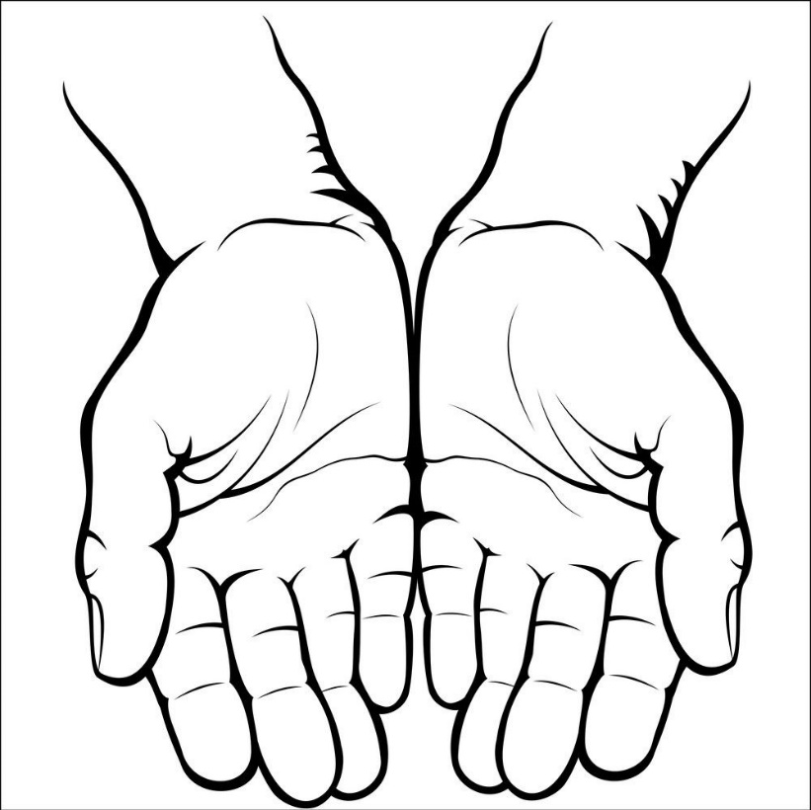
3. Write at least five things that affect poverty in different parts of the world:
4. Write in your own words what the following terms mean:
Poverty line:
___________________________________________________________________________
Living minimum:
___________________________________________________________________________
Subsistence minimum:
___________________________________________________________________________
Material deprivation:
___________________________________________________________________________
5. Decide whether the following statements are correct:
The international poverty line set by the World Bank is 31 CZK per day. | Yes | No
High levels of poverty are often found in small developed countries. | Yes | No
The subsistence minimum in the Czech Republic is set at 2,980 CZK per month. | Yes | No
Most people in extreme poverty live in South America. | Yes | No
In the Czech Republic, material deprivation affects about 16% of the population. | Yes | No
One in ten people in developing countries live below the international poverty line. | Yes | No



Worksheet – No Poverty
- Match countries with average monthly wage:
1/ Czech Republic | a/ 6,012 CZK
2/ Germany | b/ 6,886 CZK
3/ Brazil | c/ 100,247 CZK
4/ India | d/ 34,000 CZK
5/ Cuba | e/ 7,783 CZK
6/ Nicaragua | f/ 1,156 CZK
7/ Zambia | g/ 114,000 CZK
8/ Sweden | h/ 9,930 CZK
Answers: 1d, 2g, 3h, 4a, 5f, 6e, 7b, 8c
2. Write at least four things how insufficient income can affect a person’s life:
Poor food, malnutrition, housing problems, inability to buy necessities (clothes, electronics, insurance), inability to travel, cultural life
3. Write at least five things that affect poverty in different parts of the world:
War
Extremely high inflation
Work inefficiency
Political situation
Overpopulation
Environmental conditions

4. Write in your own words what the following terms mean:
Poverty line:
The lowest income which is considered sufficient in a given country.
Living minimum:
The minimum socially recognized threshold of monetary income to ensure food and other basic life needs (exclusive of housing).
Subsistence minimum:
The minimum threshold of monetary income which is considered necessary to provide food and other basic personal needs in order to survive (exclusive of housing).
Material deprivation:
A feeling of inadequate satisfaction of the needs of the household and its members.
5. Indicate whether the following statements are true or not:
The international poverty line set by the World Bank is 31 CZK per day. | Yes | No
High levels of poverty are often found in small developed unstable and conflict-affected countries. | Yes | No
The subsistence minimum in the Czech Republic is set at 2,980 CZK per month. | Yes | No
Most people in extreme poverty live in South America. Asia and Sub-Saharan Africa. | Yes | No
In the Czech Republic, material deprivation affects about 16% of the population. | Yes | No
One in ten five people in developing countries live below the international poverty line. | Yes | No

Activities for students

Activity 1 – Pictures from different parts of the world
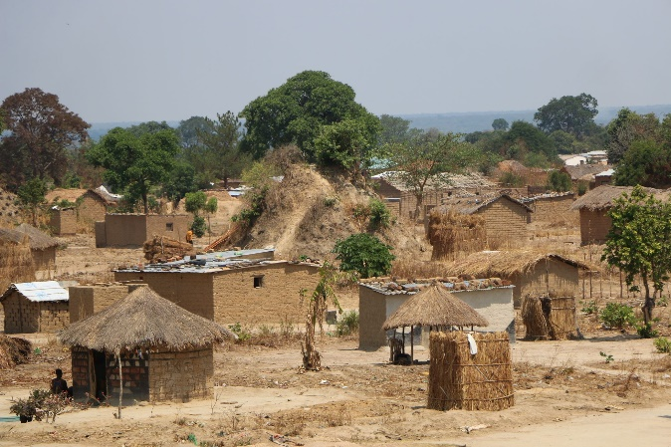
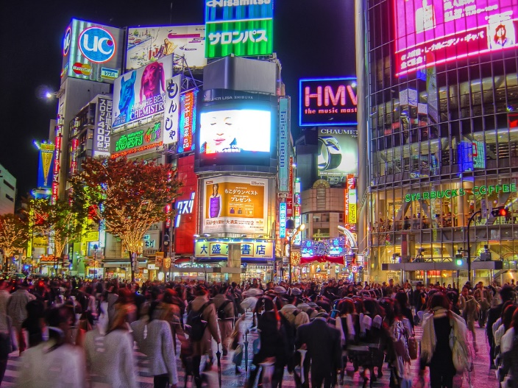
The teacher presents the students with pictures showing different developed parts of the world. The students discuss what everyday life is like in different locations around the world. The teacher leads the discussion. The pictures can be projected or printed and handed out to groups or individuals.
Picture 2 – African settlement
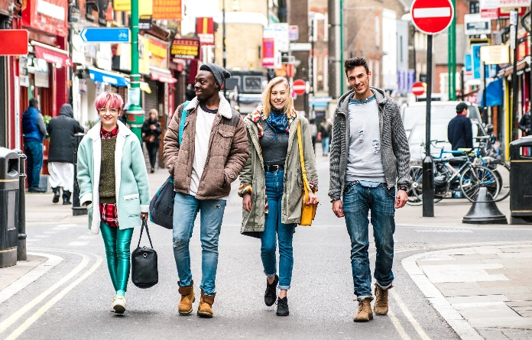
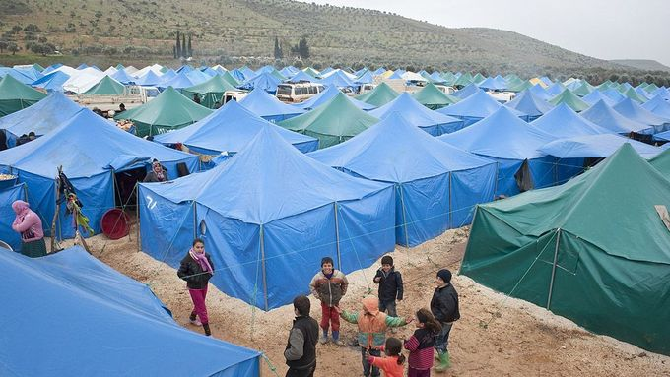
Picture 1 – Asian metropolis
Picture 3 – Refugee camp Picture 4 – European city

Activity 2 – Pictures of people from different socio-economic classes
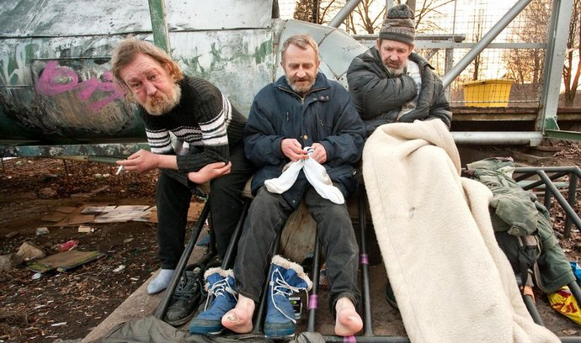
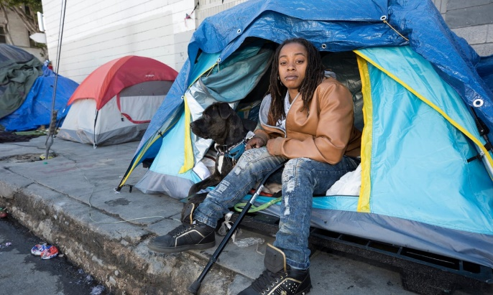
The activity is similar to the previous one. The teacher projects or hands out to groups of students printed pictures of people from different socio-economic classes and parts of the world. The students discuss their everyday lives and compare them. Then they communicate their findings to the rest of the class. The teacher moderates the discussion.

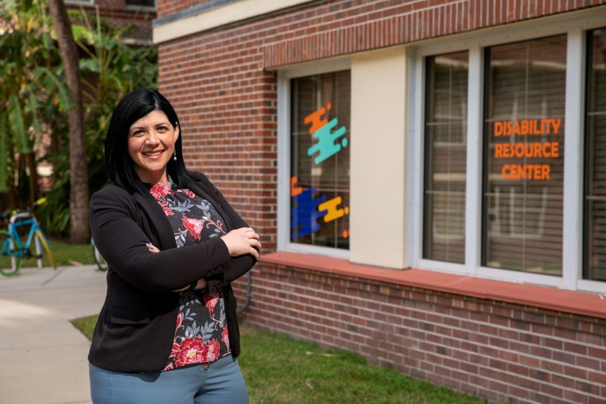
Picture 5 – Homeless person in the USA Picture 6 – Homeless people in the CR
Picture 7 – Employee of a health centre Picture 8 – Director of a marketing company

Activity 3 – Cards with goods from the definition of material deprivation
The teacher hands out to groups of students cards with goods from the definition of material deprivation. The students then choose three things they could do without in their lives and how it would make them feel. After a while, the teacher asks the groups to tell the others what they have come to. This is followed by a teacher-moderated discussion on how materially deprived people live in the Czech Republic. The teacher prepares sets of cards so that each group has one.
Ability to cope with unexpected expenses  (9,600 CZK in 2014) | Ownership of a mobile phone | No arrears (mortgage or rent payments, utility bills, repayment of purchased goods in instalments or other loan repayments)
Ability to have a meat meal, chicken, fish or vegetarian equivalent every other day | Ability to provide adequate heating | Ownership of a washing machine
Ownership of a colour television | Ability to pay for one-week holiday away from home per year | Ownership of a passenger car
Activity 4 – Living on a subsistence minimum income
Using the internet, the students create a list of what a person with a subsistence minimum income can afford per month to survive. Then they present their lists. This is followed by a teacher-moderated discussion
Activity 5 – Life different socio-economic classes
The students create lists similar to those in Activity 4 but the expenses other than housing will be the living minimum – 10 thousand and 15 thousand. In the next lesson, they compare their lists in groups and present them to the rest of the class. The teacher moderates the discussion.
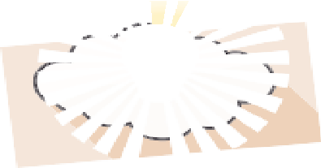

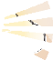



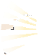
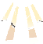

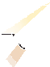



Tip for the teacher: Discuss with the students their lists. Do they forget about cultural activities or unexpected expenditure?
References:
Košlerová, A. (2022, 16 May). Příjmová chudoba vzrostla téměř o polovinu, týká se každé šesté domácnosti. iRozhlas. https://www.irozhlas.cz/zpravy-domov/prijmova-chudoba-v-cesku_2205160500_ank
Krebs, V. (2015). Sociální politika. Wolters Kluwer
MPSV. (2022, 17 August). Životní a existenční minimum. https://www.mpsv.cz/zivotni-a-existencni-minimum
UN. (undated). Fakta o chudobě. https://www.osn.cz/sdg-1-vymytit-chudobu-ve-vsech-jejich-formach-vsude-na-svete/fakta/
Šustová, Š. (2015, 19 March). Jak se měří deprivace. Statistika&My. https://www.statistikaamy.cz/2015/03/19/jak-se-meri-materialni-deprivace/
TOMEŠ, I. (2010). Úvod do teorie a metodologie sociální politiky. Portál.
Pictures:
Picture 1: https://www.bilimevi.com/images/dosyalar/tokyo9.jpg
Picture 2: https://cdn.xsd.cz/resize/12d3983d59bf3a55a73adaf2f13fe6d0_resize=1960,1306_.jpg?hash=1810aaab201bbc01e14646a482ae9c92
Picture 3: https://cdn.xsd.cz/original/67d9e243fc293d8bbcb2aa41e3a27e50.jpg
Picture 4: https://media.timeout.com/images/105906876/750/422/image.jpg
Picture 5: https://i.guim.co.uk/img/media/36412dbd81d0cab15cf56439d96f538cc7e62a5a/0_134_6720_4032/master/6720.jpg?width=965&quality=85&dpr=1&s=none
Picture 6: https://1884403144.rsc.cdn77.org/foto/2906058/NjkweDQwOC9jZW50ZXIvbWlkZGxlL3NtYXJ0L2ZpbHRlcnM6cXVhbGl0eSg4NSkvaW1n/2906058.jpg?v=0&st=4pdzeyKFMM59eByZHBX_4jzcxUsoHP35m3H2tDGEXJA&ts=1600812000&e=0
Picture 7: https://studentlife.ufl.edu/wp-content/uploads/2021/04/Edited-210329_DRC_InterpretersStory_3162-1-1024x683.jpeg
Picture 8: https://media.gettyimages.com/photos/portrait-of-a-handsome-businessman-picture-id1222820617?k=20&m=1222820617&s=612x612&w=0&h=h3_SBVnrKI6Hc0iAbxVgm0Df496Gylp7wvJp_h5gssk=

